
H.C.B-A1377
BENZ SPRINTER,VW LT BALL JOINT REMOVER (35 mm) PAT. M 362085
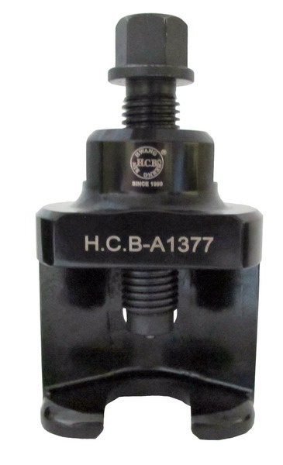
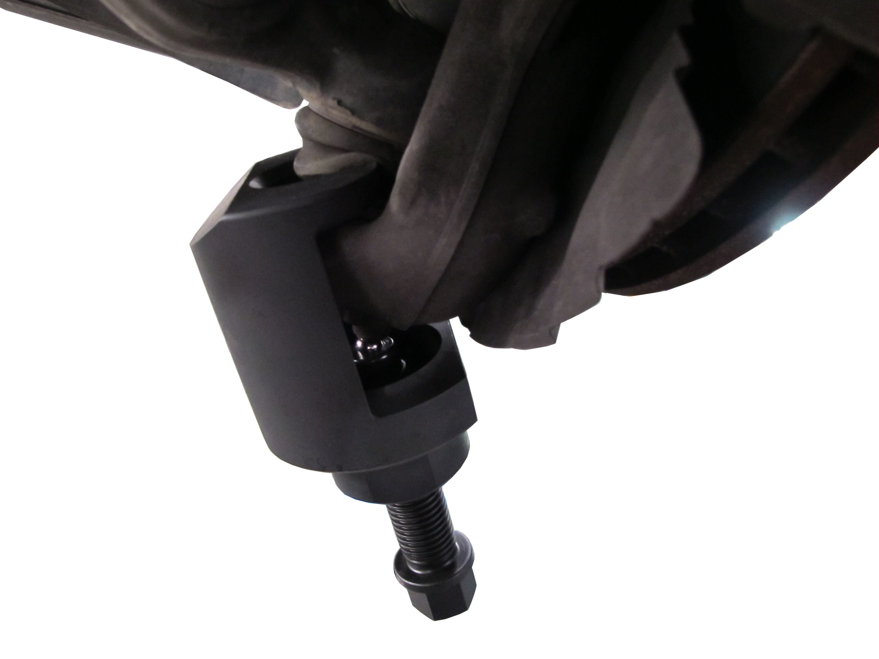

BMW (E70)

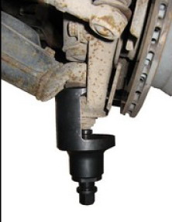
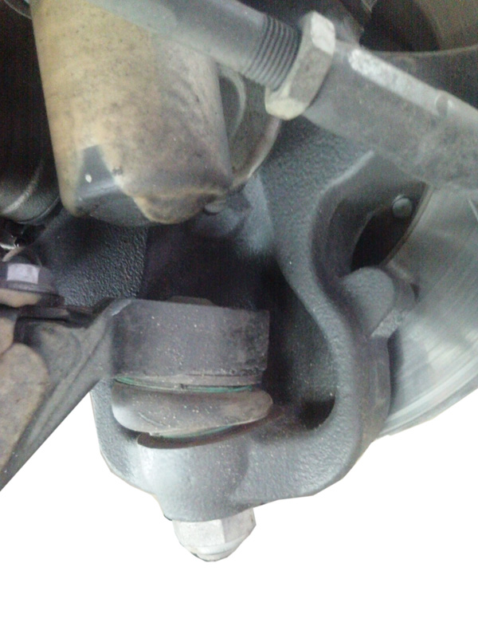

M-Benz Sprinter Ball Joint

█ The ball joint remover has a ball bearing pressure peak which used with an impact wrench. With the pressure and impact moment great, loosening torque is achieved.
█ Application: Mercedes Benz Sprinter, BMW (E70) and VW LT for loosening the very tight suspension ball joint at the front suspension.

H.C.B-A1377
BENZ SPRINTER,VW LT BALL JOINT REMOVER (35 mm) PAT. M 362085

BMW (E70)

M-Benz Sprinter Ball Joint

█ The ball joint remover has a ball bearing pressure peak which used with an impact wrench. With the pressure and impact moment great, loosening torque is achieved.
█ Application: Mercedes Benz Sprinter, BMW (E70) and VW LT for loosening the very tight suspension ball joint at the front suspension.

