
H.C.B-A1369
BENZ SPRINTER REAR AXLES SOCKET
Dr. 1/2”
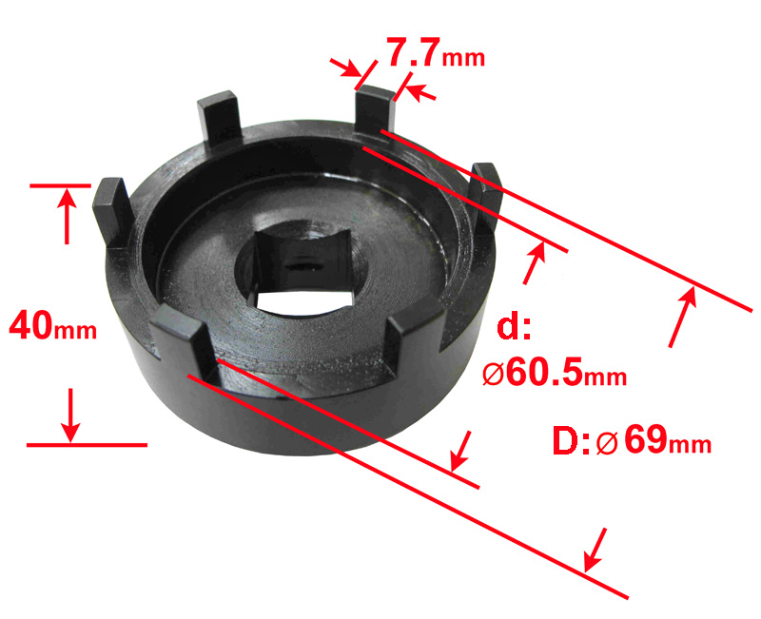

■ Application : BENZ Sprinter

H.C.B-A1369
BENZ SPRINTER REAR AXLES SOCKET
Dr. 1/2”

■ Application : BENZ Sprinter

