
H.C.B-A1363
VOLVO TRUCK KING PIN BEARING PULLER
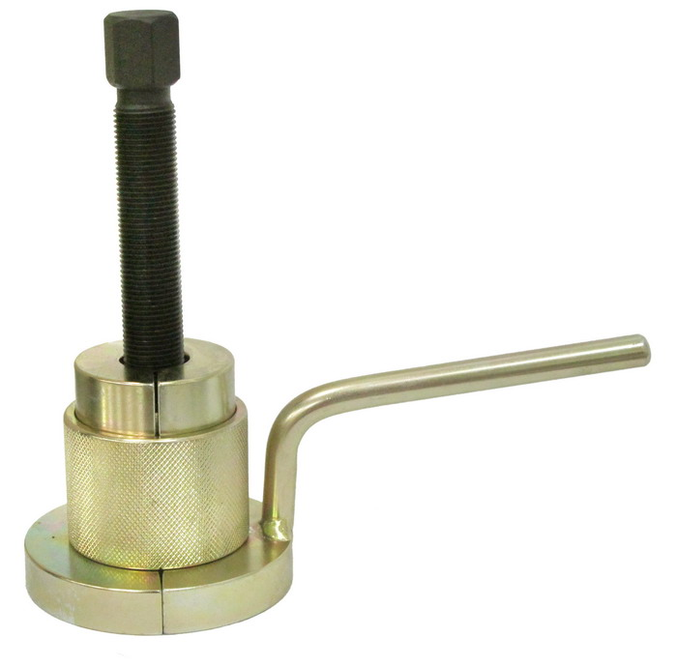

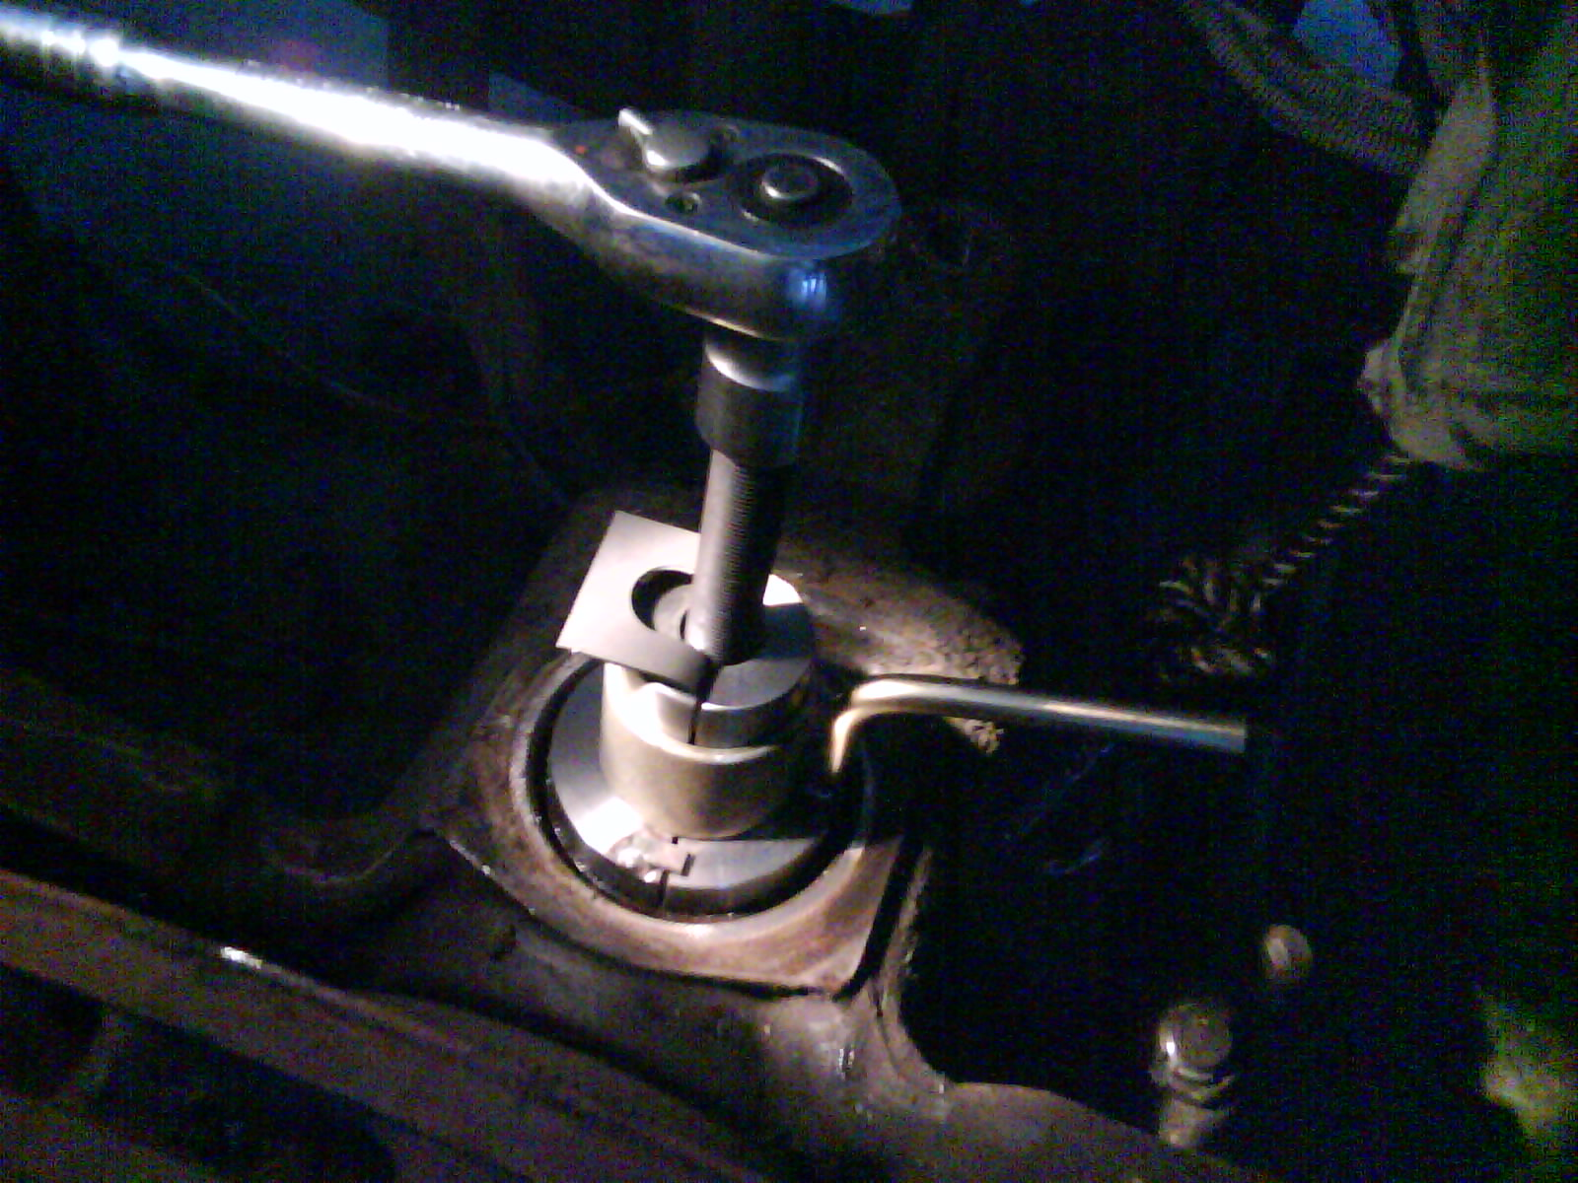
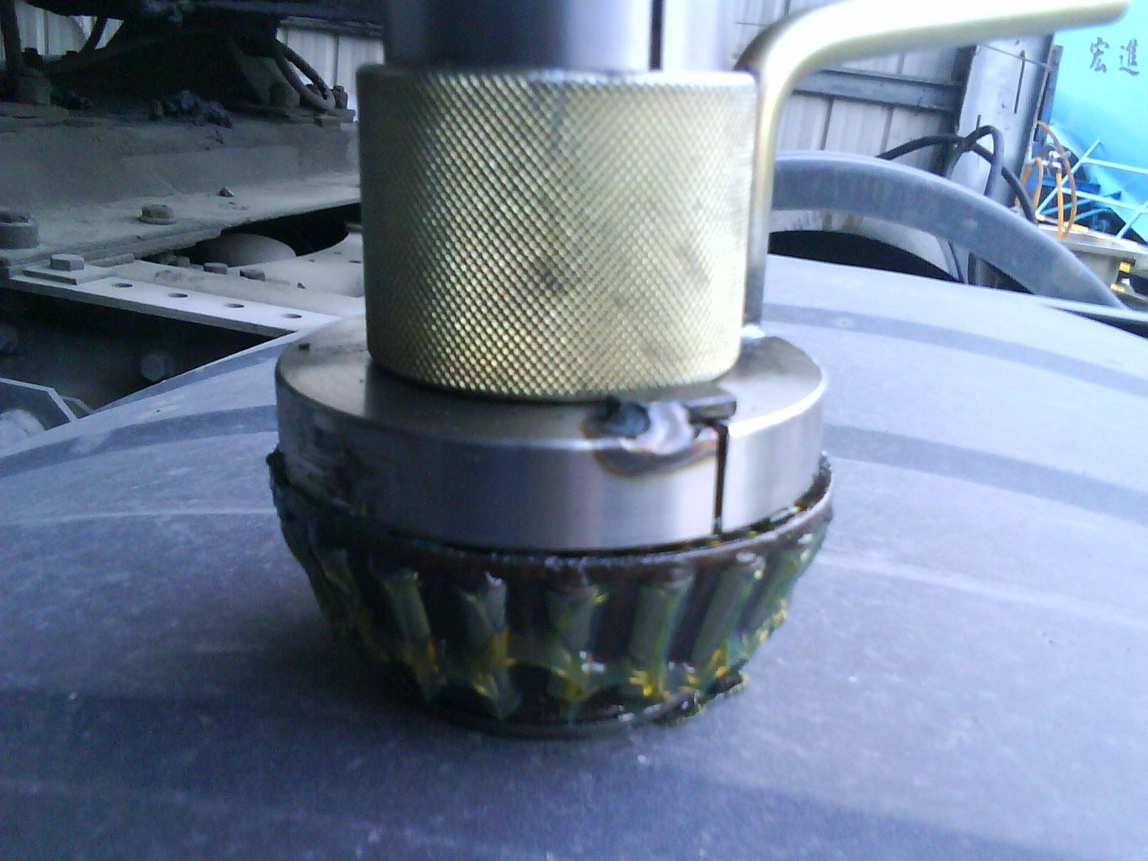

- For removing king pin bearing.
- Applicable for VOLVO truck new series after FM12.
- Genuine no.: 9998621
- Stock no. of bearing: SKF 2619334W

H.C.B-A1363
VOLVO TRUCK KING PIN BEARING PULLER

- For removing king pin bearing.
- Applicable for VOLVO truck new series after FM12.
- Genuine no.: 9998621
- Stock no. of bearing: SKF 2619334W

