
H.C.B-A1361
VOLVO CYLINDER HEAD REMOVER

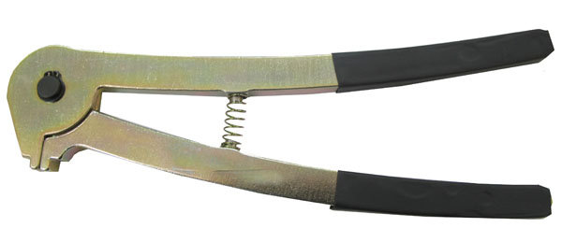

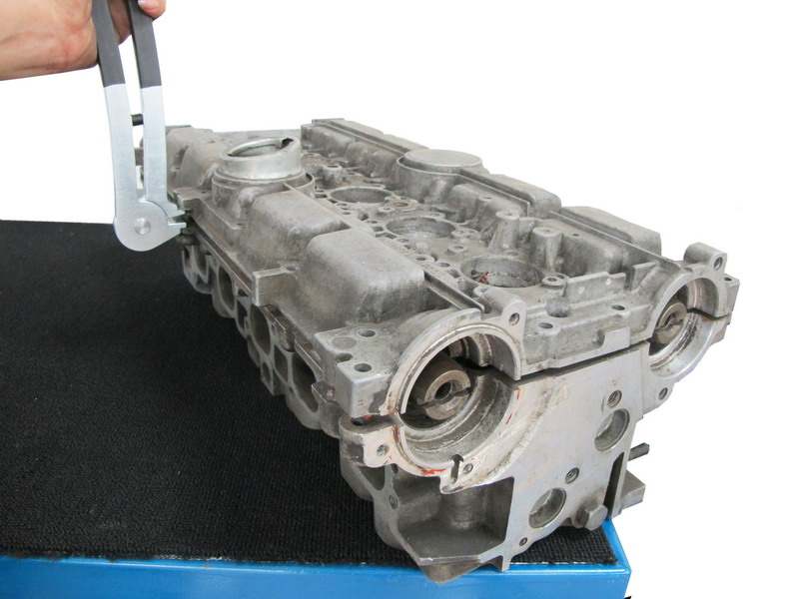
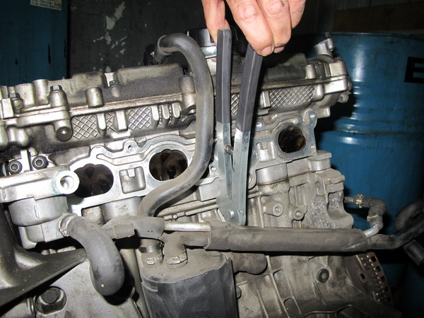

- The tool is used for removing cylinder head.
- Application: V70 (08-), XC70 (08-), S80 (-06), XC90, V70 (00-08), V70 XC (01-) / XC70 (-07), S60, C30, C70 (06-), S40 (04-), V50, S40 (-04), V40, 850, C70 Coupe (-02), C70 Conv (-05), S70, V70 (-00), V70 XC (-00), 960, S90, V90, S80 (07-)
- VOLVO OEM no. ref.: 9995670

H.C.B-A1361
VOLVO CYLINDER HEAD REMOVER

- The tool is used for removing cylinder head.
- Application: V70 (08-), XC70 (08-), S80 (-06), XC90, V70 (00-08), V70 XC (01-) / XC70 (-07), S60, C30, C70 (06-), S40 (04-), V50, S40 (-04), V40, 850, C70 Coupe (-02), C70 Conv (-05), S70, V70 (-00), V70 XC (-00), 960, S90, V90, S80 (07-)
- VOLVO OEM no. ref.: 9995670

