
H.C.B-A1358
VOLVO DIFFERENTIAL SEALING NUT WRENCH

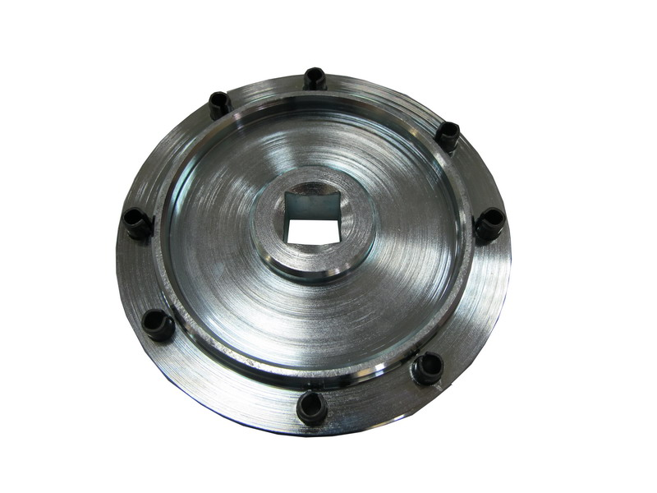

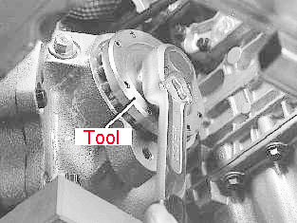

A1358

- Application：XC90, V70 (00-08), V70 XC (01-) / XC70 (-07), S60, 850, S70, V70 (-00), V70 XC (-00), 940, 940 SE, 960, S80 (-06)
- VOLVO OEM no. ref.: 9995371
H.C.B-A1358
VOLVO DIFFERENTIAL SEALING NUT WRENCH

A1358

- Application：XC90, V70 (00-08), V70 XC (01-) / XC70 (-07), S60, 850, S70, V70 (-00), V70 XC (-00), 940, 940 SE, 960, S80 (-06)
- VOLVO OEM no. ref.: 9995371

