
H.C.B-A1355
VOLVO BALL JOINT REMOVER
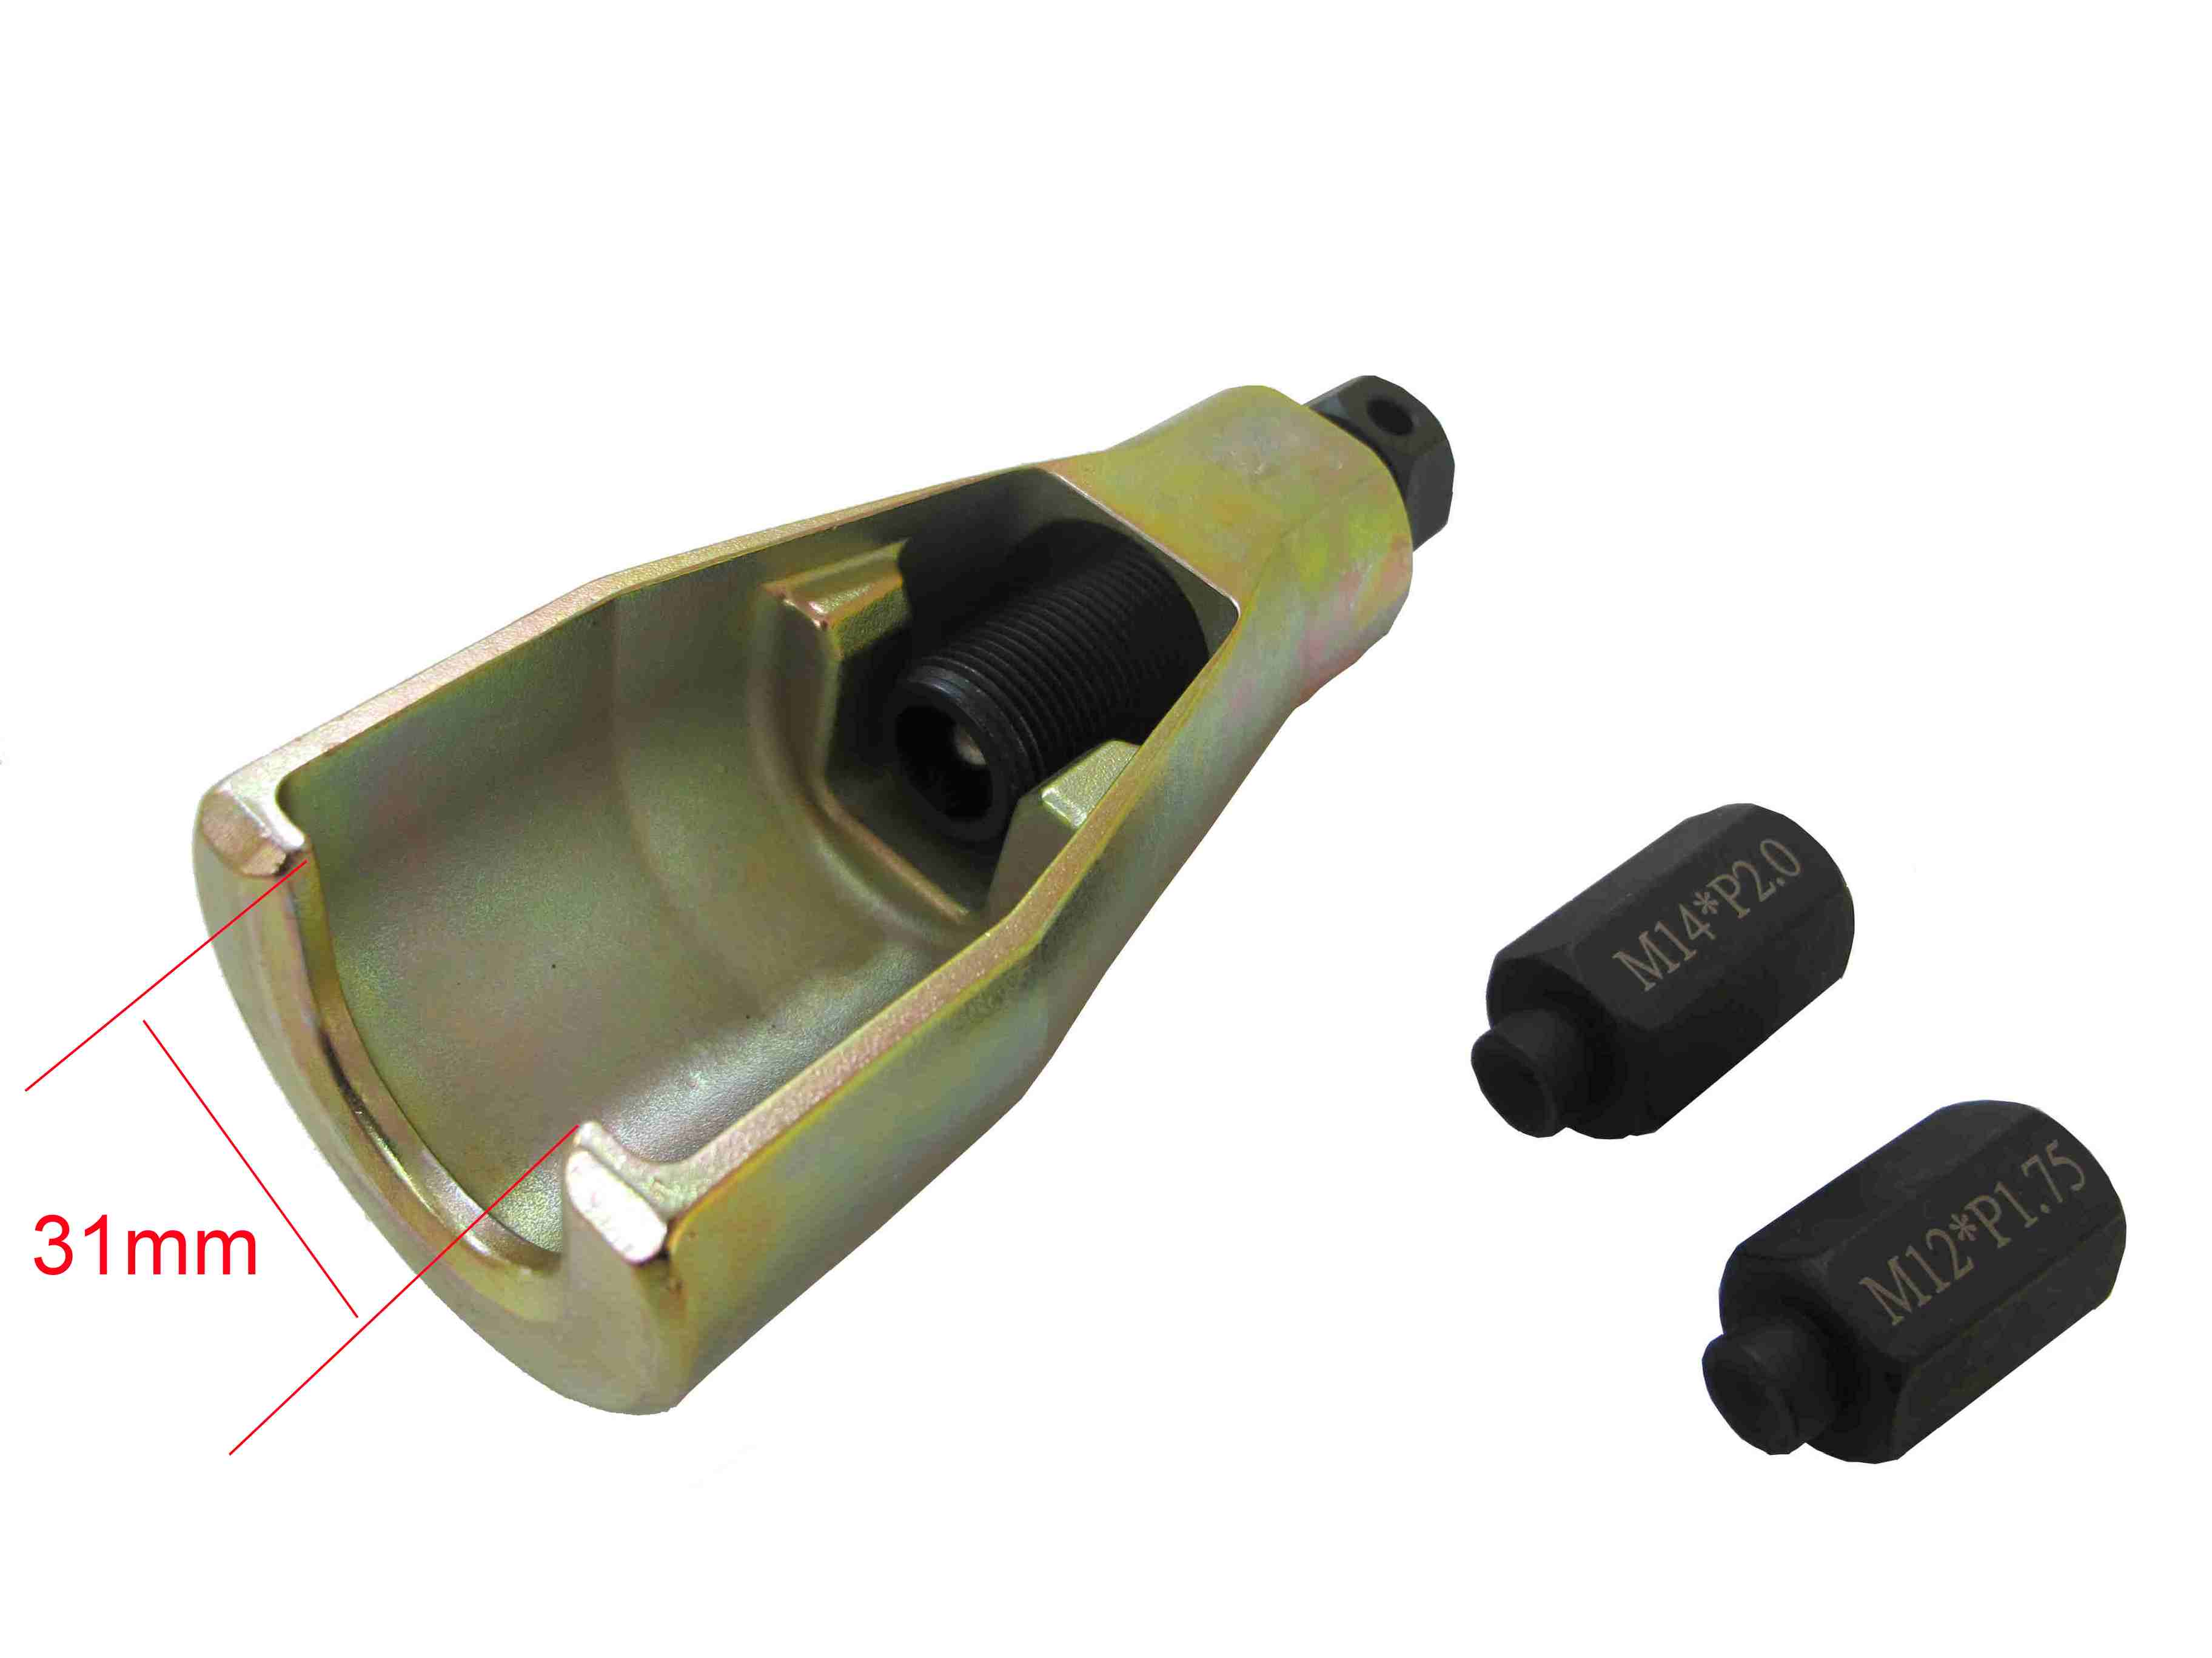

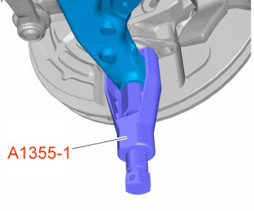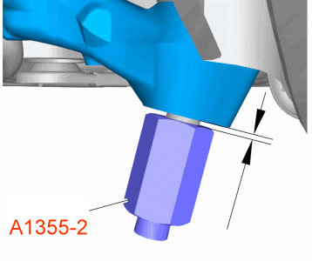

- For remove lower control arms, ball joints and suspension parts
- Aim H.C.B-A1355-1 and control arm at H.C.B-A1355-2.
- Tighten H.C.B-A1355-1 and release the ball joint from control arm.
- Application: V70 (00-08), V70 XC (01-) / XC70 (-07), S60, S80 (-06)、XC90.
- Size of nuts: M12 x P1.75, M14 x P2.0

H.C.B-A1355
VOLVO BALL JOINT REMOVER

- For remove lower control arms, ball joints and suspension parts
- Aim H.C.B-A1355-1 and control arm at H.C.B-A1355-2.
- Tighten H.C.B-A1355-1 and release the ball joint from control arm.
- Application: V70 (00-08), V70 XC (01-) / XC70 (-07), S60, S80 (-06)、XC90.
- Size of nuts: M12 x P1.75, M14 x P2.0

