
H.C.B-A1344
MAN, BENZ DIFFERENTIAL REAR NUT SOCKET (Dr. 3/4", 6 TEETH)

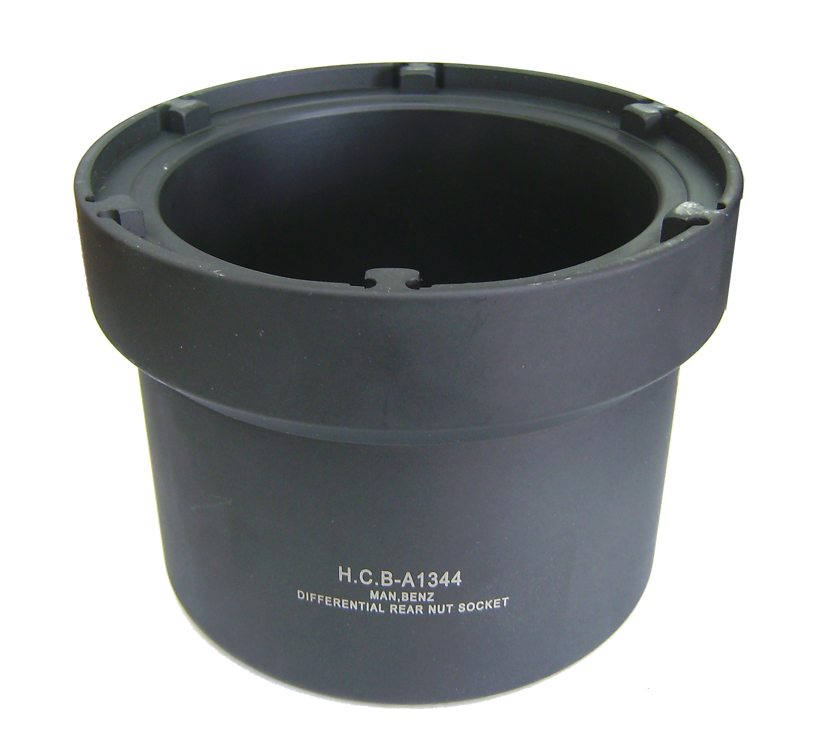
Dr. 3/4”

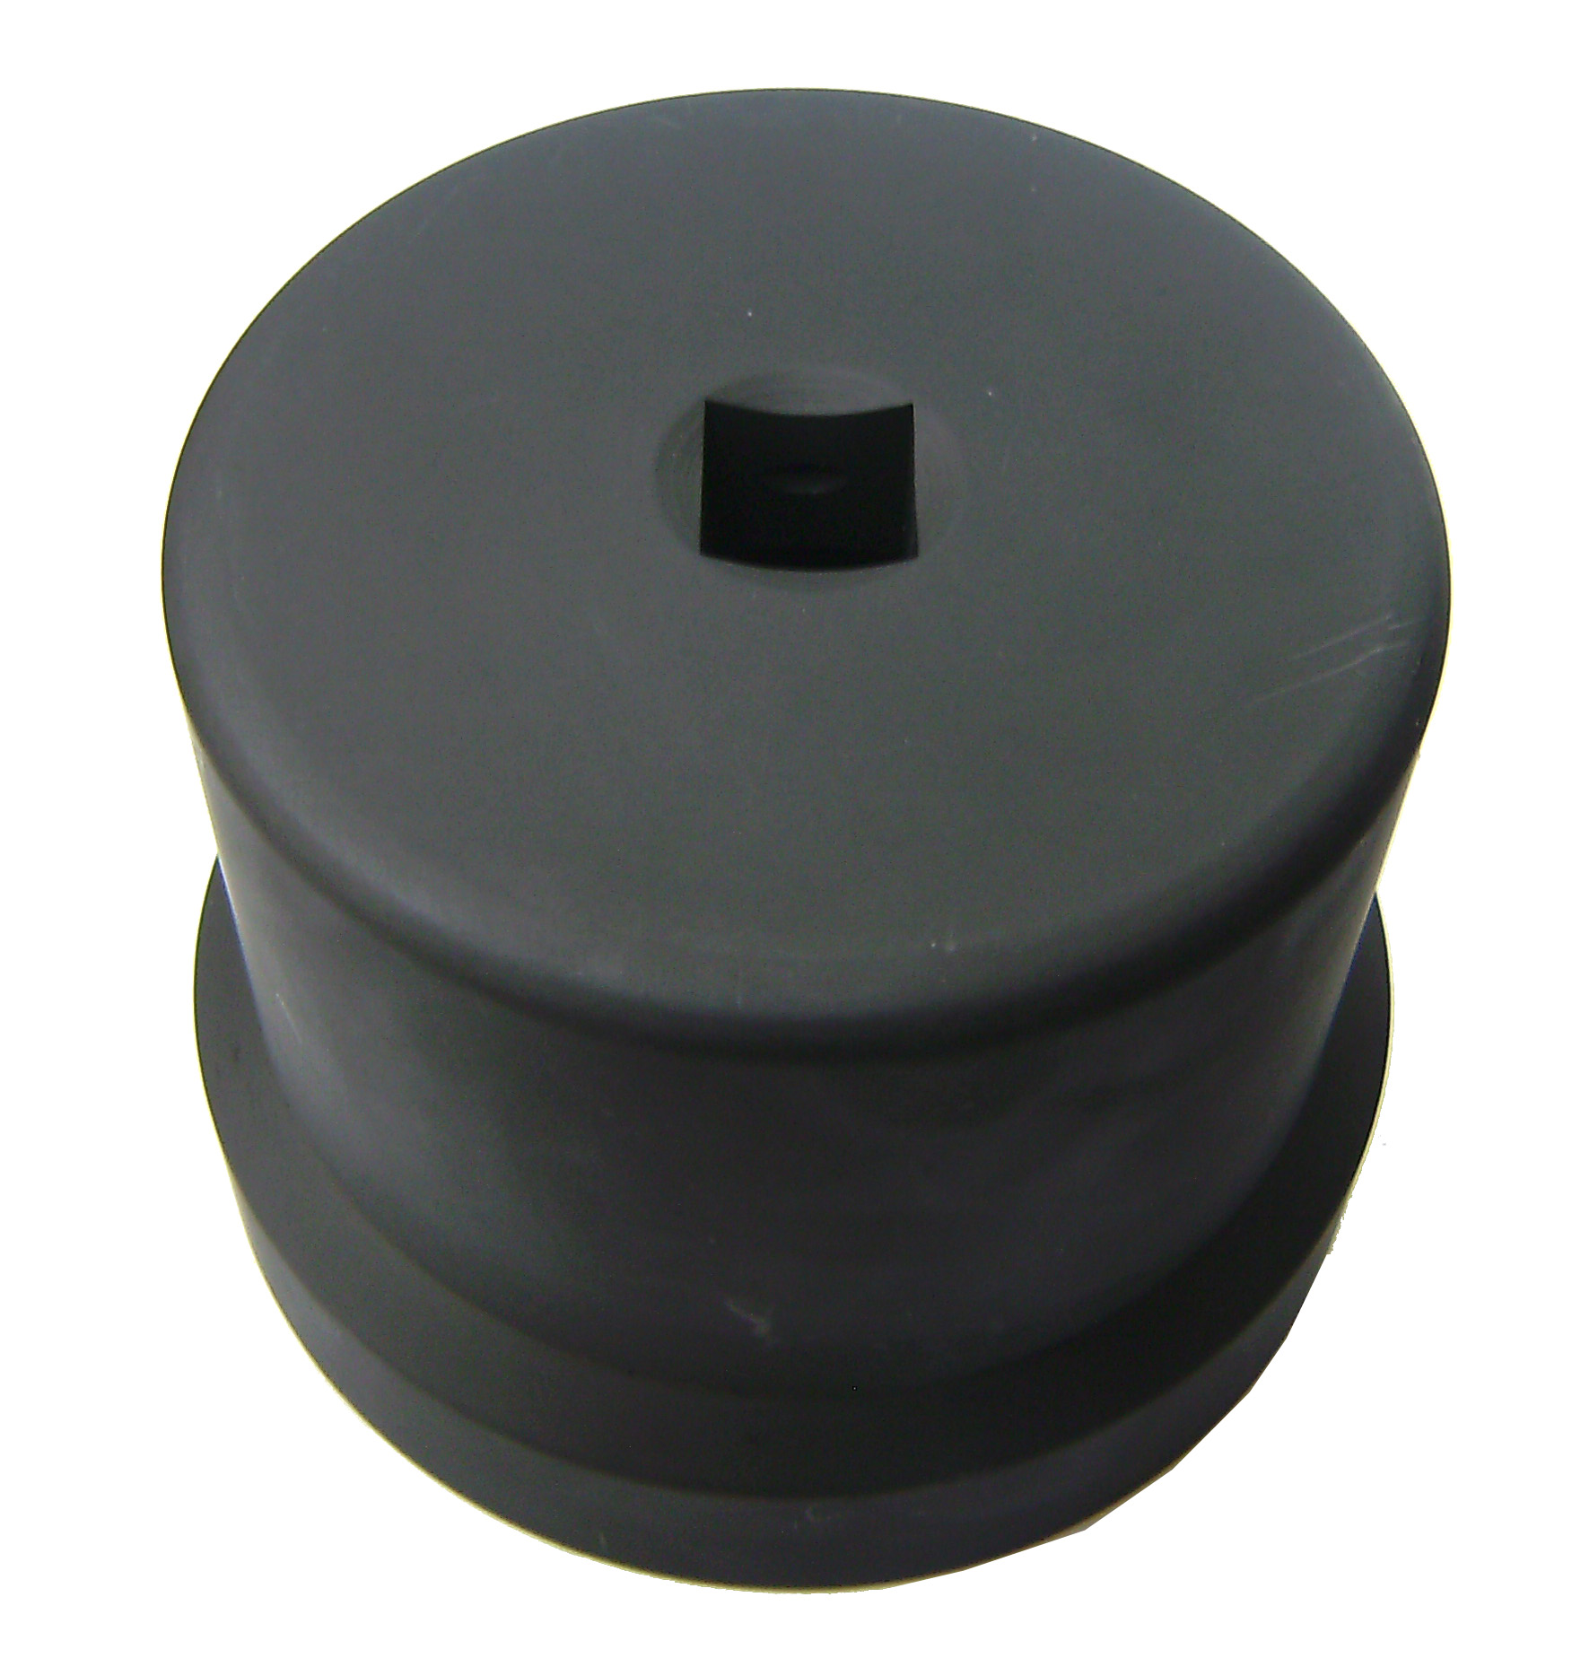

Nut Size
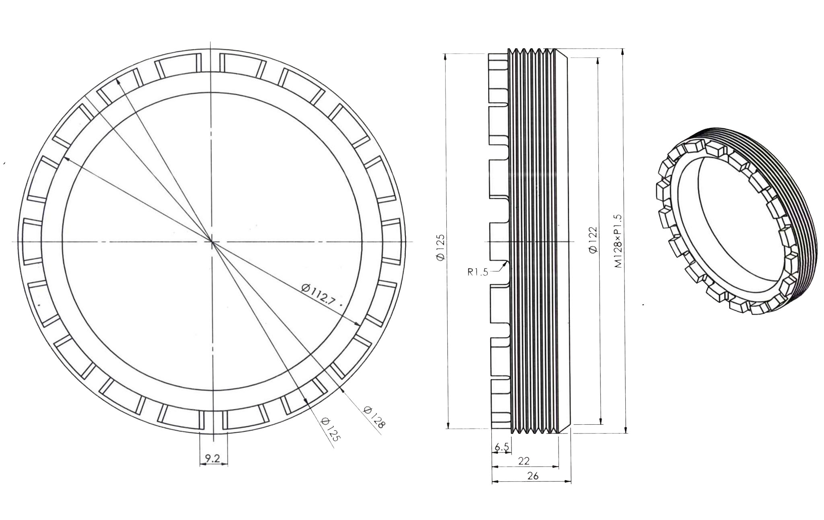

- To remove the differential rear nut.
- Applicable: MAN, Benz truck.

H.C.B-A1344
MAN, BENZ DIFFERENTIAL REAR NUT SOCKET (Dr. 3/4", 6 TEETH)

Dr. 3/4”

Nut Size

- To remove the differential rear nut.
- Applicable: MAN, Benz truck.

