
H.C.B-A1329
MAN TGA DRIVE AXLE NUT SOCKET
(Dr. 3/4”, H60, 158 mm)
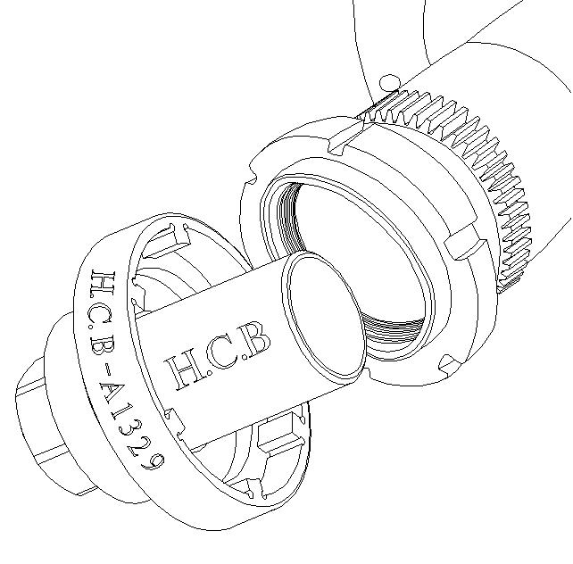
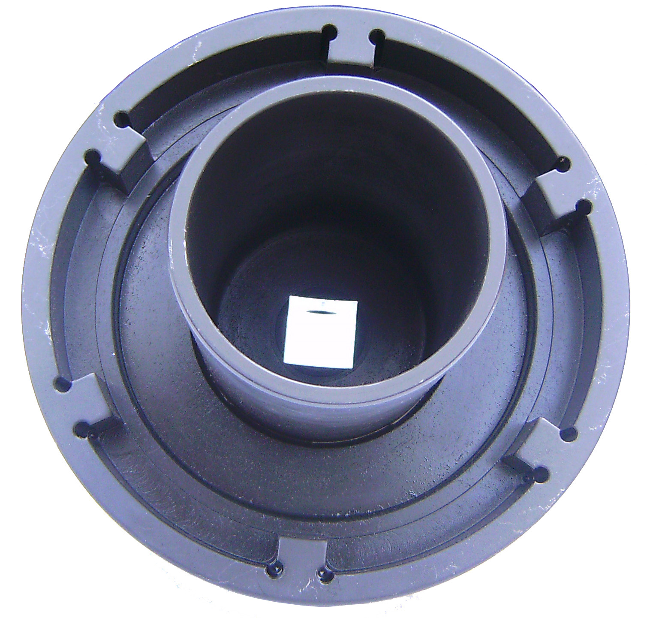

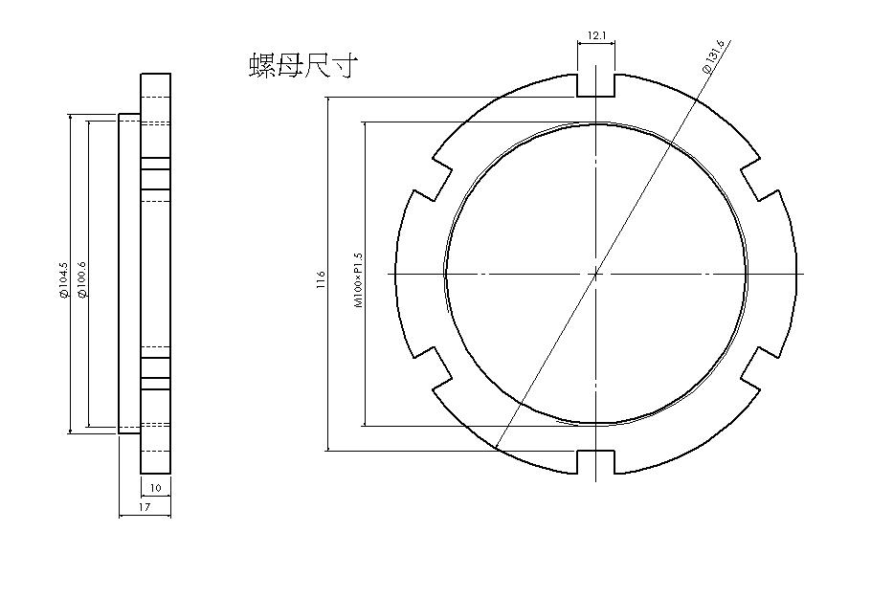
NUT SIZE

- Fix bearing while removing or installing the truck nut.
- Use the air wrench or rod to control the nut to tighten
or loosen bearing.
- Applicable : MAN-TGA RARE WHEEL

MADE IN TAIWAN
H.C.B-A1329
MAN TGA DRIVE AXLE NUT SOCKET
(Dr. 3/4”, H60, 158 mm)

NUT SIZE

- Fix bearing while removing or installing the truck nut.
- Use the air wrench or rod to control the nut to tighten
or loosen bearing.
- Applicable : MAN-TGA RARE WHEEL

MADE IN TAIWAN

