
H.C.B-A1328
MAN TGA FRONT WHEEL AXLE
NUT SOCKET (Dr. 3/4", H60, 93mm)
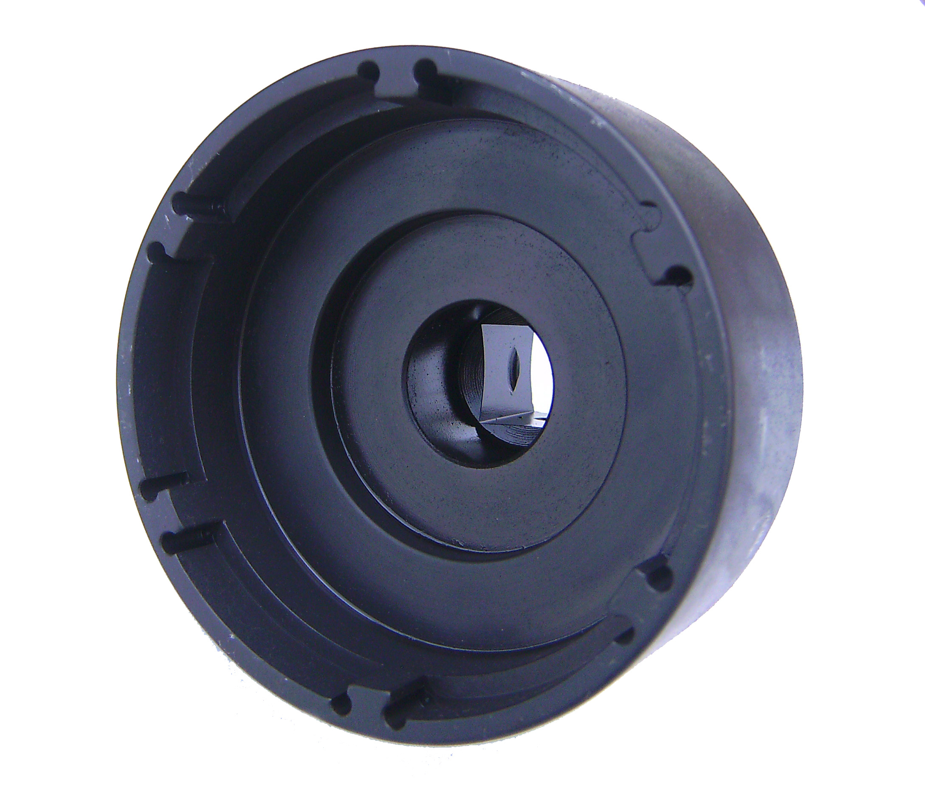

Dr. 3/4"

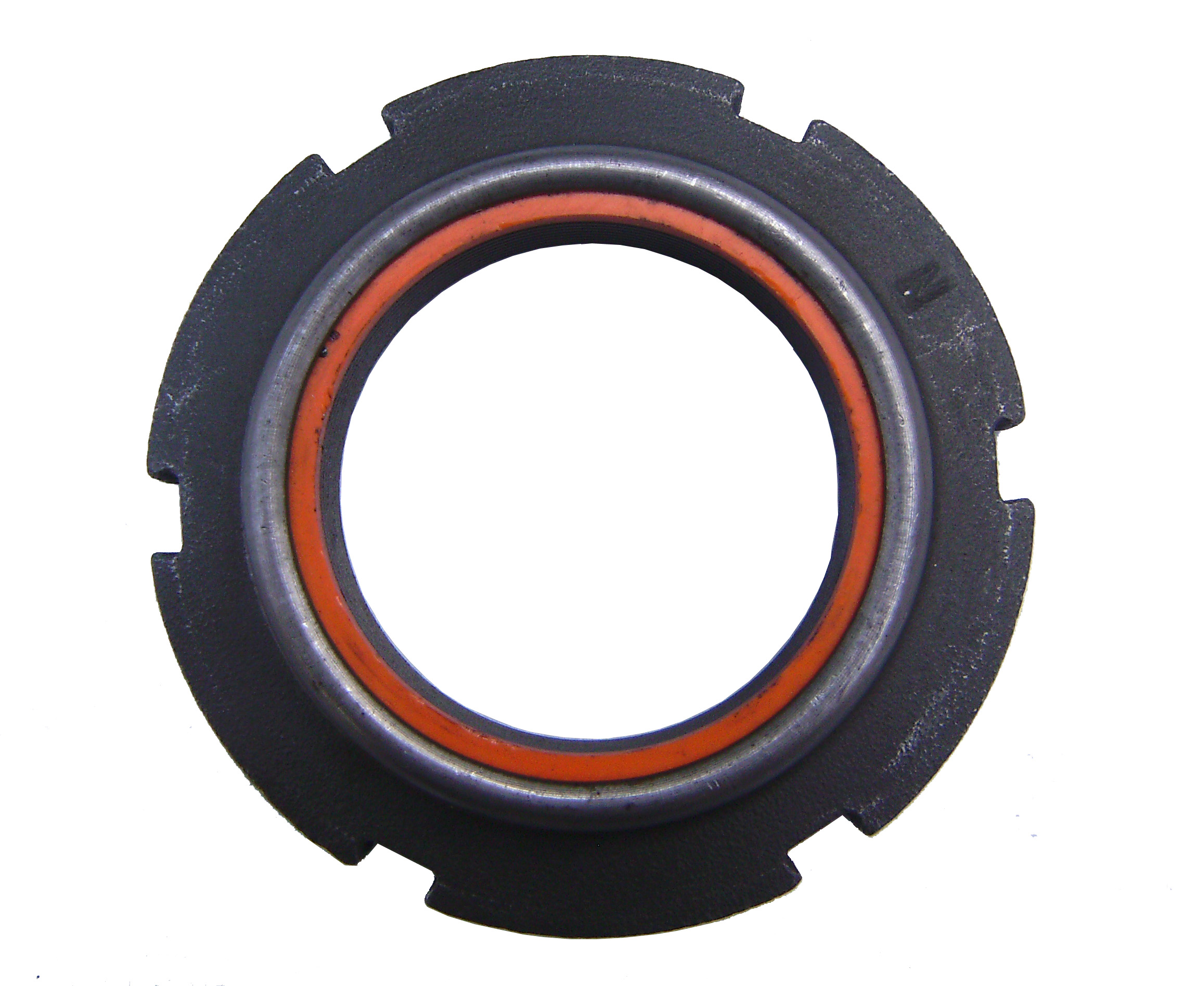
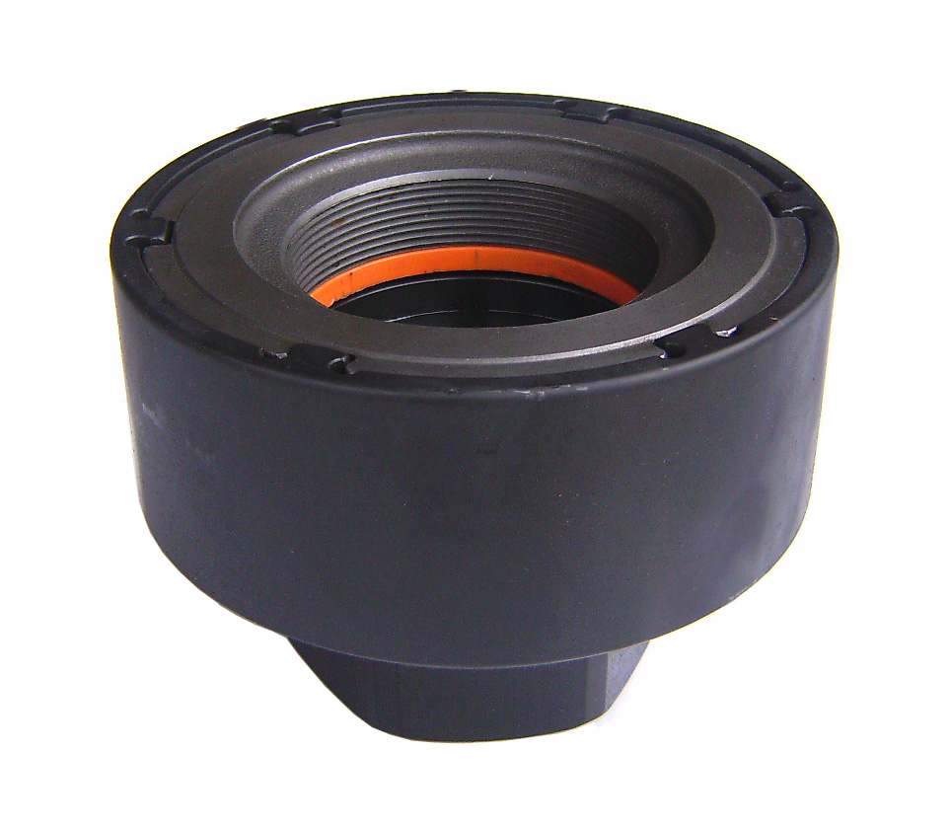

H60

- Fix bearing while removing or installing the truck nut.
- Use the air wrench or rod to control the nut to tighten
or loosen bearing.
- Applicable : MAN-TGA FRONT WHEEL

H.C.B-A1328
MAN TGA FRONT WHEEL AXLE
NUT SOCKET (Dr. 3/4", H60, 93mm)

Dr. 3/4"

H60

- Fix bearing while removing or installing the truck nut.
- Use the air wrench or rod to control the nut to tighten
or loosen bearing.
- Applicable : MAN-TGA FRONT WHEEL

