
H.C.B-A1281
BPW 16 TONS ROLLER BEARING
AXLE NUT SCOKET (Dr. 3/4”, 85mm)
Dr. 3/4”
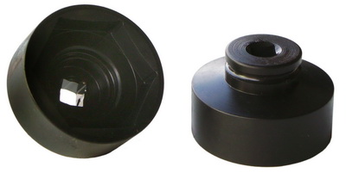
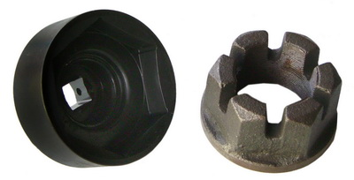

Demission: SW 85 mm

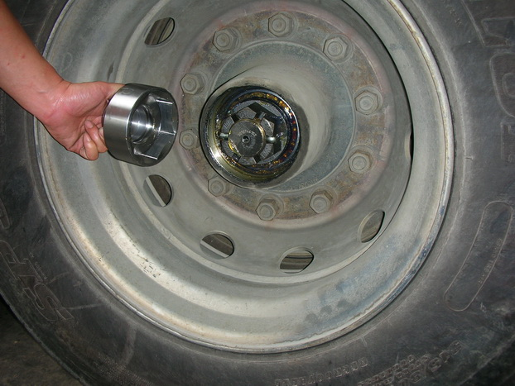

- Designed to remove the nut then replace the new bearing with adjustable toque wrench. (Please follow the standard of original)
- Application: BPW axle nuts (crown nuts) 16 tons axles

H.C.B-A1281
BPW 16 TONS ROLLER BEARING
AXLE NUT SCOKET (Dr. 3/4”, 85mm)
Dr. 3/4”

Demission: SW 85 mm

- Designed to remove the nut then replace the new bearing with adjustable toque wrench. (Please follow the standard of original)
- Application: BPW axle nuts (crown nuts) 16 tons axles

