
H.C.B-A1278
SCANIA (420) AXLE HUB NUT SOCKET
(Dr. 3/4”, 8 TEETH)

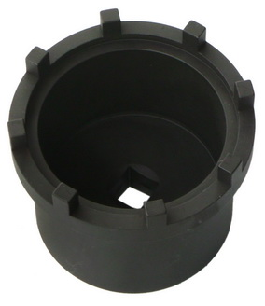
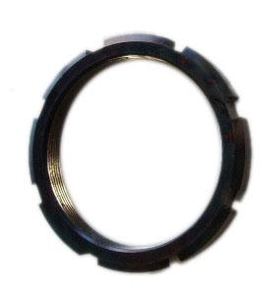
Nut
Dr. 3/4”

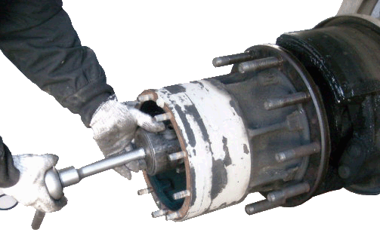

H.C.B-A1278

- Fix bearing while removing or installing the truck nut.

H.C.B-A1278
SCANIA (420) AXLE HUB NUT SOCKET
(Dr. 3/4”, 8 TEETH)

Nut
Dr. 3/4”

H.C.B-A1278

- Fix bearing while removing or installing the truck nut.

