
H.C.B-A1277
SCANIA (320/340) STEERING MECHANISM BEARING PULLER
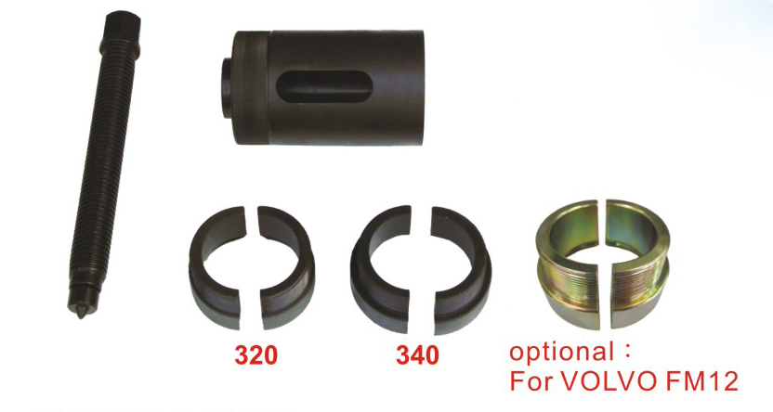
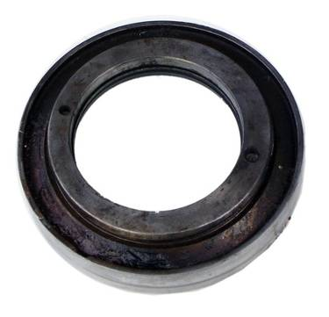
7
8
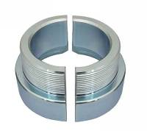

optional:
For MAN 414
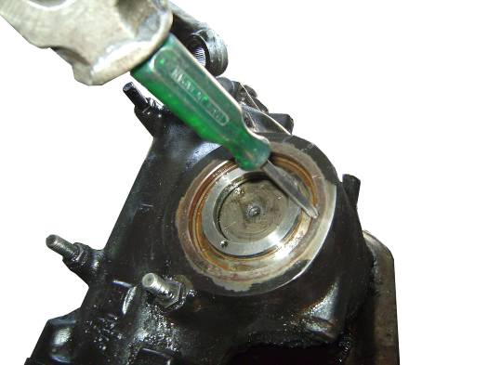
SCANIA 320 Bearing

Please open it after use this tools

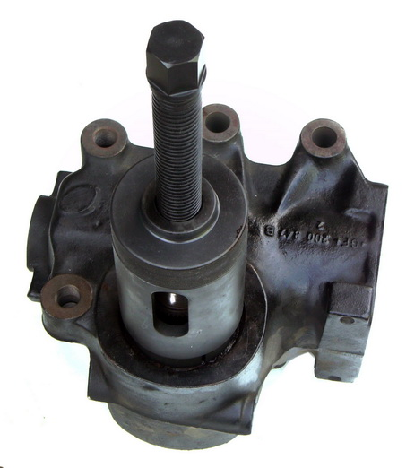
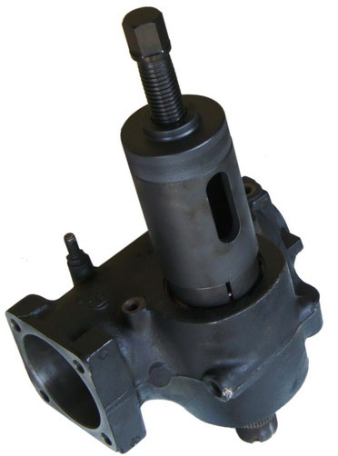

- Designed to remove the bearing of steering mechanism and replace oil seal.
- Applicable: SCANIA 320/340

- Designed to remove the bearing of steering mechanism and replace oil seal.
- Application: SCANIA 320(113)/340(114),MAN FE414(Genuine no. of bearing 10-8325) VOLVO(FM12)
H.C.B-A1277
SCANIA (320/340) STEERING MECHANISM BEARING PULLER
7
8

optional:
For MAN 414
SCANIA 320 Bearing
Please open it after use this tools

- Designed to remove the bearing of steering mechanism and replace oil seal.
- Applicable: SCANIA 320/340

- Designed to remove the bearing of steering mechanism and replace oil seal.
- Application: SCANIA 320(113)/340(114),MAN FE414(Genuine no. of bearing 10-8325) VOLVO(FM12)

