
H.C.B-A1274
MAN (FE410A) STEERING MECHANISM
OIL SEAL SOCKET (Dr. 1/2", 4 POINTS)

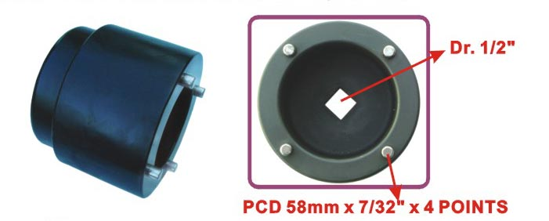

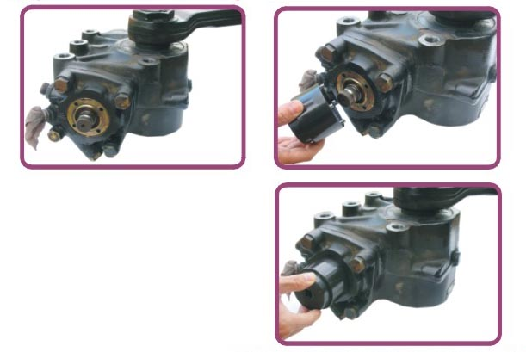

- To replace steering mechanism oil seal for by loosening/ tightening the nut.
- It might damage the related parts while replacing the oil seal without this tool.
- Application: MAN Tractor trailer FE410A.

H.C.B-A1274
MAN (FE410A) STEERING MECHANISM
OIL SEAL SOCKET (Dr. 1/2", 4 POINTS)

- To replace steering mechanism oil seal for by loosening/ tightening the nut.
- It might damage the related parts while replacing the oil seal without this tool.
- Application: MAN Tractor trailer FE410A.

