
H.C.B-A1263
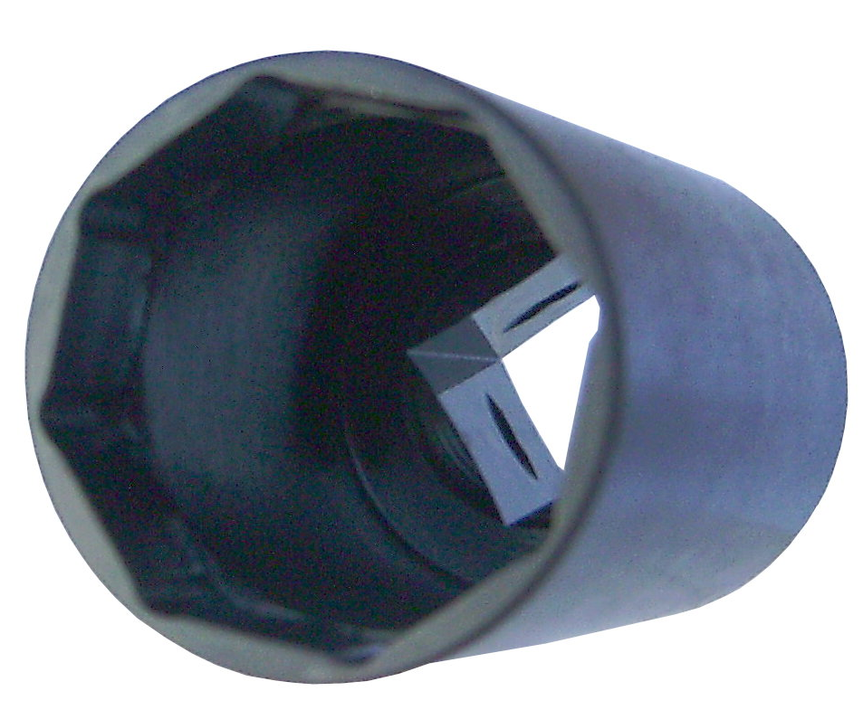
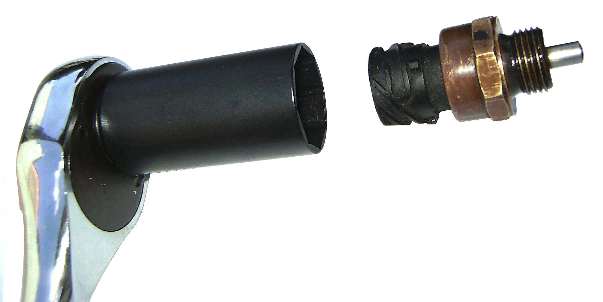
TRUCK POSITION SENSOR SOCKET
(Dr. 1/2”, 8 POINTS, 27mm)

Dr. 1/2’’

- To remove / replace truck sensor.
- Application: Mercedes-Benz commercial vehicles of the SK series, Actros, MAN commercial vehicles, Scania, ZF16 speed gear box
- Size: Dr. 1/2”, 8 points, 27mm
- Material: SCM440, HRC30ﾟ~35ﾟ
- Length: 60mm

H.C.B-A1263
TRUCK POSITION SENSOR SOCKET
(Dr. 1/2”, 8 POINTS, 27mm)

Dr. 1/2’’

- To remove / replace truck sensor.
- Application: Mercedes-Benz commercial vehicles of the SK series, Actros, MAN commercial vehicles, Scania, ZF16 speed gear box
- Size: Dr. 1/2”, 8 points, 27mm
- Material: SCM440, HRC30ﾟ~35ﾟ
- Length: 60mm

