
H.C.B-A1238
VOLVO TRUCK AXLE NUT SOCKET
(Dr. 3/4”, 6 POINTS, 105mm)
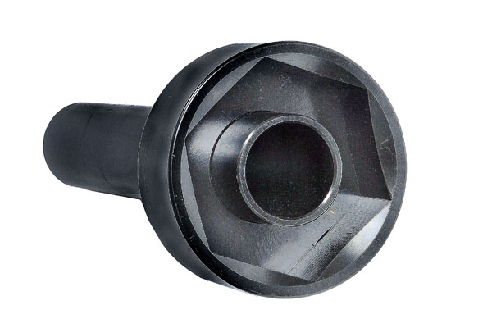

105mm

- Fix bearing while removing or installing the truck nut.
- Use the air wrench or rod to control the nut to tighten or loose bearing.

H.C.B-A1238
VOLVO TRUCK AXLE NUT SOCKET
(Dr. 3/4”, 6 POINTS, 105mm)

105mm
- Fix bearing while removing or installing the truck nut.
- Use the air wrench or rod to control the nut to tighten or loose bearing.

