
H.C.B-A1234
VW OIL SEAL PULLER (32mm)
LONG BODY

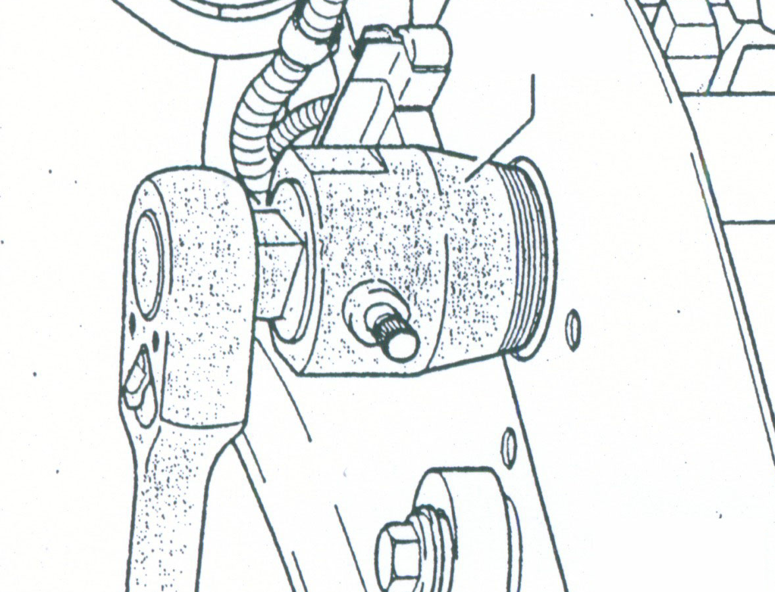

- Removes left and right front camshaft oil seals.
- Application: VW VR6, AUDI V6
- N.W. : 0.902 KGS.

- Removes left and right front camshaft oil seals.
- Application: VW VR6, AUDI V6
- N.W. : 0.902 KGS.

H.C.B-A1234
VW OIL SEAL PULLER (32mm)
LONG BODY
- Removes left and right front camshaft oil seals.
- Application: VW VR6, AUDI V6
- N.W. : 0.902 KGS.

