
H.C.B-A1233
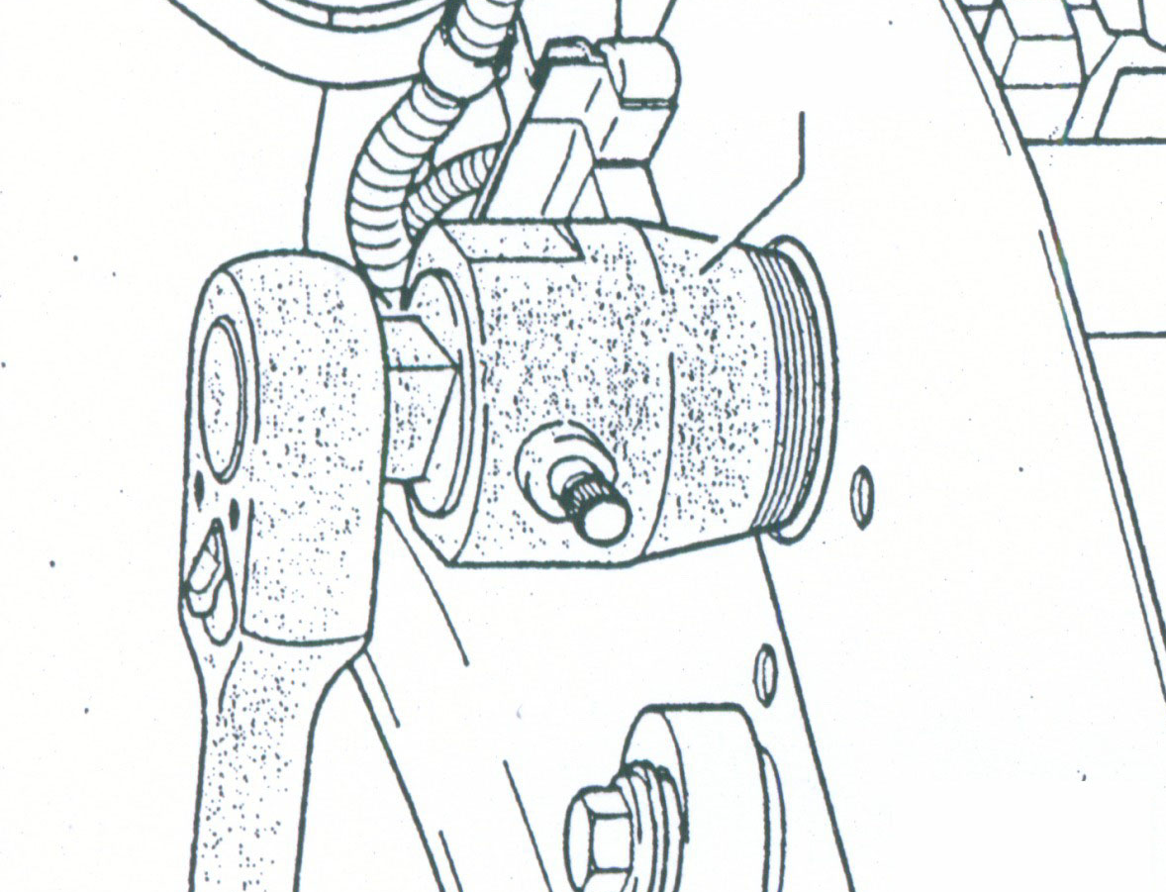
VW OIL SEAL PULLER - 35mm
- For removing front crankshaft (pulley) seal at the vibration damper.
- Application: VW & AUDI late models.
- N.W.: 0.64 KGS.
- OEM no.: 2085

H.C.B-A1233
VW OIL SEAL PULLER - 35mm
- For removing front crankshaft (pulley) seal at the vibration damper.
- Application: VW & AUDI late models.
- N.W.: 0.64 KGS.
- OEM no.: 2085

