
H.C.B-A1232
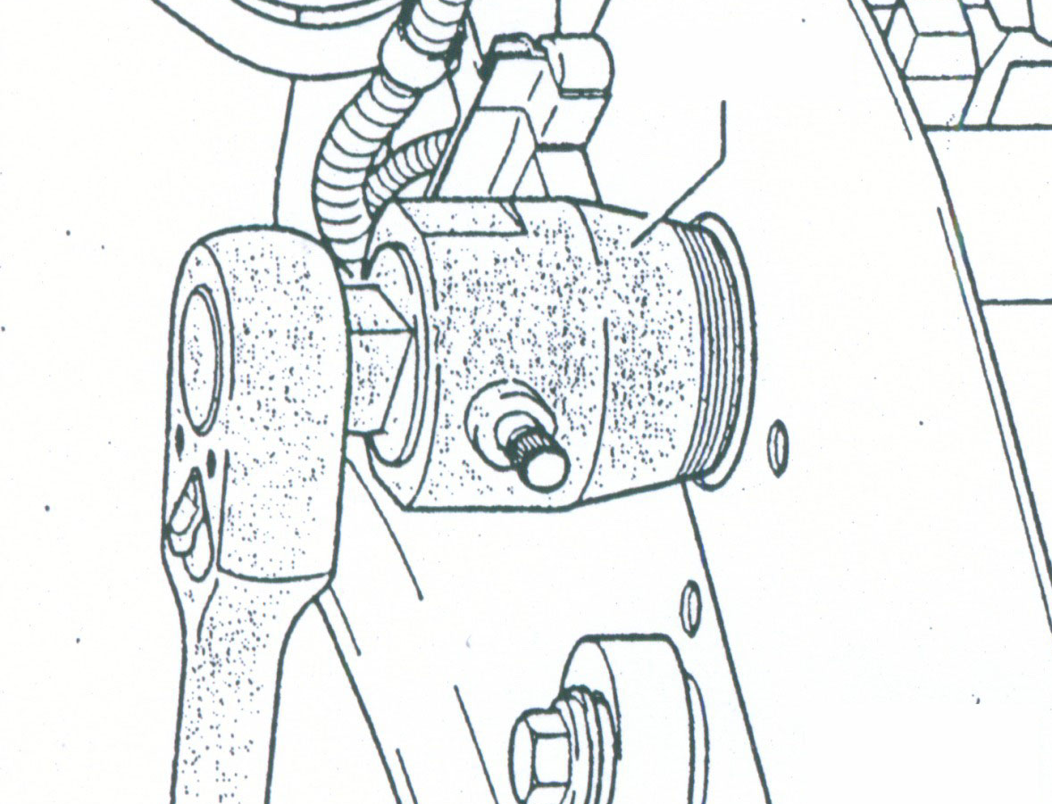
VW OIL SEAL PULLER (32mm)
▓ Remove crankshaft (early), camshaft and cam position sensor seals.
▓ Application: VW & AUDI, all engines except diesel.

H.C.B-A1232
VW OIL SEAL PULLER (32mm)
▓ Remove crankshaft (early), camshaft and cam position sensor seals.
▓ Application: VW & AUDI, all engines except diesel.

