
H.C.B-A1229
VOVOL TRUCK TRANSMISSION CLUTCH (CALIPER PISTONS DEPTH LEVEL GAUGE) (FM12)

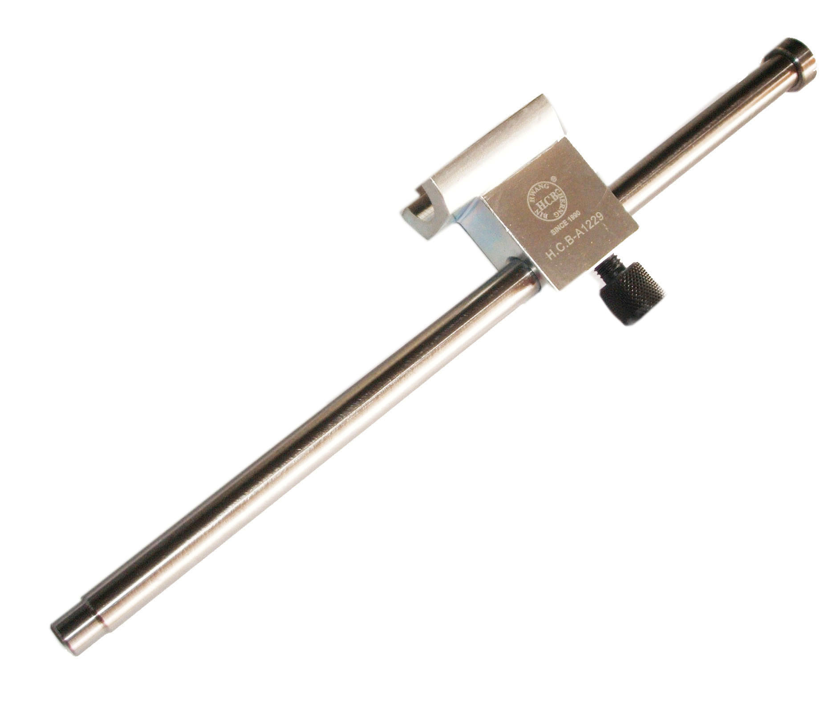
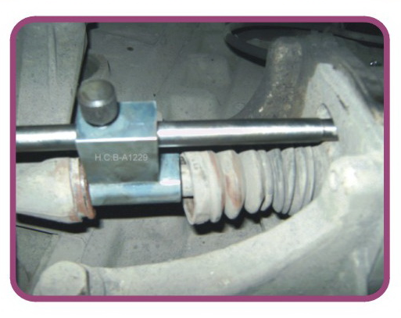

H.C.B-A1229
VOVOL TRUCK TRANSMISSION CLUTCH (CALIPER PISTONS DEPTH LEVEL GAUGE) (FM12)

