
H.C.B-A1226
TRUCK BALL JOINT PULLER (39 mm) (HYDRAULIC)
- On car maintenance.
- Best tool for removal truck ball-joint.
- No damage to ball-joint and related parts.
- Applicable: 4 tons truck and most of trucks .For example SCANIA,BENZ,MAN,HINO …etc.
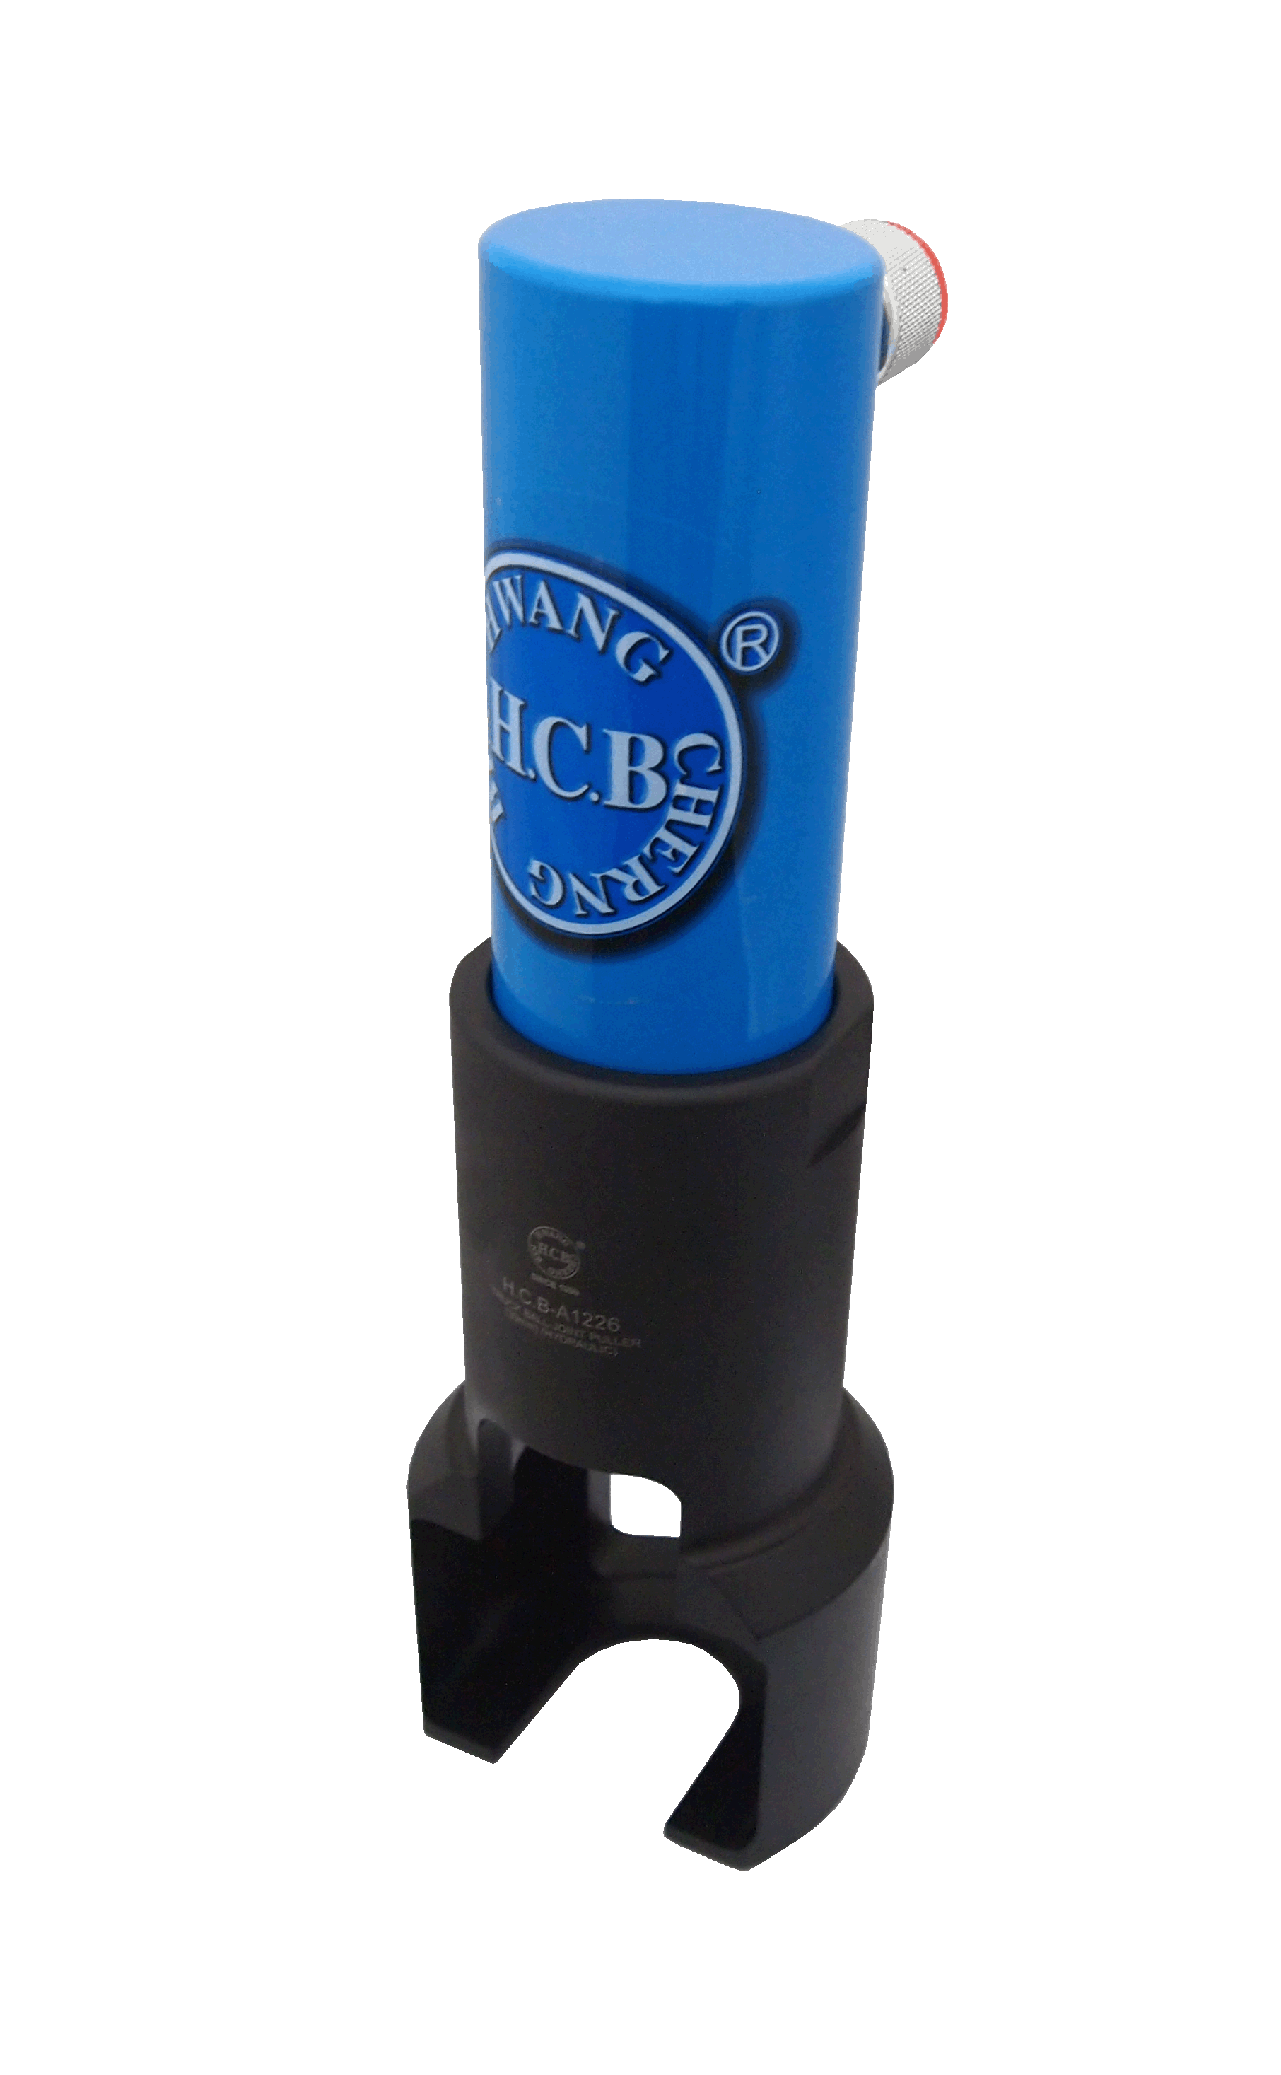

H.C.B-A1226
TRUCK BALL JOINT PULLER (39 mm) (HYDRAULIC)
- On car maintenance.
- Best tool for removal truck ball-joint.
- No damage to ball-joint and related parts.
- Applicable: 4 tons truck and most of trucks .For example SCANIA,BENZ,MAN,HINO …etc.

