
H.C.B-A1225
TRUCK BALL JOINT PULLER
(32 mm) (HYDRAULIC)

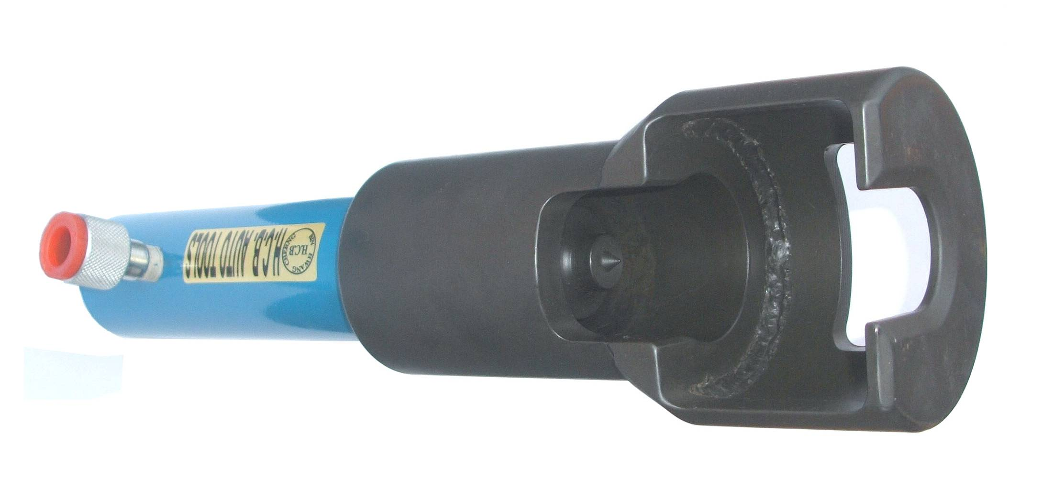

■ On car maintenance.
■ This tool is designed to remove truck ball-joint. Best tool for removal truck ball-joint.
■ No damage to ball-joint and related parts.
■ Application: 3.5 tons medium-sized wagon~8.8 tons small-sizes truck

H.C.B-A1225
TRUCK BALL JOINT PULLER
(32 mm) (HYDRAULIC)

■ On car maintenance.
■ This tool is designed to remove truck ball-joint. Best tool for removal truck ball-joint.
■ No damage to ball-joint and related parts.
■ Application: 3.5 tons medium-sized wagon~8.8 tons small-sizes truck

