
H.C.B-A1222
UNIVERSAL CRANKSHAFT PULLEY EXTRACTOR
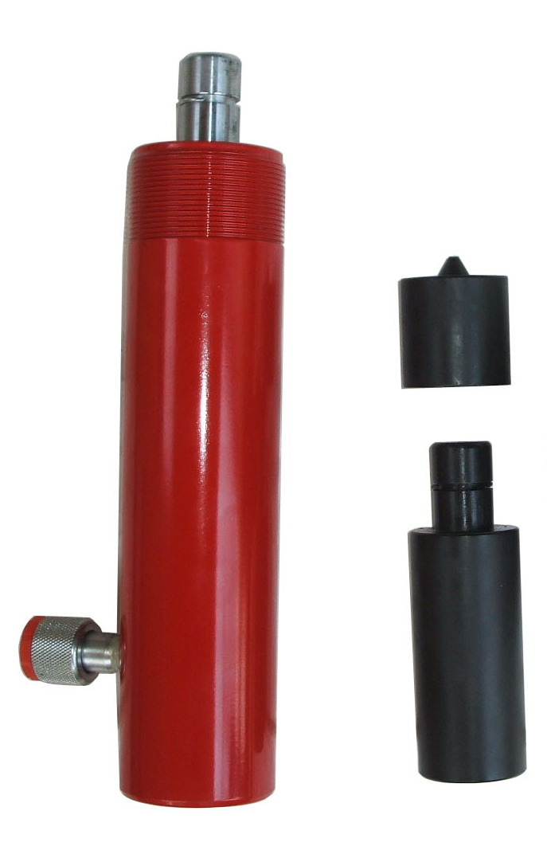
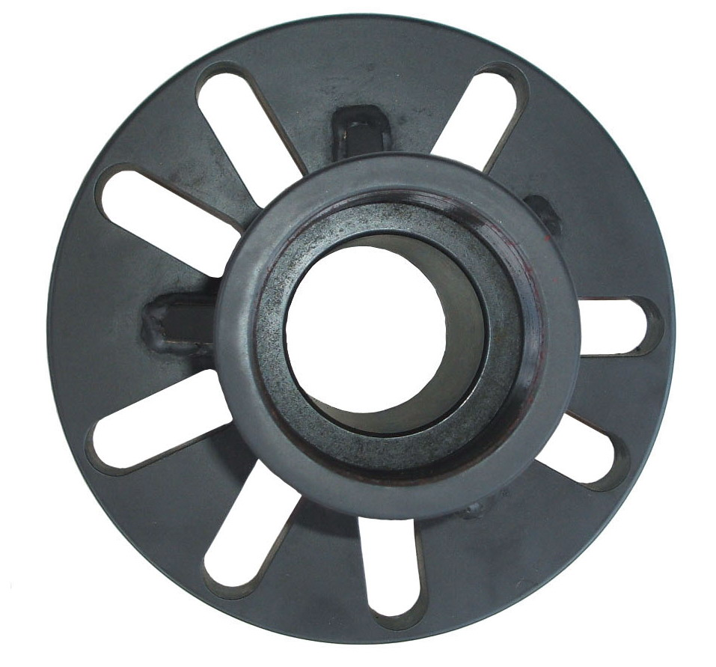

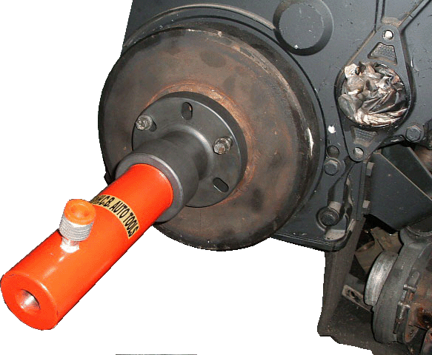
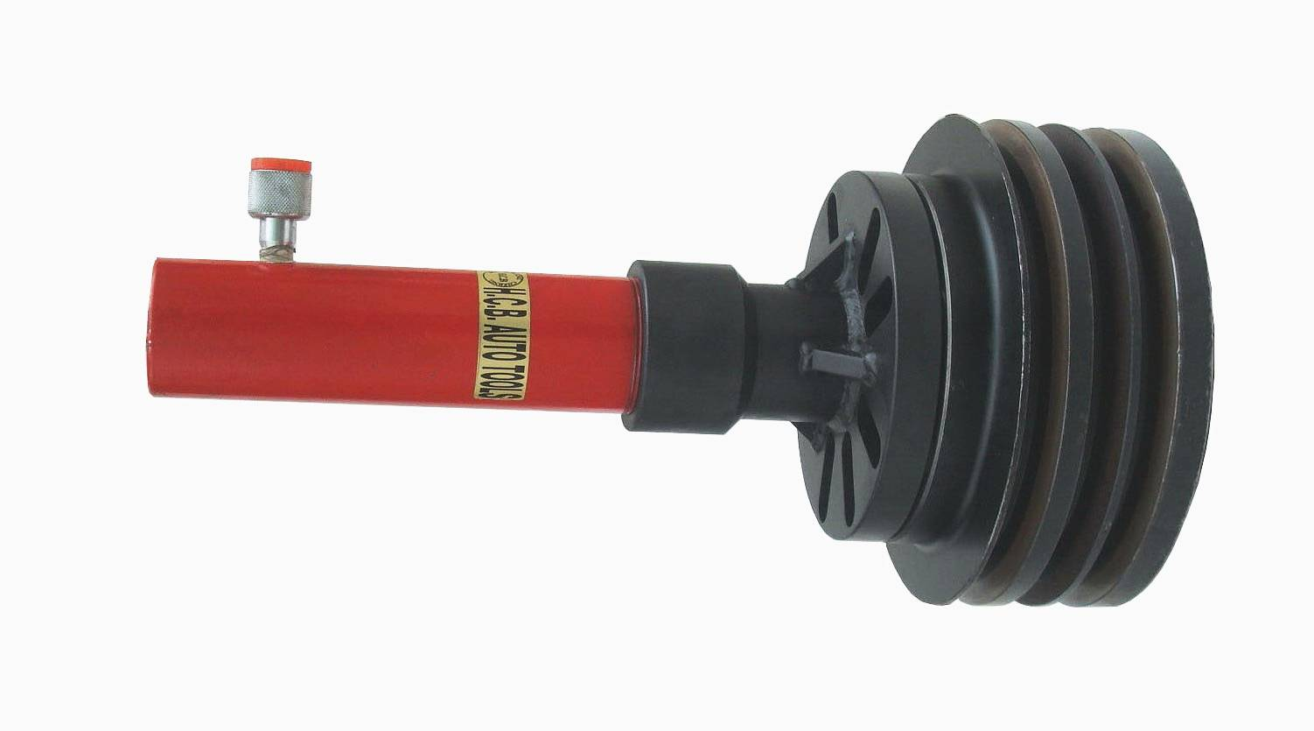

- To remove the pulley of trucks.
- Car drive shaft is not able to remove when rusted. Use this tool （available for 4 holes & 5 holes）to take apart of the drive shaft and easy to remove the hub.
- Application：
Most models of Japanese and European trucks , such as HINO 20 tons、35 tons new & old models and SCANIA, Mercedes Benz, VOLVO…etc.

H.C.B-A1222
UNIVERSAL CRANKSHAFT PULLEY EXTRACTOR

- To remove the pulley of trucks.
- Car drive shaft is not able to remove when rusted. Use this tool （available for 4 holes & 5 holes）to take apart of the drive shaft and easy to remove the hub.
- Application：
Most models of Japanese and European trucks , such as HINO 20 tons、35 tons new & old models and SCANIA, Mercedes Benz, VOLVO…etc.

