
H.C.B-A1203
MAN DIFFERENTIAL BEARING EXTRACTOR
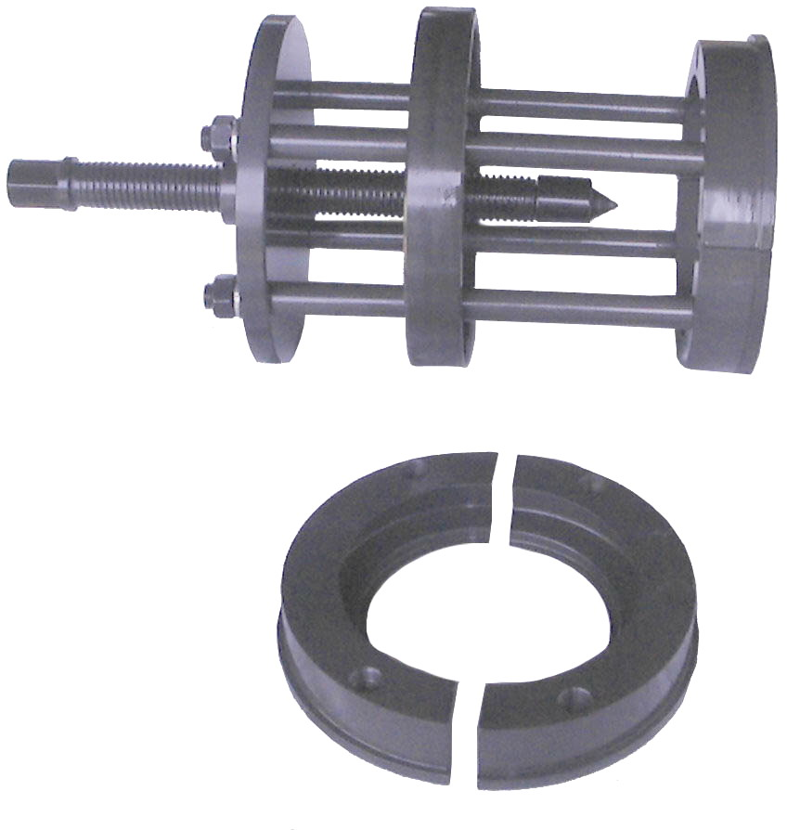

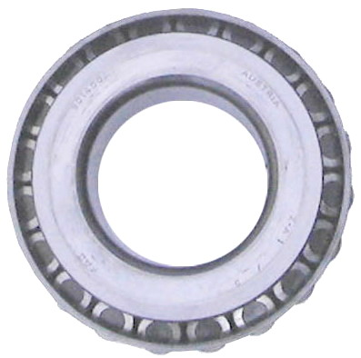
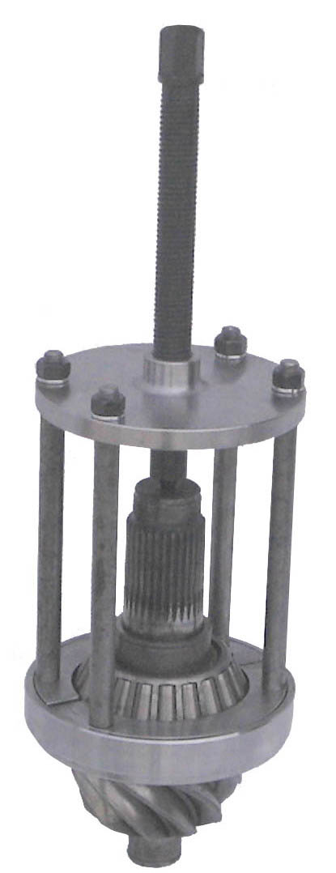
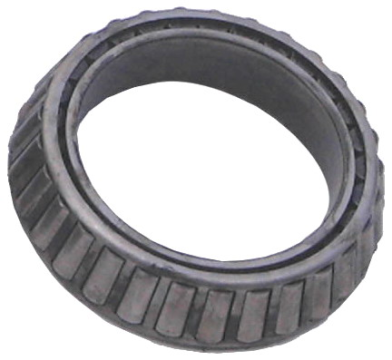
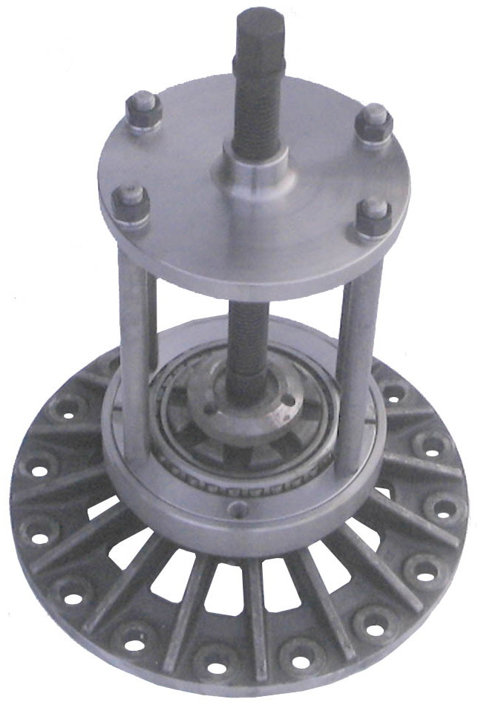
No. FAG 801400A
Austria Z.A1/3
No. FAG 32024X
Austria 013 Y.A

- For replace MAN differential bearing and remove the old bearings.
- Turn the screw to remove the bearing.

