
H.C.B-A1190
DAF STEERING LINKAGE FIXING BASE SOCKET (Dr. 1/2”)
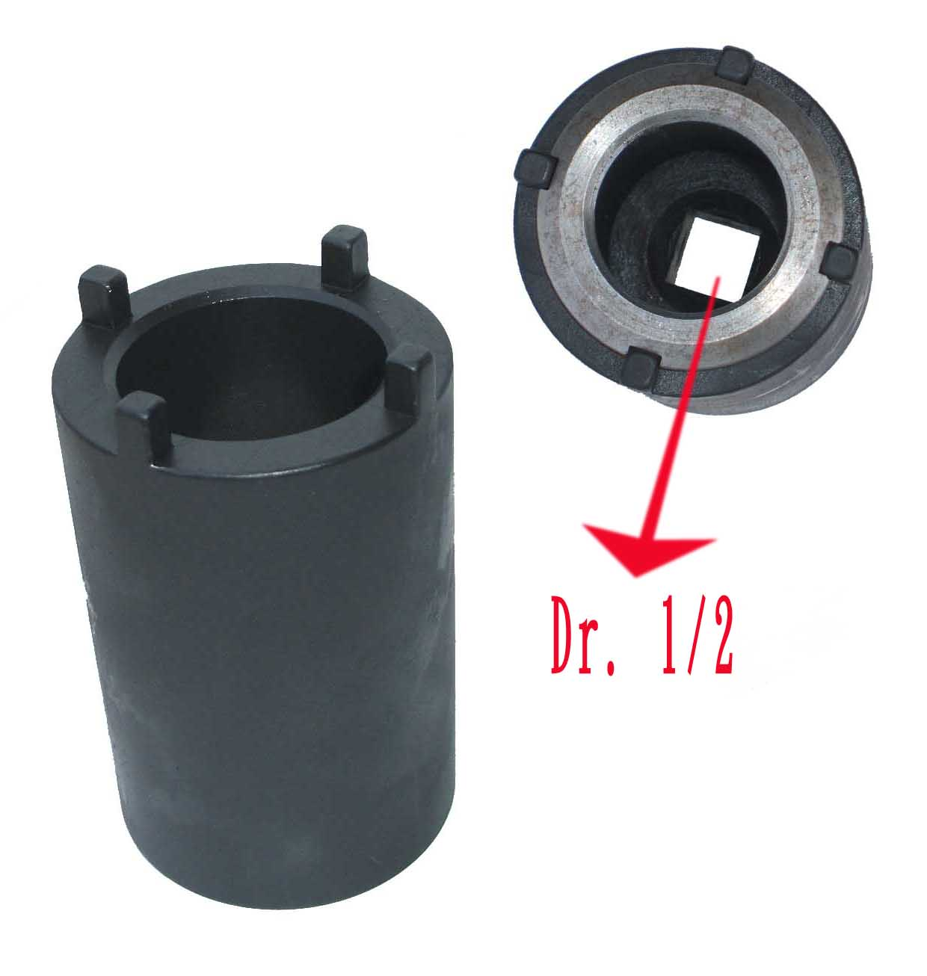
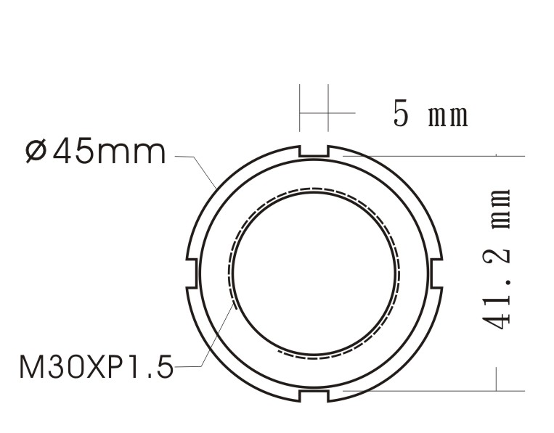

H.C.B-A1190
DAF STEERING LINKAGE FIXING BASE SOCKET (Dr. 1/2”)

