

H.C.B-A1183
VIDEO
TRUCK THREAD CORRECTOR
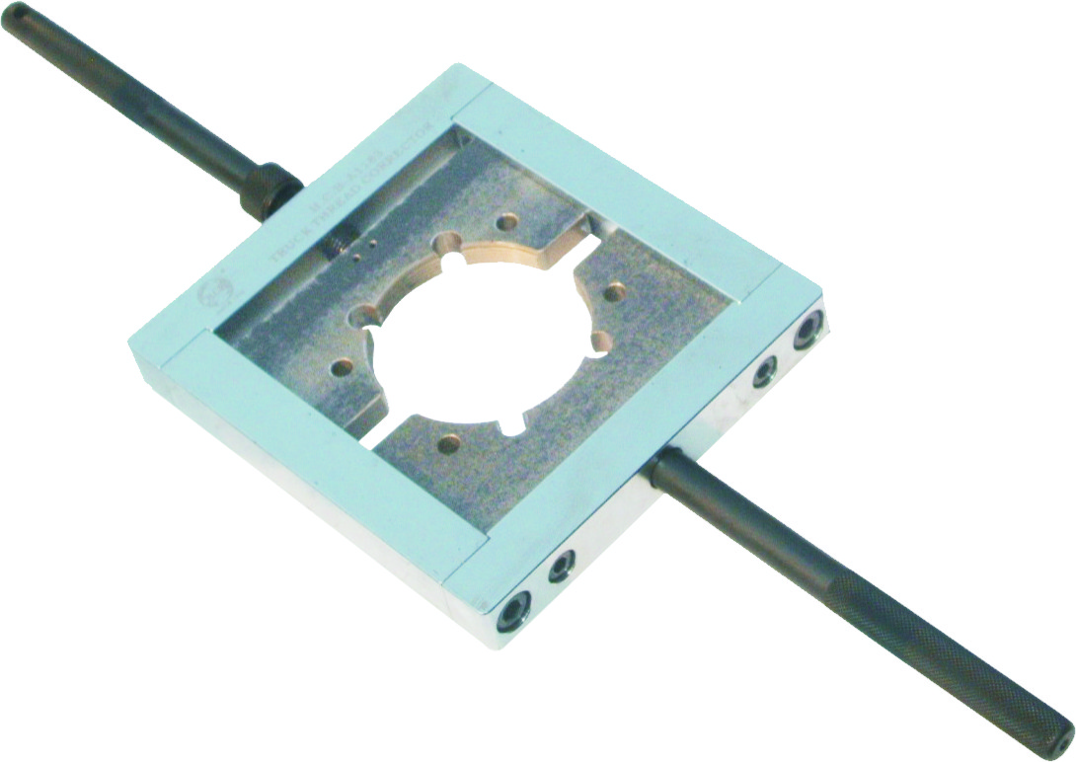
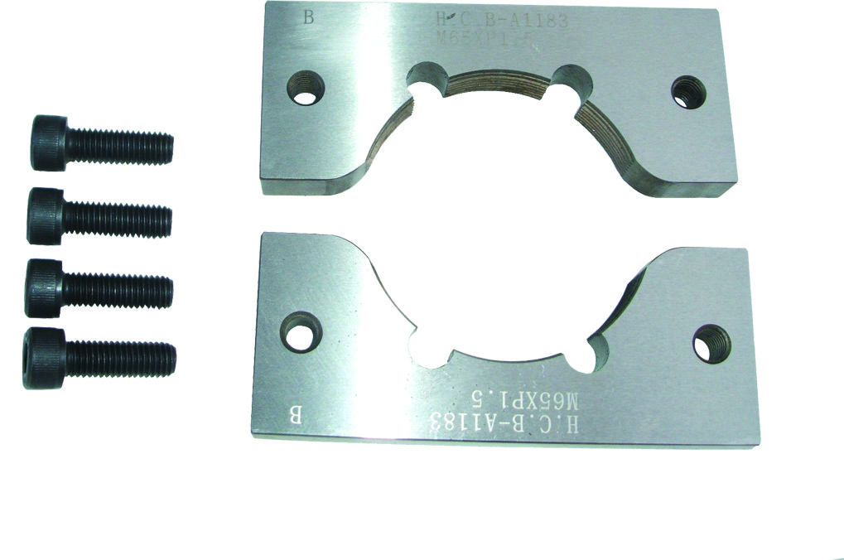

MATERIAL: SKD11
Hardness: HRC 60°-62°

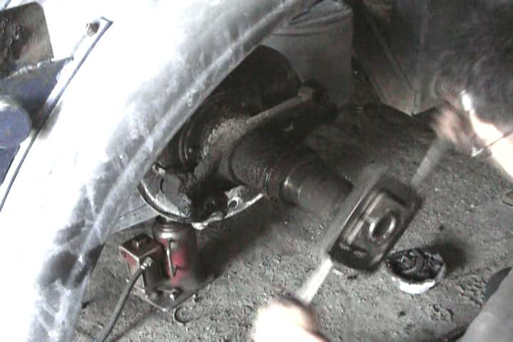
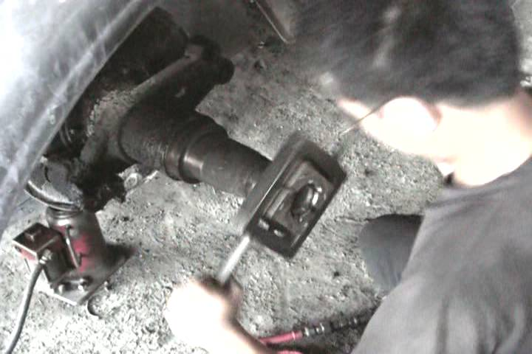
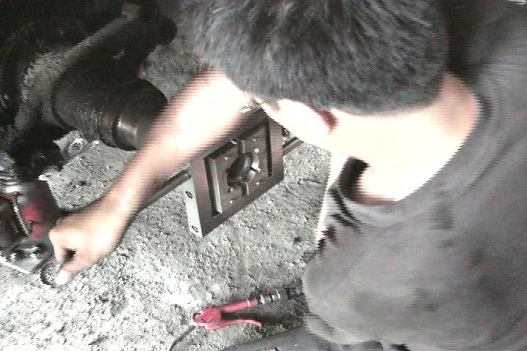

WARNING:
- To clean the trailer axle before operating. Then correct the thread from inside to outside
- Please don’t over tight the corrector. Correct the thread for several times and gently.

- Choose the proper thread corrector to modify the thread which makes the nut screws in easier.

Application | Size
European: SCANIA front wheel  BPW trailer 16 tons | M60 x P2.0
Renault 10 wheels trail (P370) drive axle  Japanese: FUSO, HINO, UD,  ISUZU back wheel  European: SCANIA back wheel | M85 x P2.0
Optional:
1) ROR trailer | M61-65 x P1.5
2) YORK trailer | 2¹/₂ x 16 thread
3) BPW trailer 12 tons UD over 10.5 tons front wheel | M52 x P2.0
4) FUSO | M91-M95 x P2.0
5) HINO over 15 tons & trailer front wheel/  UD under 10.5 tons front wheel /  FUSO 8.8 tons & 10.5 tons front wheel/  MAN 410/414 front wheel | M40 x P1.5
6) FUSO 15/20 tons & trailer front wheel/  DAEWOO Front wheel | M48 x P1.5
7) VOLVO FL10 | M52 x P1.5
8) KW Truck rear axle | UNC 3 1/4”x12 W
9) ROR Trailer axle | UNC 2 5/8”x16 W
10)BENZ 2640/Schmitz trailer rear axle SAF | M75-M80 x P1.5
11)BENZ 2640(EXTRA) | M100 x P1.5
12)FUSO、HINO rear wheel (10TONS) | M60-M65x P2.0
13)DAF (CF 85) rear wheel drive axle | M86-M90 x P2.0
14) DAF (CF 85)front wheel drive axle | M66-M70x P1.5
15) DAF (CF 85) front wheel drive axle | M56-M60x P1.5
16) ROR disc brake 3 1/2”x12 UNC
17) BENZ 120 tons crane, Demag crane | M75 x P2.0
18) SITRAK | M85 x P1.5
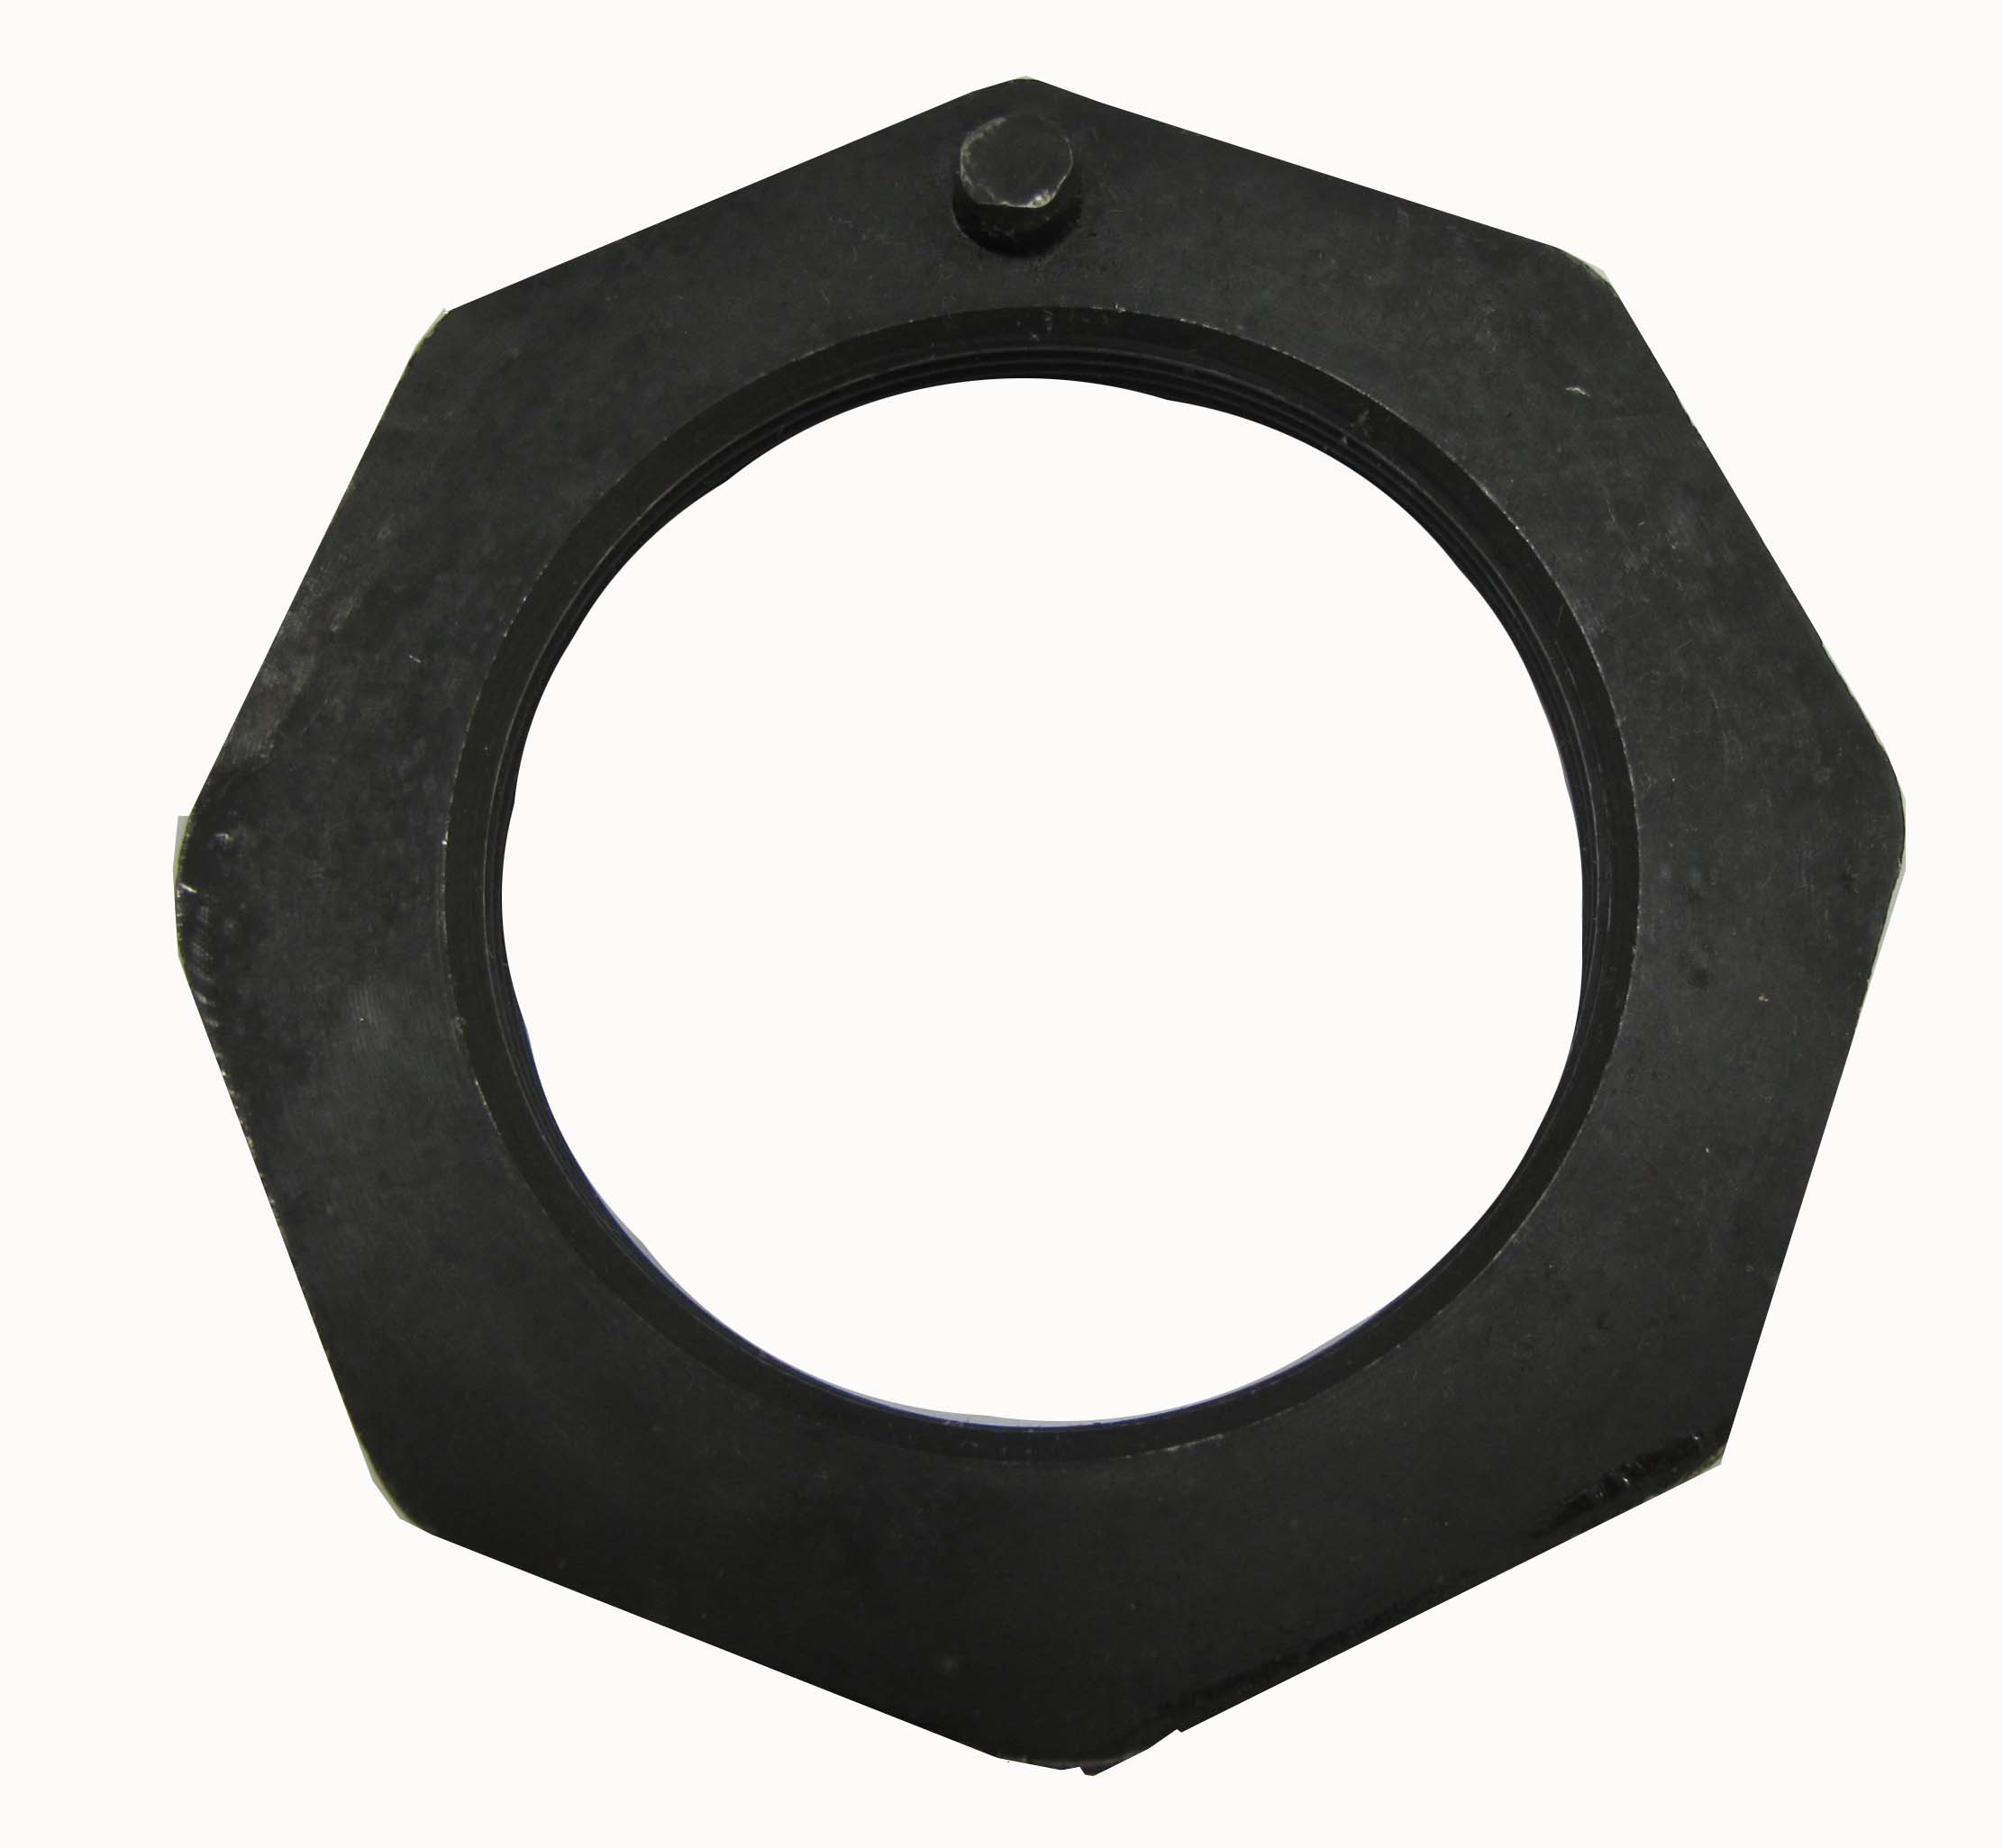
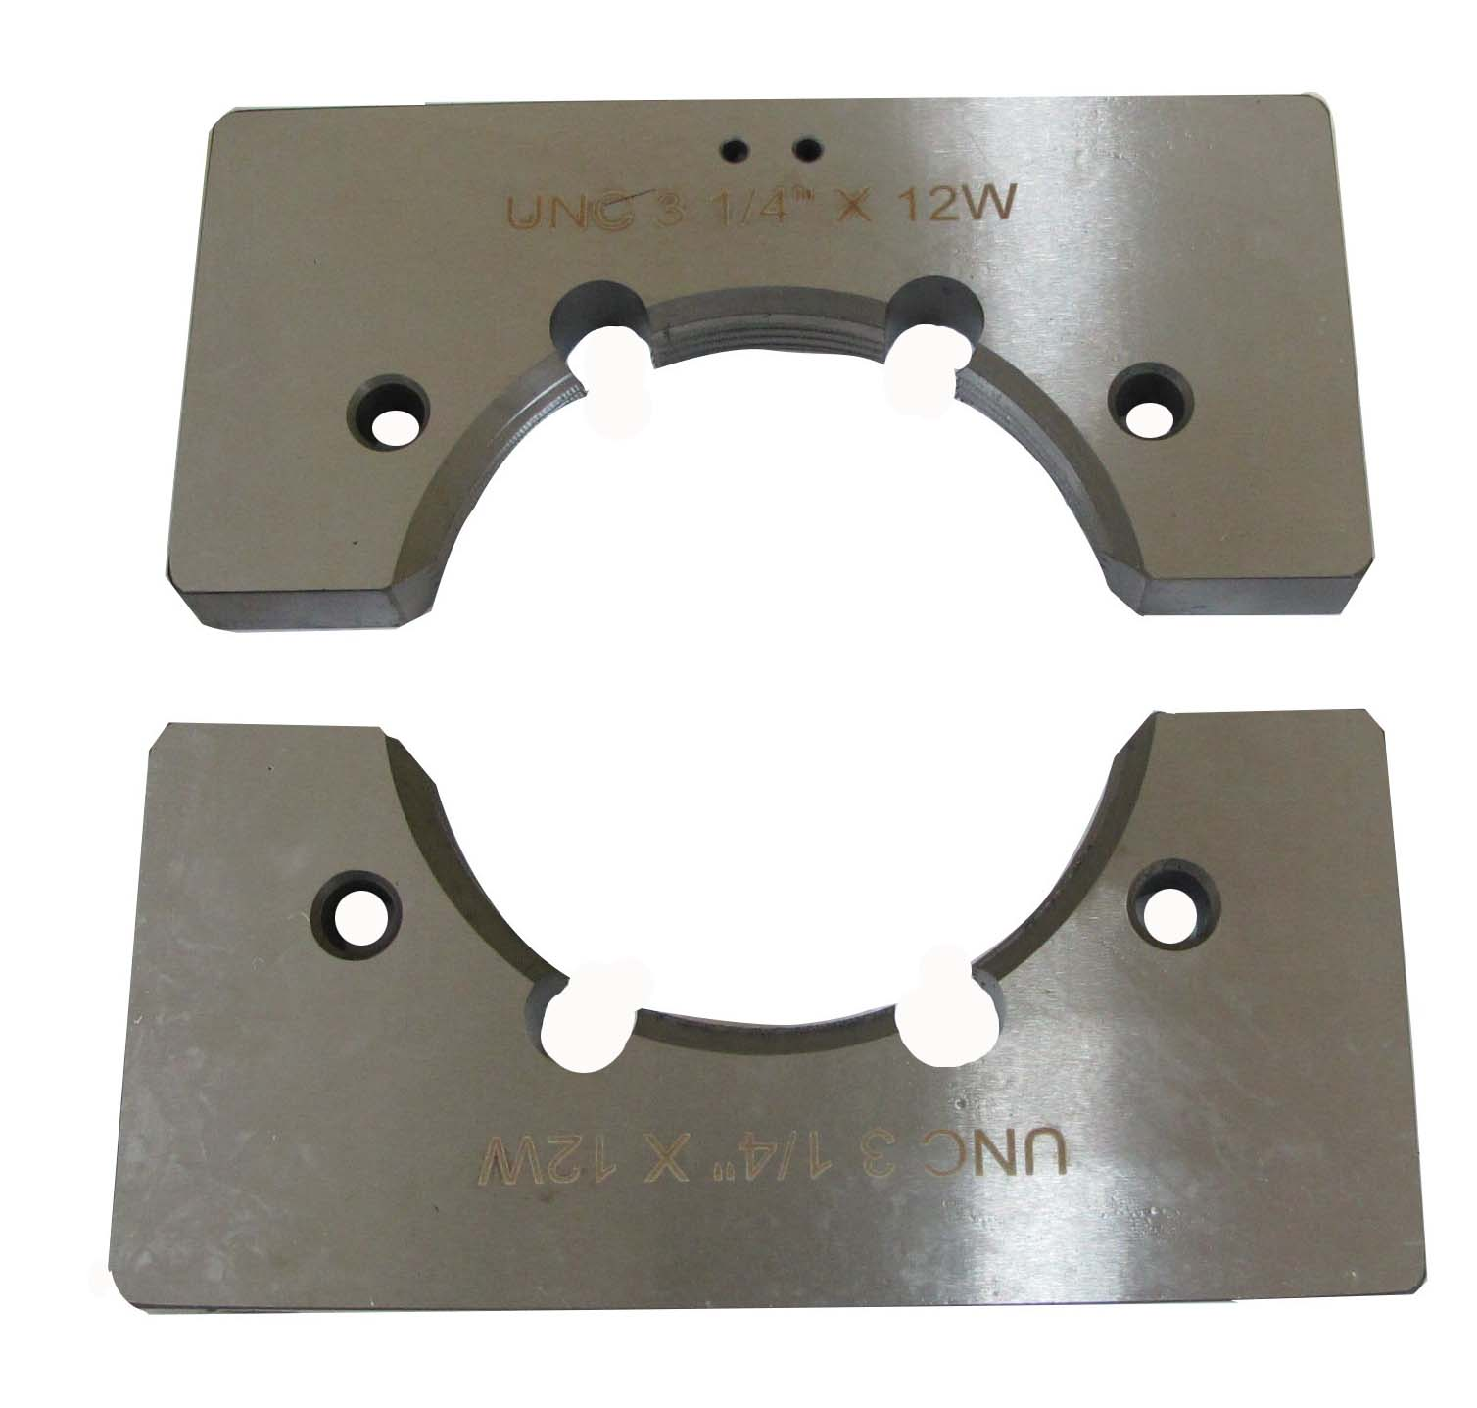
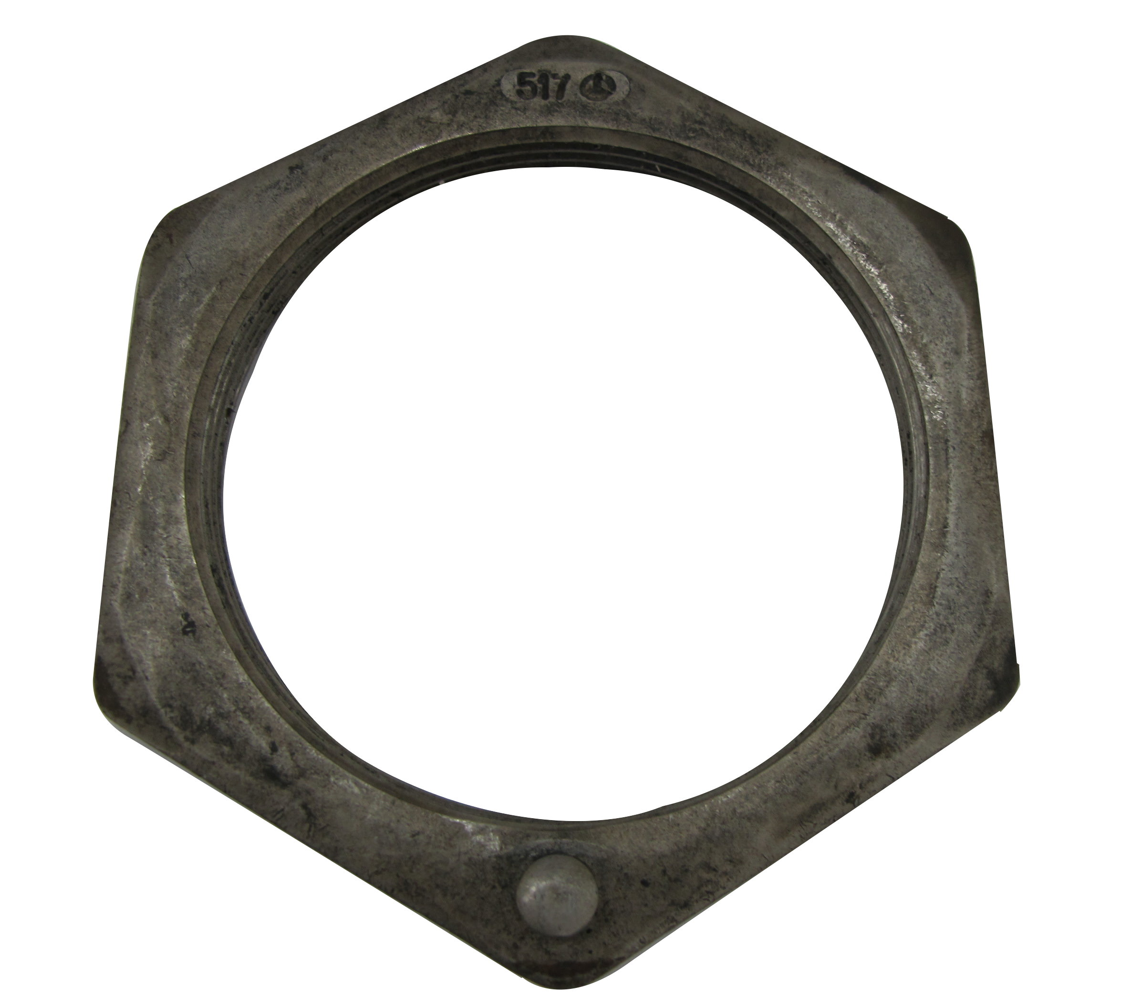
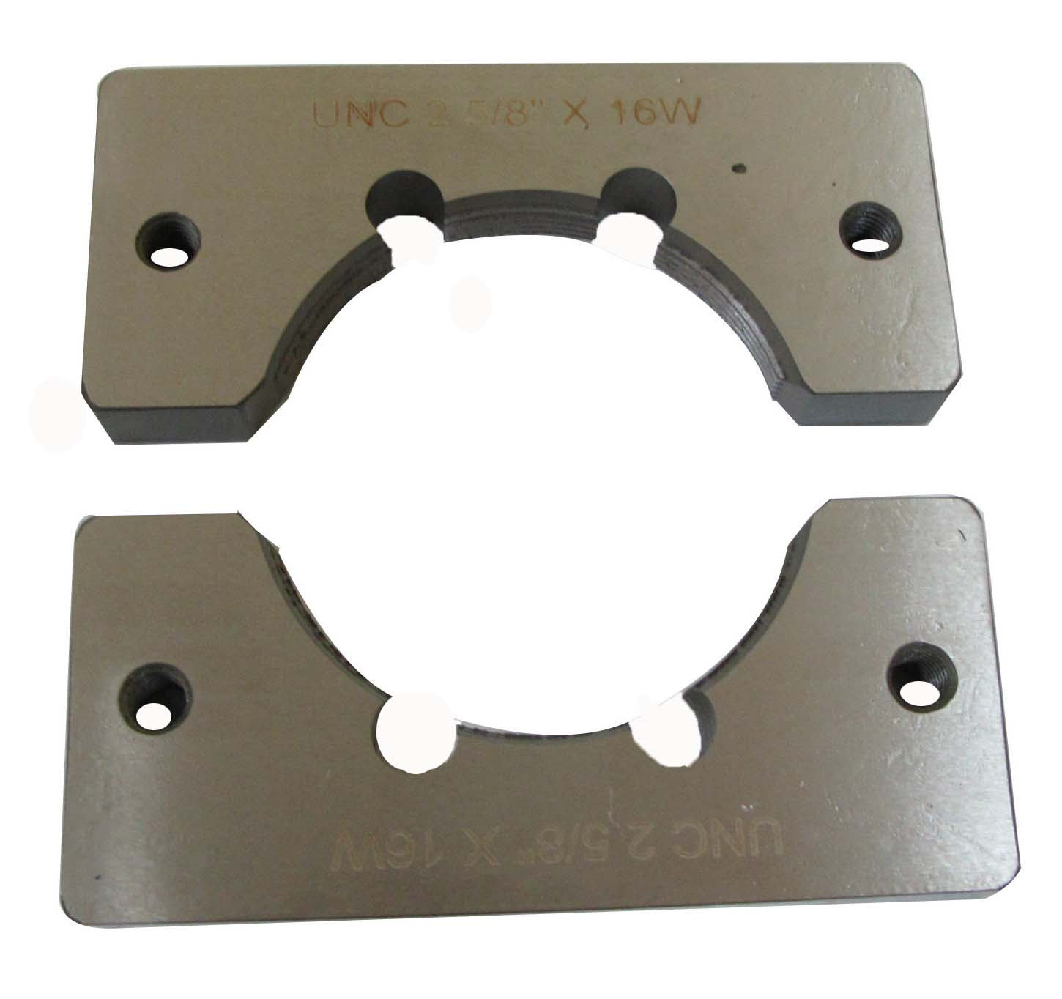
A1183-8 UNC 3 1/4” x 12 W suit for KW TRUCK REAR AXLE

NUT OF KW REAR AXLE
A1183-9 UNC 2 5/8” x 16W suit for ROR TRAILER AXLE

UNC 3 1/4” x 12W
UNC 2 5/8” x 16W

NUT OF ROR TRAILER AXLE

