
H.C.B-A1176
VOLVO WHEEL SHAFT COVER SOCKET
(Dr. 3/4”, 8 POINTS, 115 mm)

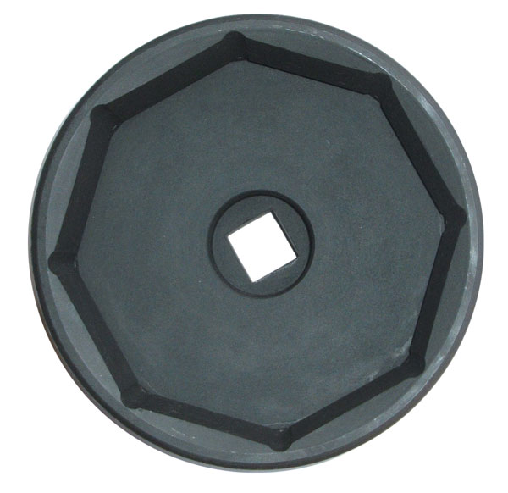
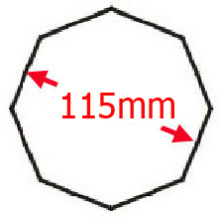
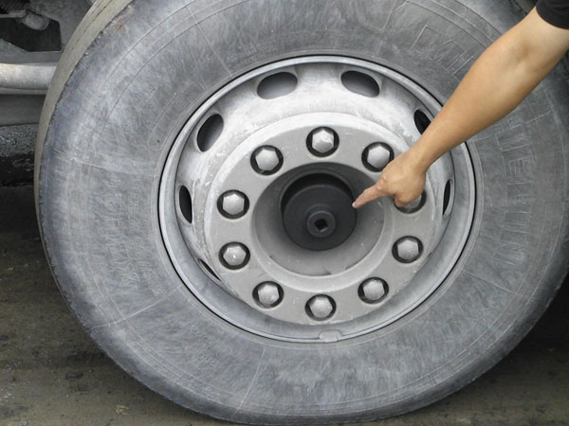
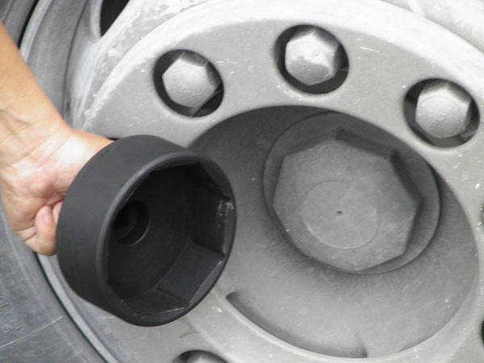
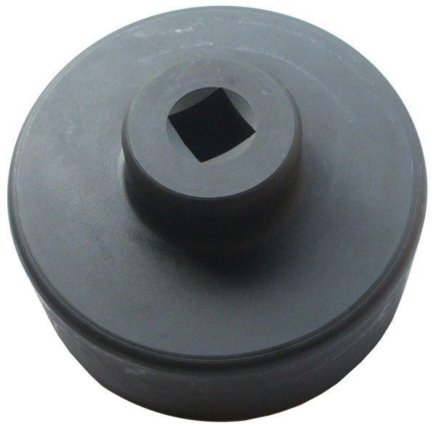
Dr. 3/4”
- To dismantle the front / rear wheel axle cover of VOLVO
- Application: FH12&FH16 (After 1993)
- Size: 115 mm, octagon

H.C.B-A1176
VOLVO WHEEL SHAFT COVER SOCKET
(Dr. 3/4”, 8 POINTS, 115 mm)

Dr. 3/4”

- To dismantle the front / rear wheel axle cover of VOLVO
- Application: FH12&FH16 (After 1993)
- Size: 115 mm, octagon

