
H.C.B-A1172
MAN AXLE BEARING EXTRACTOR
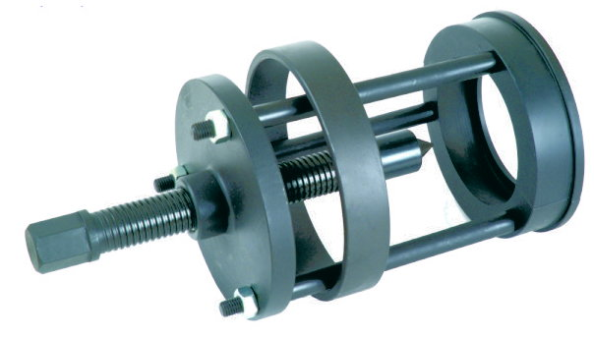

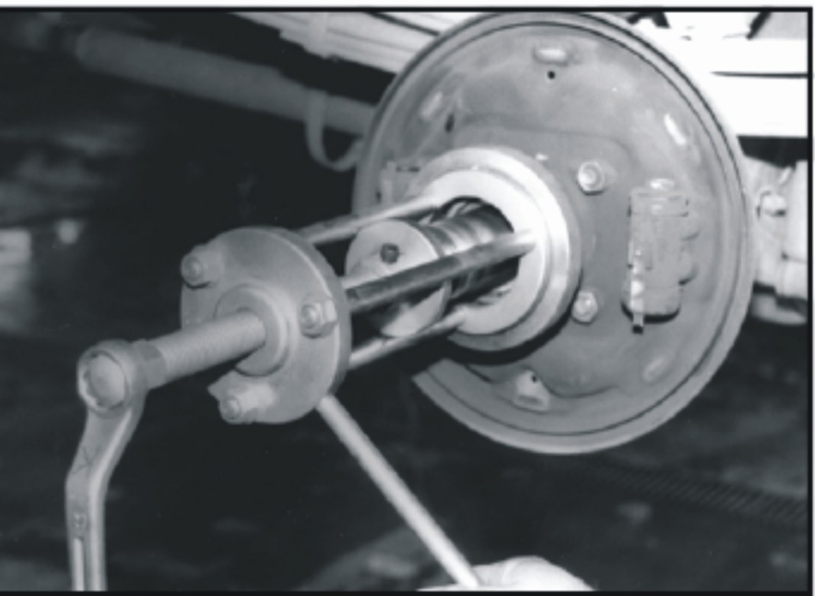
- For replace MAN truck hub bearings and remove the old bearings.
- Turn the screw to remove the bearing.

