
H.C.B-A1167
SCANIA, BENZ (W203/W209) WRENCH SOCKET (FLUID RESERVOIR ON CONDENSER) (Dr. 1/2”, 27 mm)
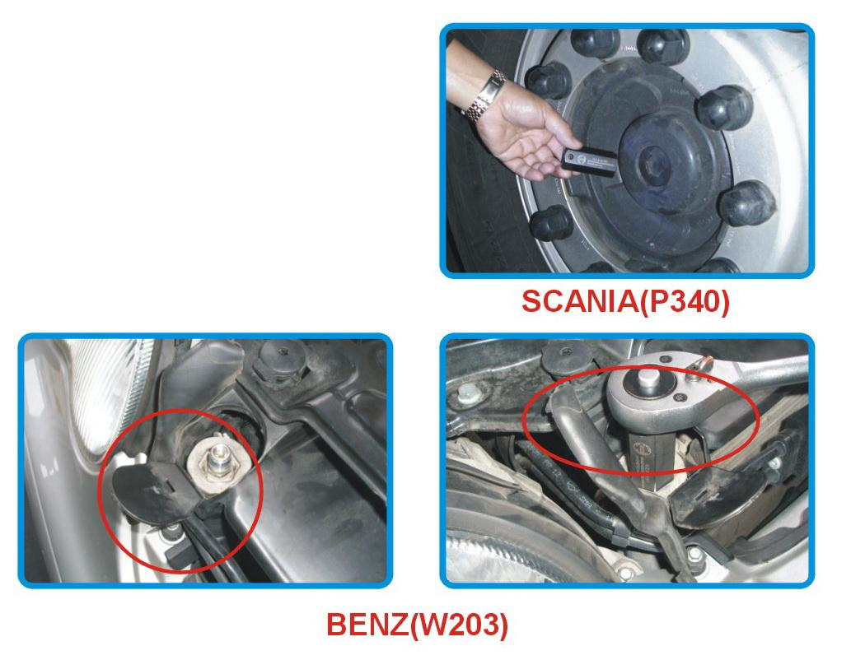
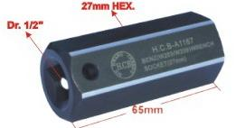

▉ For screw plug removal and installation on fluid reservoir on condenser
▉ Also used for SCANIA front wheel plastic cover.
▉ Application: BENZ (W203/W209) & SCANIA truck
▉ Genuine Stock No.: 203 589 00 10 00

H.C.B-A1167
SCANIA, BENZ (W203/W209) WRENCH SOCKET (FLUID RESERVOIR ON CONDENSER) (Dr. 1/2”, 27 mm)

▉ For screw plug removal and installation on fluid reservoir on condenser
▉ Also used for SCANIA front wheel plastic cover.
▉ Application: BENZ (W203/W209) & SCANIA truck
▉ Genuine Stock No.: 203 589 00 10 00

