**H.C.B-A1117-7**

**VW DSG 6/ 7 SPEED TRANSMISSION SUPPORT**

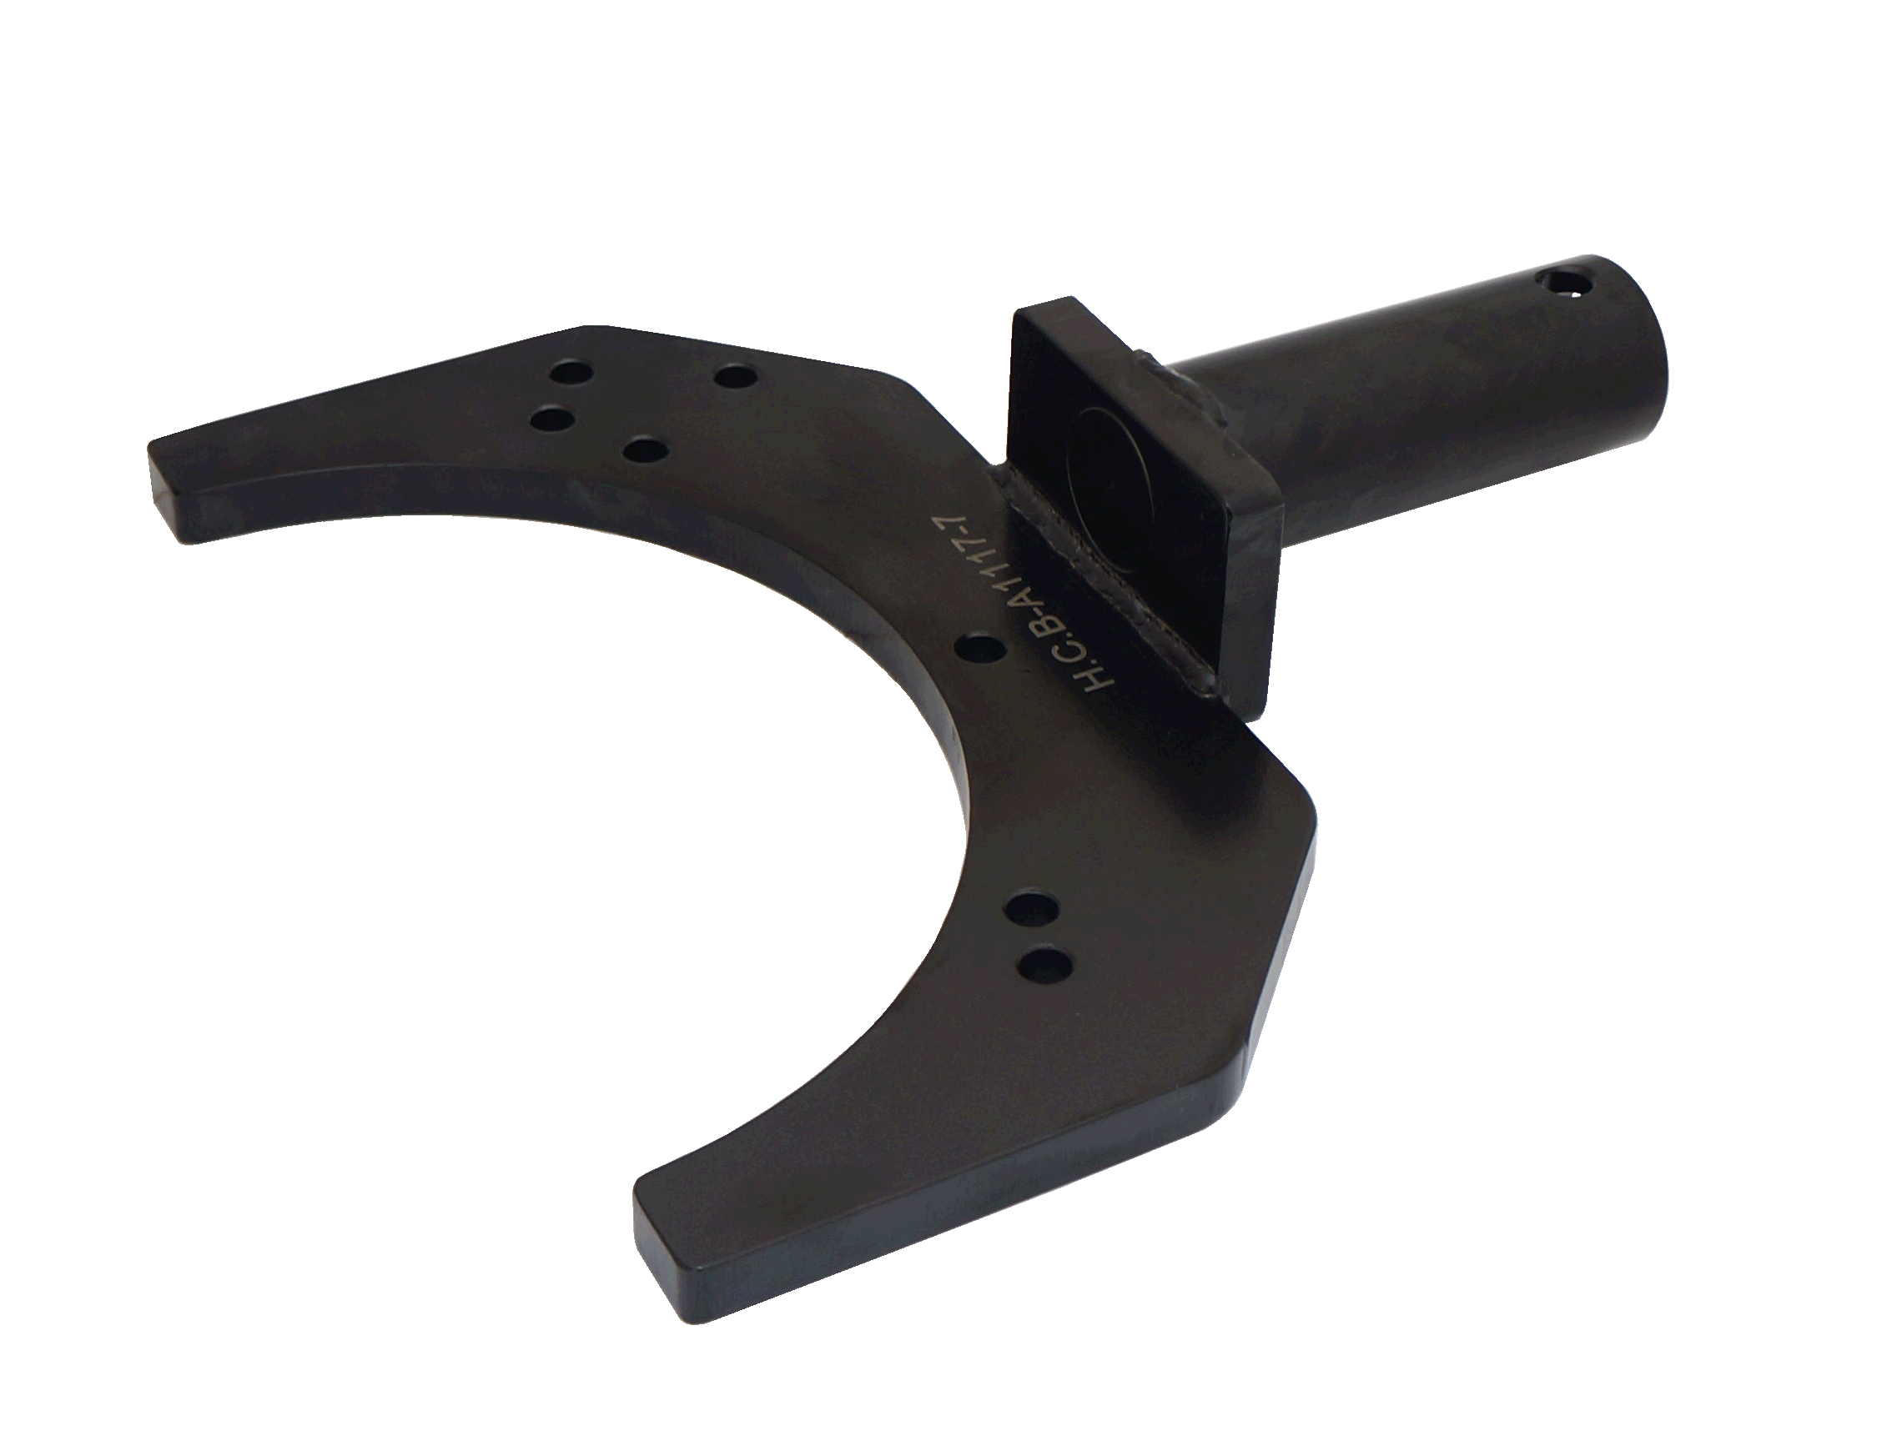

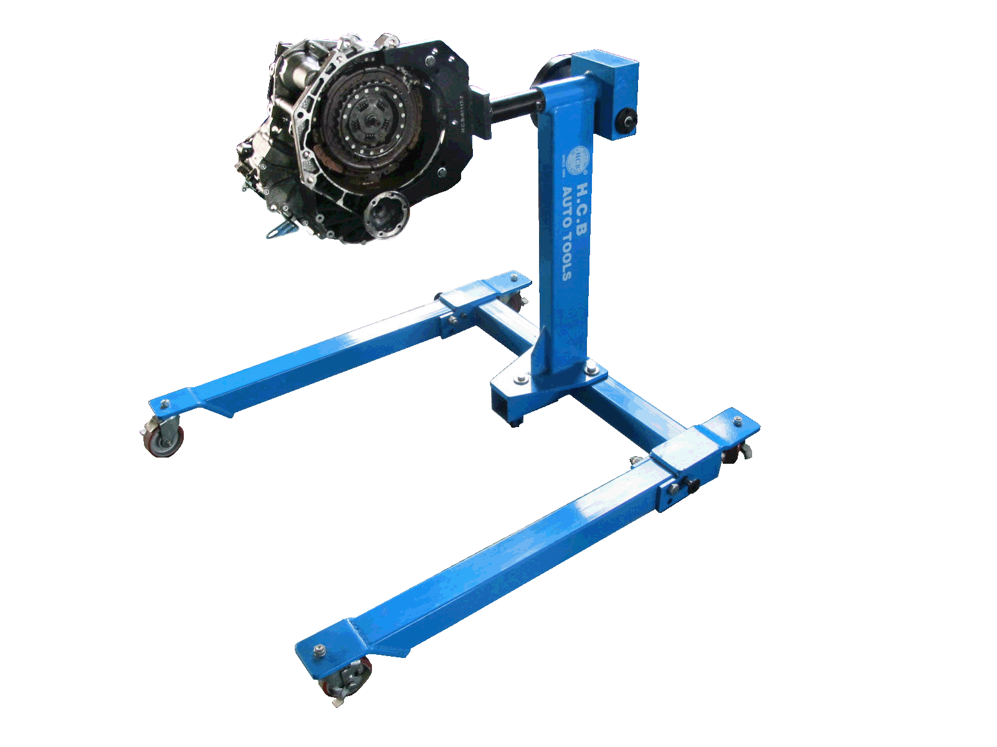

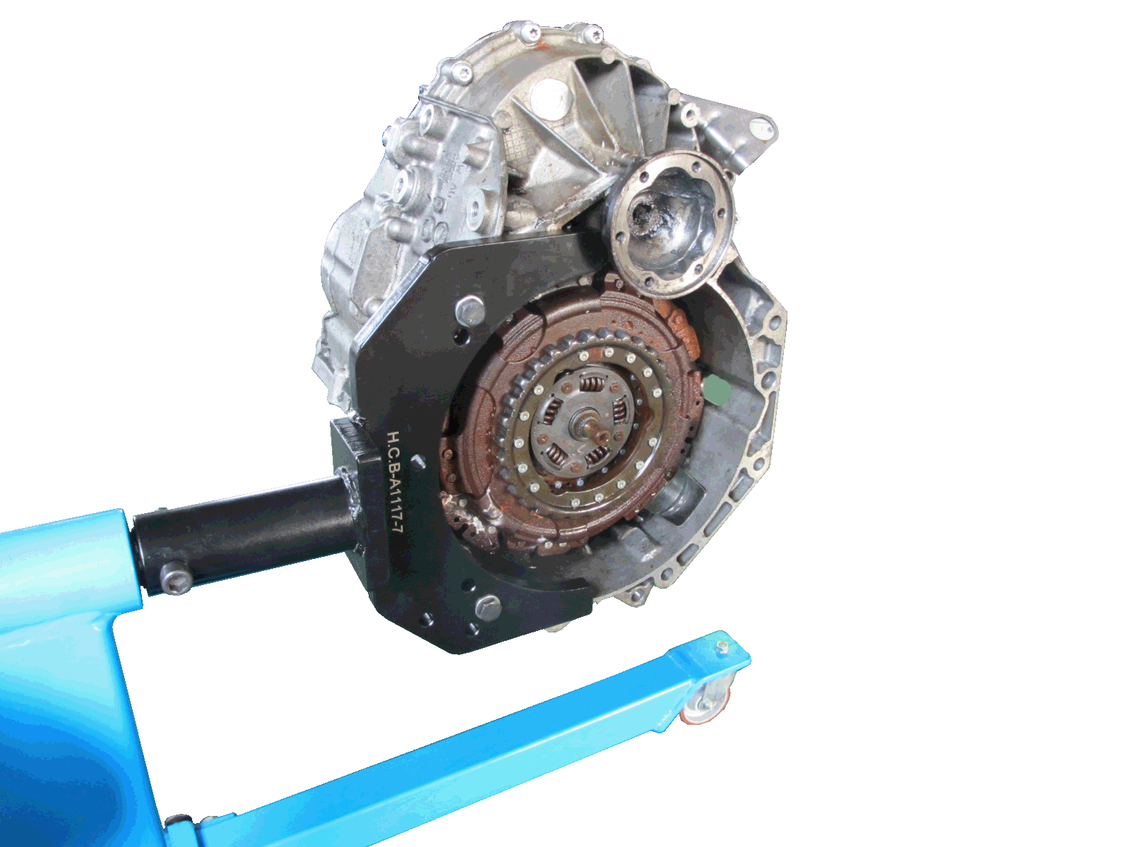

* **Special transmission support for Volkswagen DSG 6/ 7 speed transmission.**
* **This support is combined with H.C.B-A1117 or H.C.B-A1097.**
* **Transmission can be turned 360∘, thus extraction or installation of any parts of transmission in different angles is able. It is really convenient and useful.**