
H.C.B-A1117-5
600 TRANSMISSION HOLDING BASE
TW PAT. USA PAT. PEN

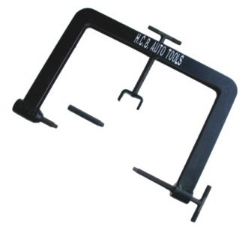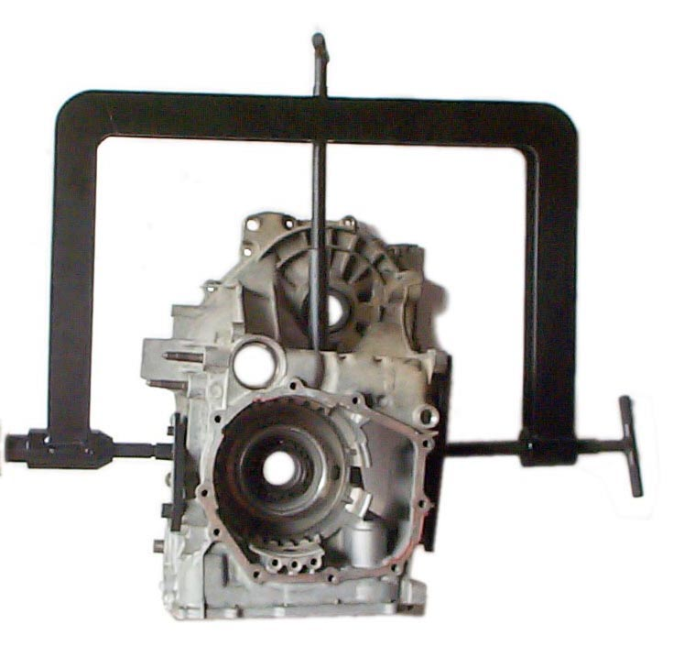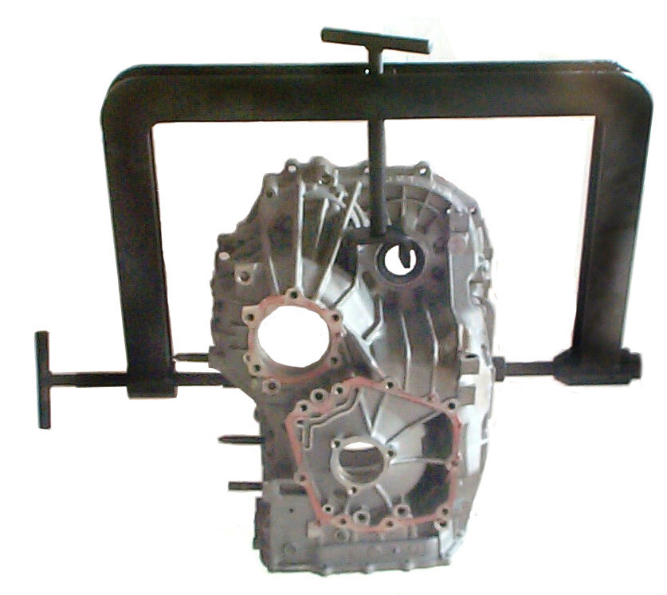

- This tool is combines with H.C.B-A1117 or H.C.B-A1097 that are designed to turning 360∘when repair transmission. Repairs could extract or install any parts of transmission in different angles. It is really convenient and useful.

- Length : 600mm

