
H.C.B-A1117-4
500 C-TYPE TRANSMISSION HOLDING BASE
PAT. M 270936 USA PAT. 7093809

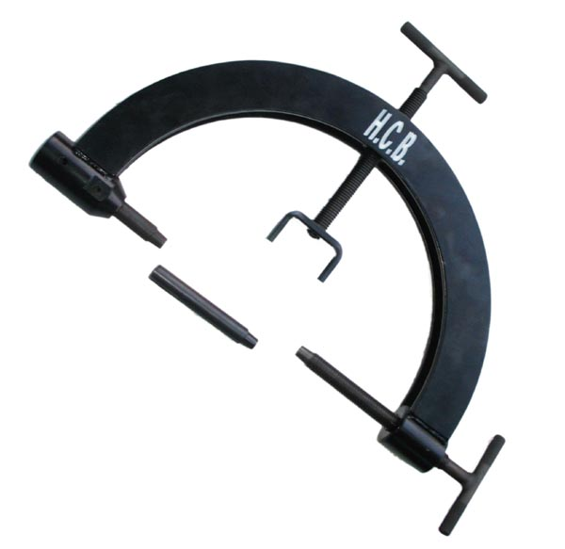
PAT. M 270936
USA PAT. 7093809

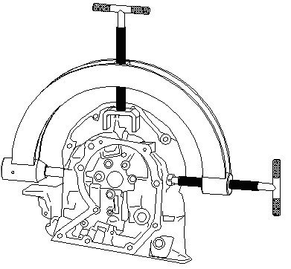 | 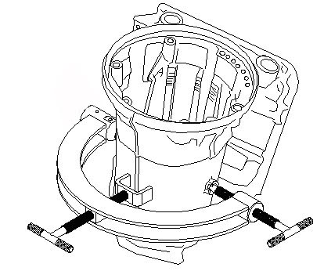

- This tool is combines with H.C.B-A1117 or H.C.B-A1097 that are designed to turning 360∘when repair transmission. Repairs could extract or install any parts of transmission in different angles. It is really convenient and useful.
- Length : 500mm

