
H.C.B-A1117-4-3
AUDI TRANSMISSION TOOL FITMENT
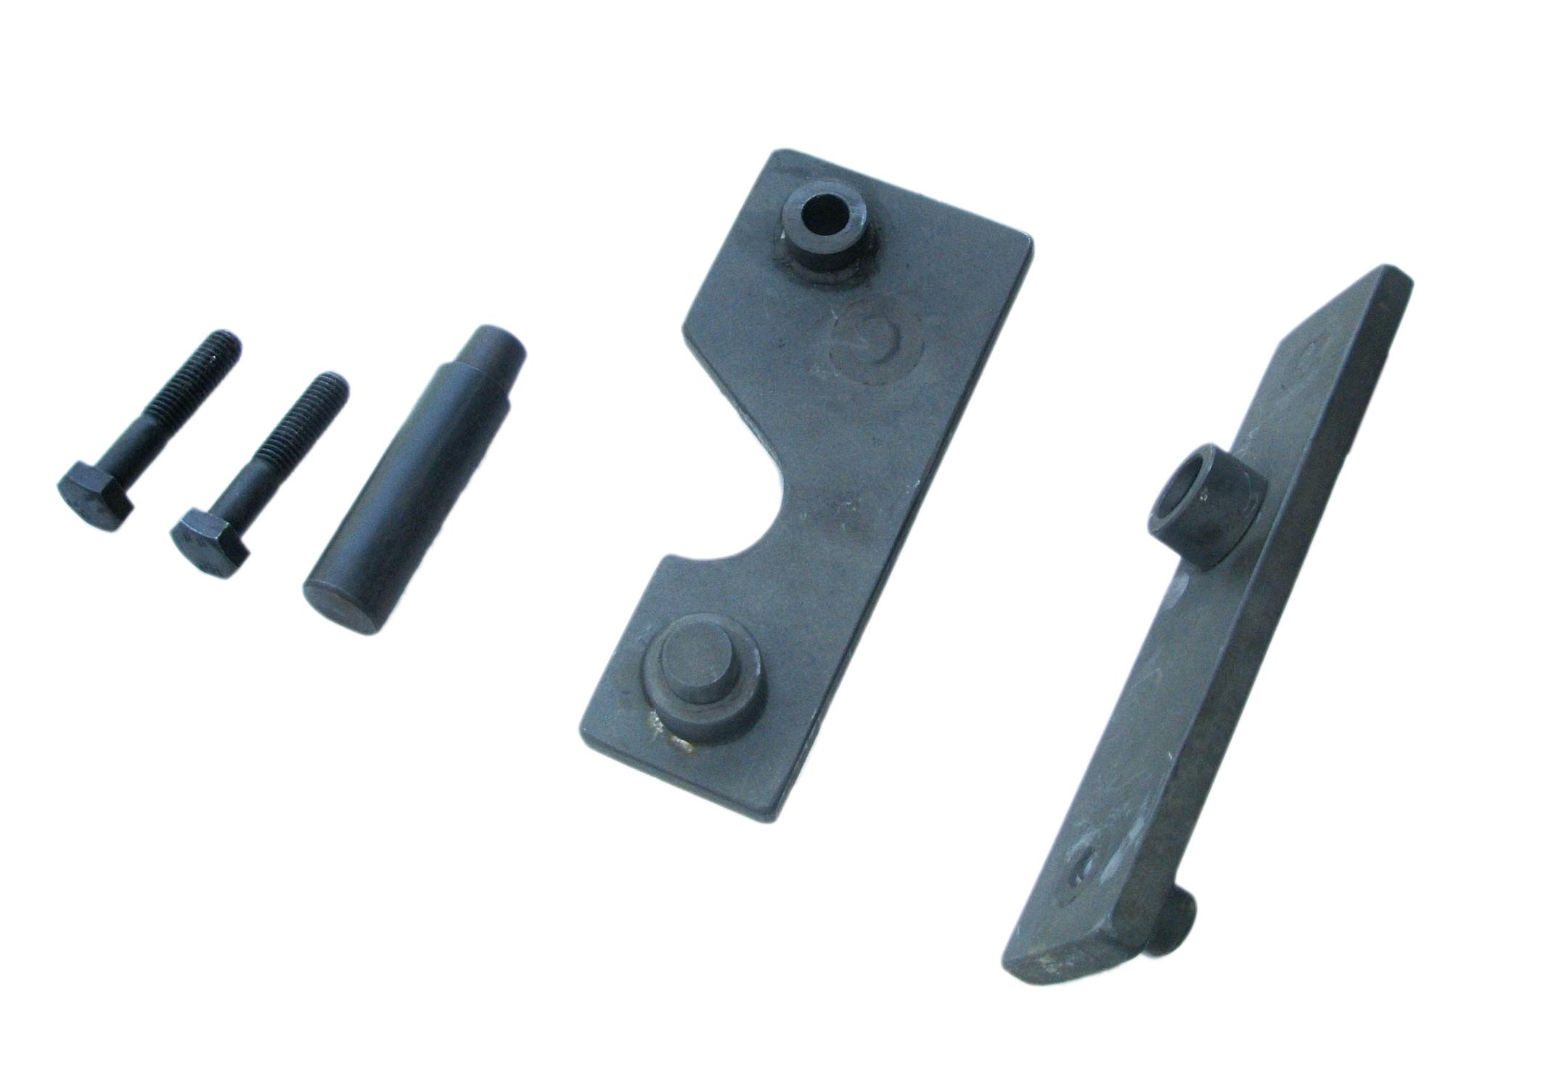

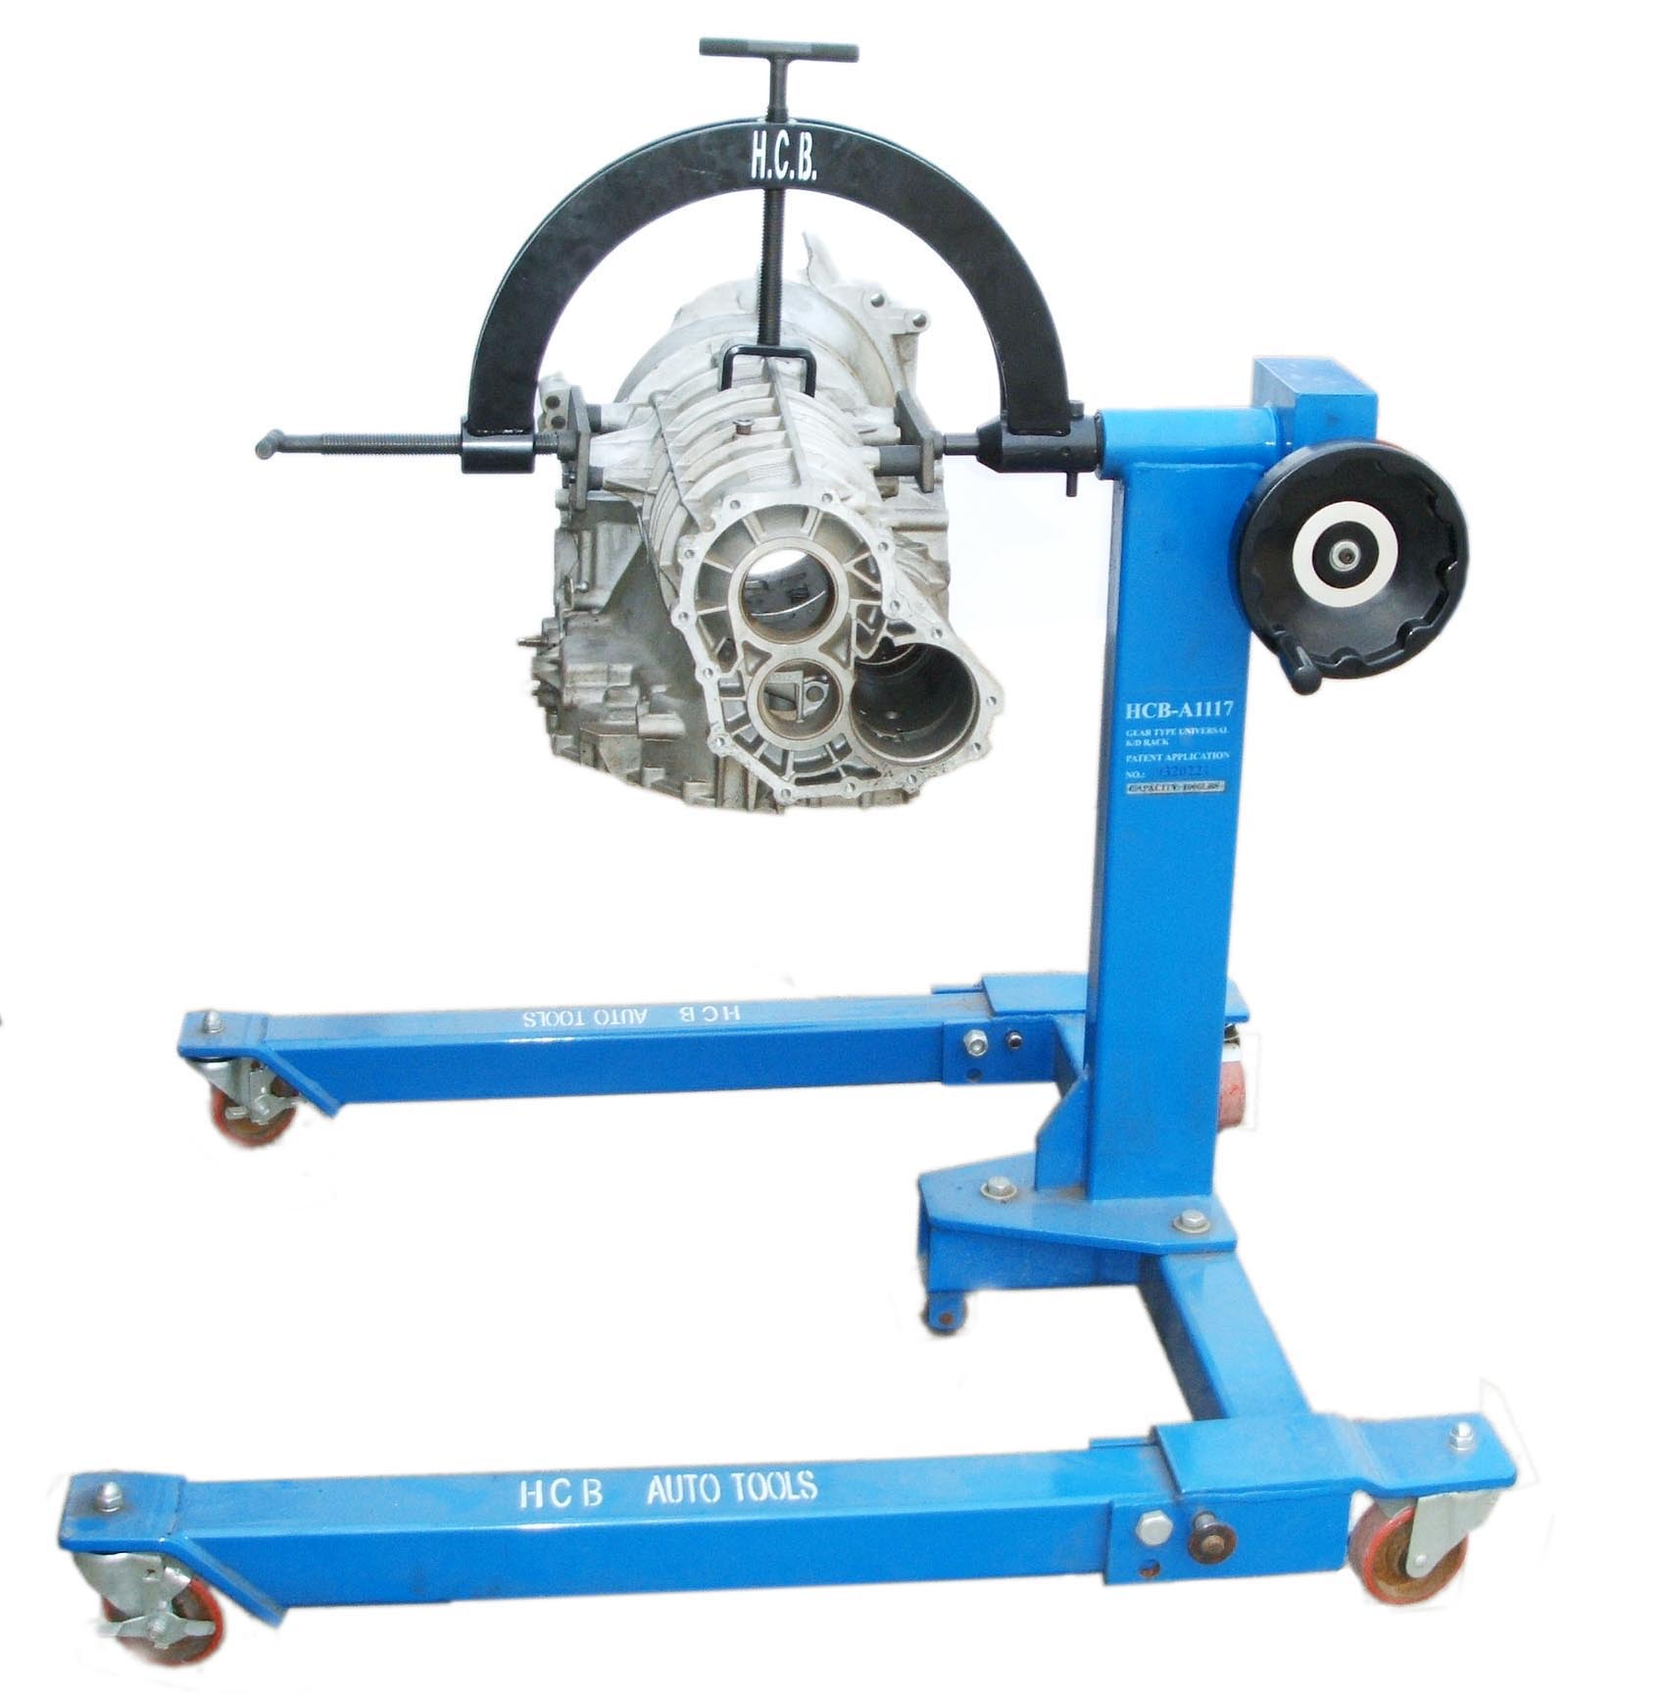

█ This tool must be combined with A1117-4.

█ Applicable: AUDI A3, A4 1.8T TURBO, A6 1.8T

