
H.C.B-A1100
BMW (5HP18/ 5HP19) TRANSMISSION SOCKET (4 TEETH)

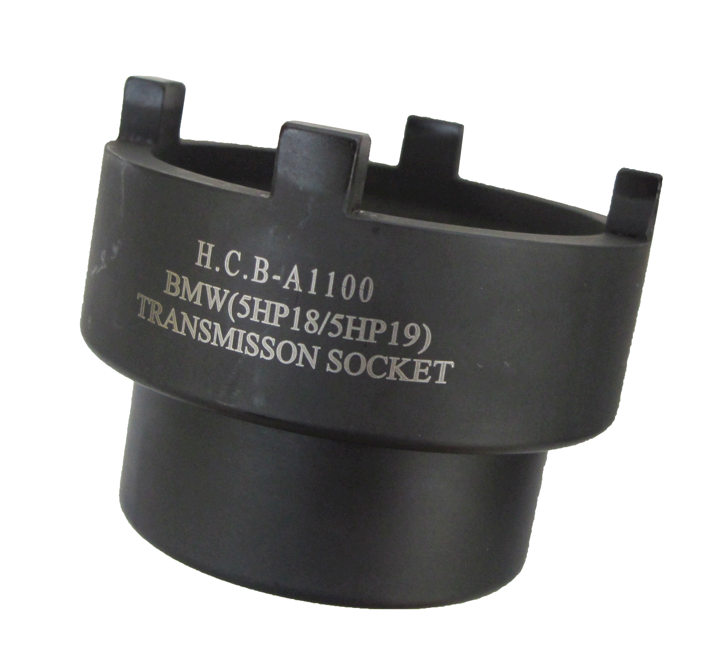
8mm

Dr. 1/2”

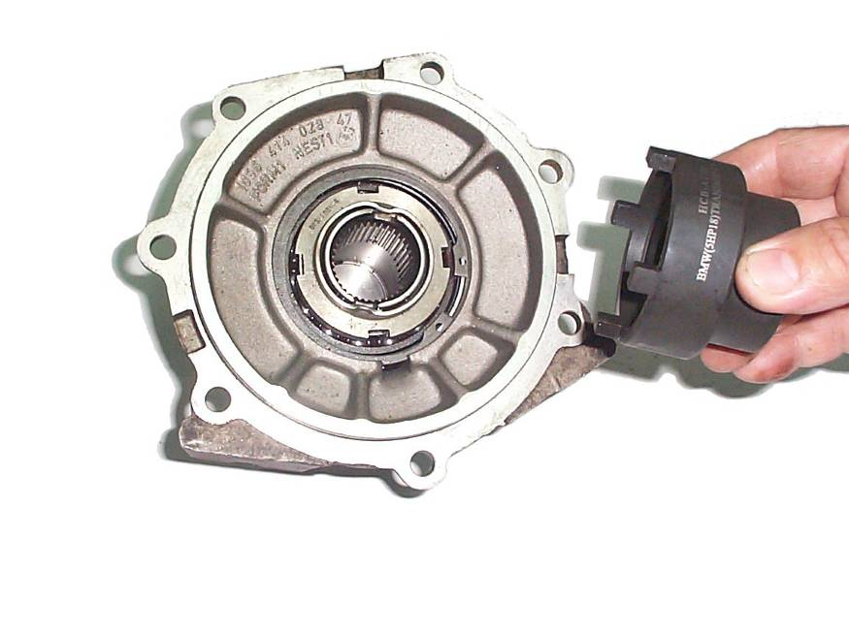
- Dr. 1/2”, FOR GROOVED NUT ON TRANSMISSION DRIVE SHAFT FLANGE.
- D=64MM
- d=53.5MM
- APPLICABLE: BMW (5HP18, 5HP19) TRANSMISSION

H.C.B-A1100
BMW (5HP18/ 5HP19) TRANSMISSION SOCKET (4 TEETH)

8mm

Dr. 1/2”

- Dr. 1/2”, FOR GROOVED NUT ON TRANSMISSION DRIVE SHAFT FLANGE.
- D=64MM
- d=53.5MM
- APPLICABLE: BMW (5HP18, 5HP19) TRANSMISSION

