
H.C.B-A1097
UNIVERSAL GEAR TYPE ENGINE K/D RACK USA PAT .PEN PAT.089901

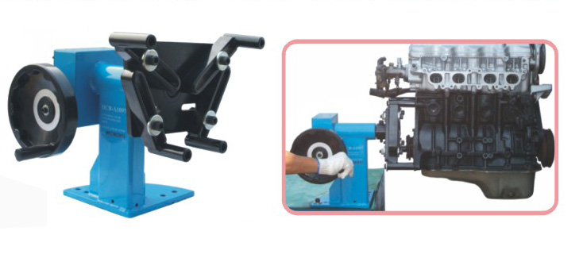

- Rotating engine by gear, can assemble & disassemble engines more convenient and effort-saving.
- Small volume, store up very easy.
- DIM.34.5x40x43.5cm
- N.W.:29.5KGS

H.C.B-A1097
UNIVERSAL GEAR TYPE ENGINE K/D RACK USA PAT .PEN PAT.089901

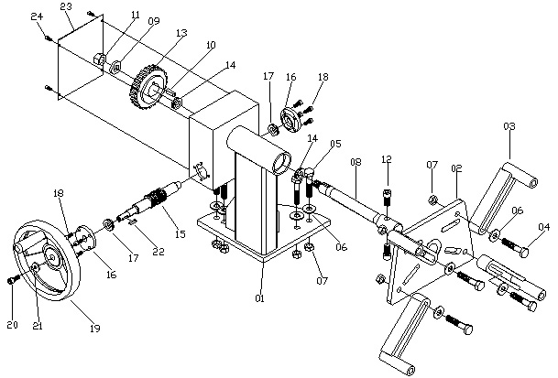
H.C.B-A1097 PARTS SPECIFICATION
NO. | TITLE/SPECIFICATIONS | QUANTITY | NO. | TITLE/SPECIFICATIONS | Q’TY
01 | IDENTITY | 1 | 13 | TURBINE GEAR WHEEL | 1
02 | ENGINE STEADY SEAT | 1 | 14 | BEARING 6205-ZZ | 2
03 | ENGINE STEADY HOLDER | 4 | 15 | TURBINE SHAFT | 1
04 | HEXAGONAL SCREW  M12╳P1.75╳65L | 4 | 16 | FIXED SEAT | 2
05 | HEXAGONAL SCREW  M12╳P1.75╳50L | 4 | 17 | BEARING 6002-ZZ | 2
06 | ψ1/2”╳ψ34╳3t WASHER | 8 | 18 | HEXAGONAL SCREW  M6╳P1.0╳20L | 8
07 | H19 NUT  M12╳P1.75╳10L | 8 | 19 | 8” HAND WHEEL | 1
08 | CENTRAL SHAFT | 1 | 20 | HEXAGONAL SCREW  M8╳P1.25╳20L | 1
09 | ψ16╳ψ46╳5t WASHER | 1 | 21 | ψ8╳ψ23╳3t WASHER | 1
10 | KEY 8╳8╳25L | 1 | 22 | KEY 5╳5╳20L | 1
11 | H26╳15L NUT  M16╳P1.5╳15L | 1 | 23 | COVER | 1
12 | HEXAGONAL SCREW  M12╳P1.75╳60L | 1 | 24 | HEXAGONAL SCREW  M5╳P0.8╳10L | 4

