
H.C.B-A1097-5
TOYOTA LEXUS TRANSMISSION
HOLDER BASE
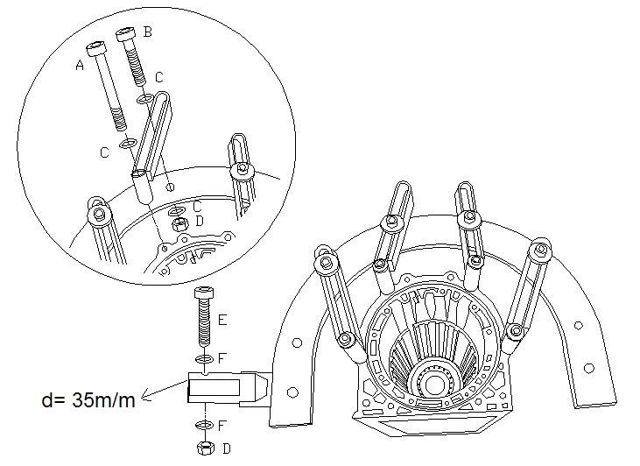
- Fix transmission case sub-assy turning 360° to dismantle and assemble in different angles.
- Accessory: C type fixed base x 1, slide fixed lever (adjustable to different size of transmission) x 4 sets, screw x 4 pcs.
- Notice: Conjunction with any K/ D rack of the three: H.C.B-A1097, H.C.B-A1117, H.C.B-A1157.
- Application: apply to the car (front wheel drive), as TOYOTA LEXUS…etc.

