
H.C.B-A1094
BENZ 722.6 TRANSMISSION OIL LEVEL GAUGE
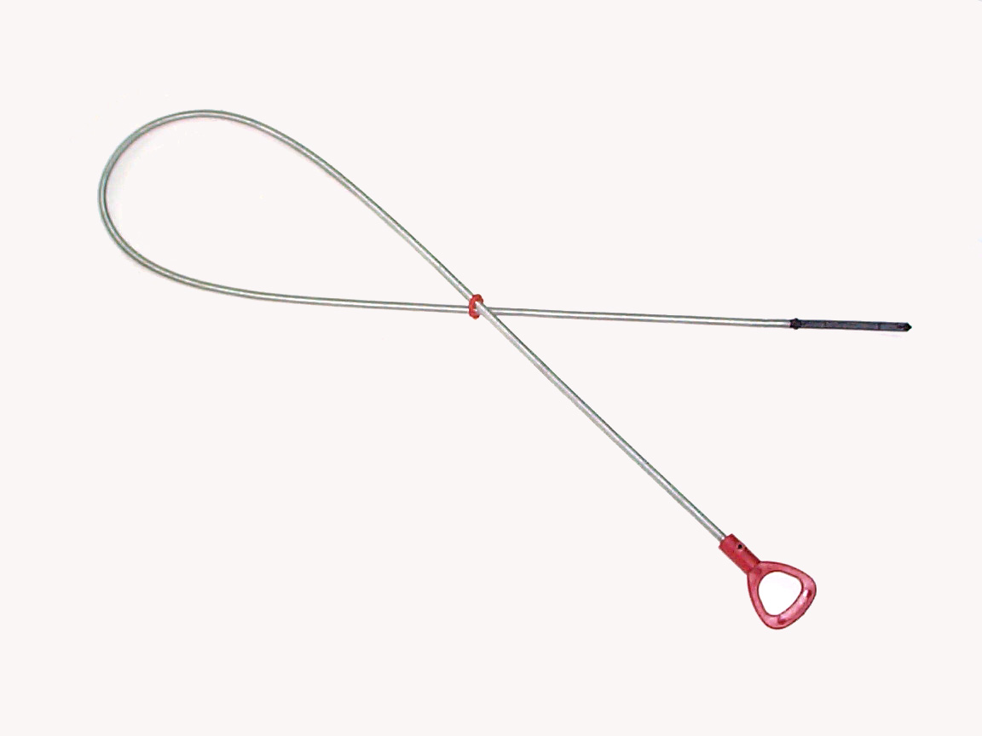

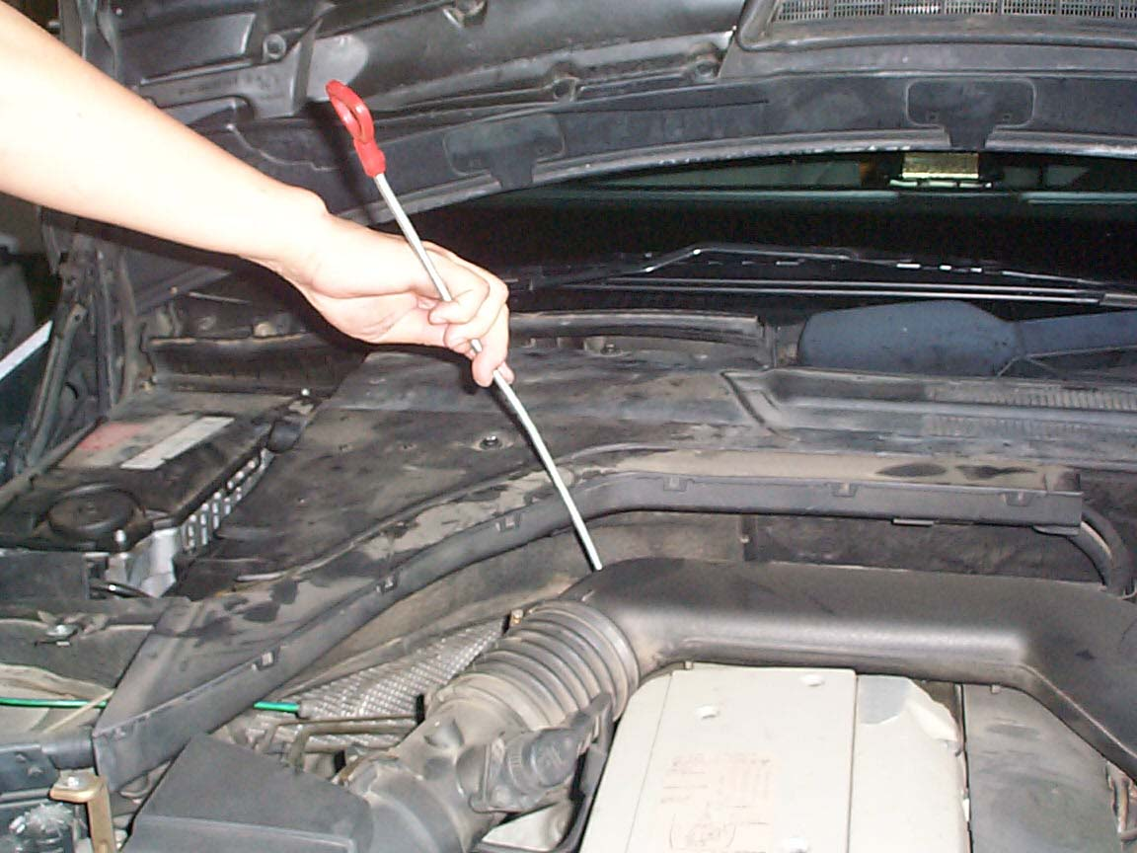

- Genuine stock No.:140 589 15 21 00
- The tool is designed for checking ATF level.
- Application: MERCEDES models 1997 and newer with 722.6 transmission.
- Full length: 1220mm
H.C.B-A1094
BENZ 722.6 TRANSMISSION OIL LEVEL GAUGE

- Genuine stock No.:140 589 15 21 00
- The tool is designed for checking ATF level.
- Application: MERCEDES models 1997 and newer with 722.6 transmission.
- Full length: 1220mm

