
H.C.B-A1075
MAN FRONT WHEEL HUB EXTRACTOR

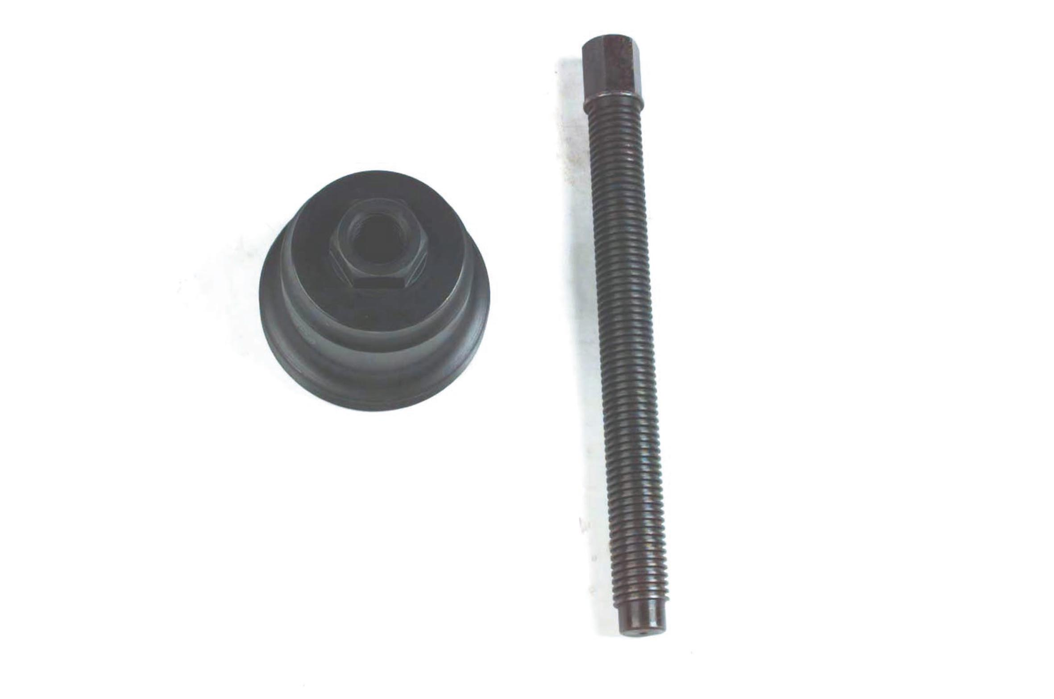

- To remove the front wheel hub
- Application: MAN truck
- Specification: M115 x P 1.5

H.C.B-A1075
MAN FRONT WHEEL HUB EXTRACTOR

- To remove the front wheel hub
- Application: MAN truck
- Specification: M115 x P 1.5

