
H.C.B-A1066-3-2
BPW 12 TONS AXLE EXTRACTOR
(M136 x P2.5)
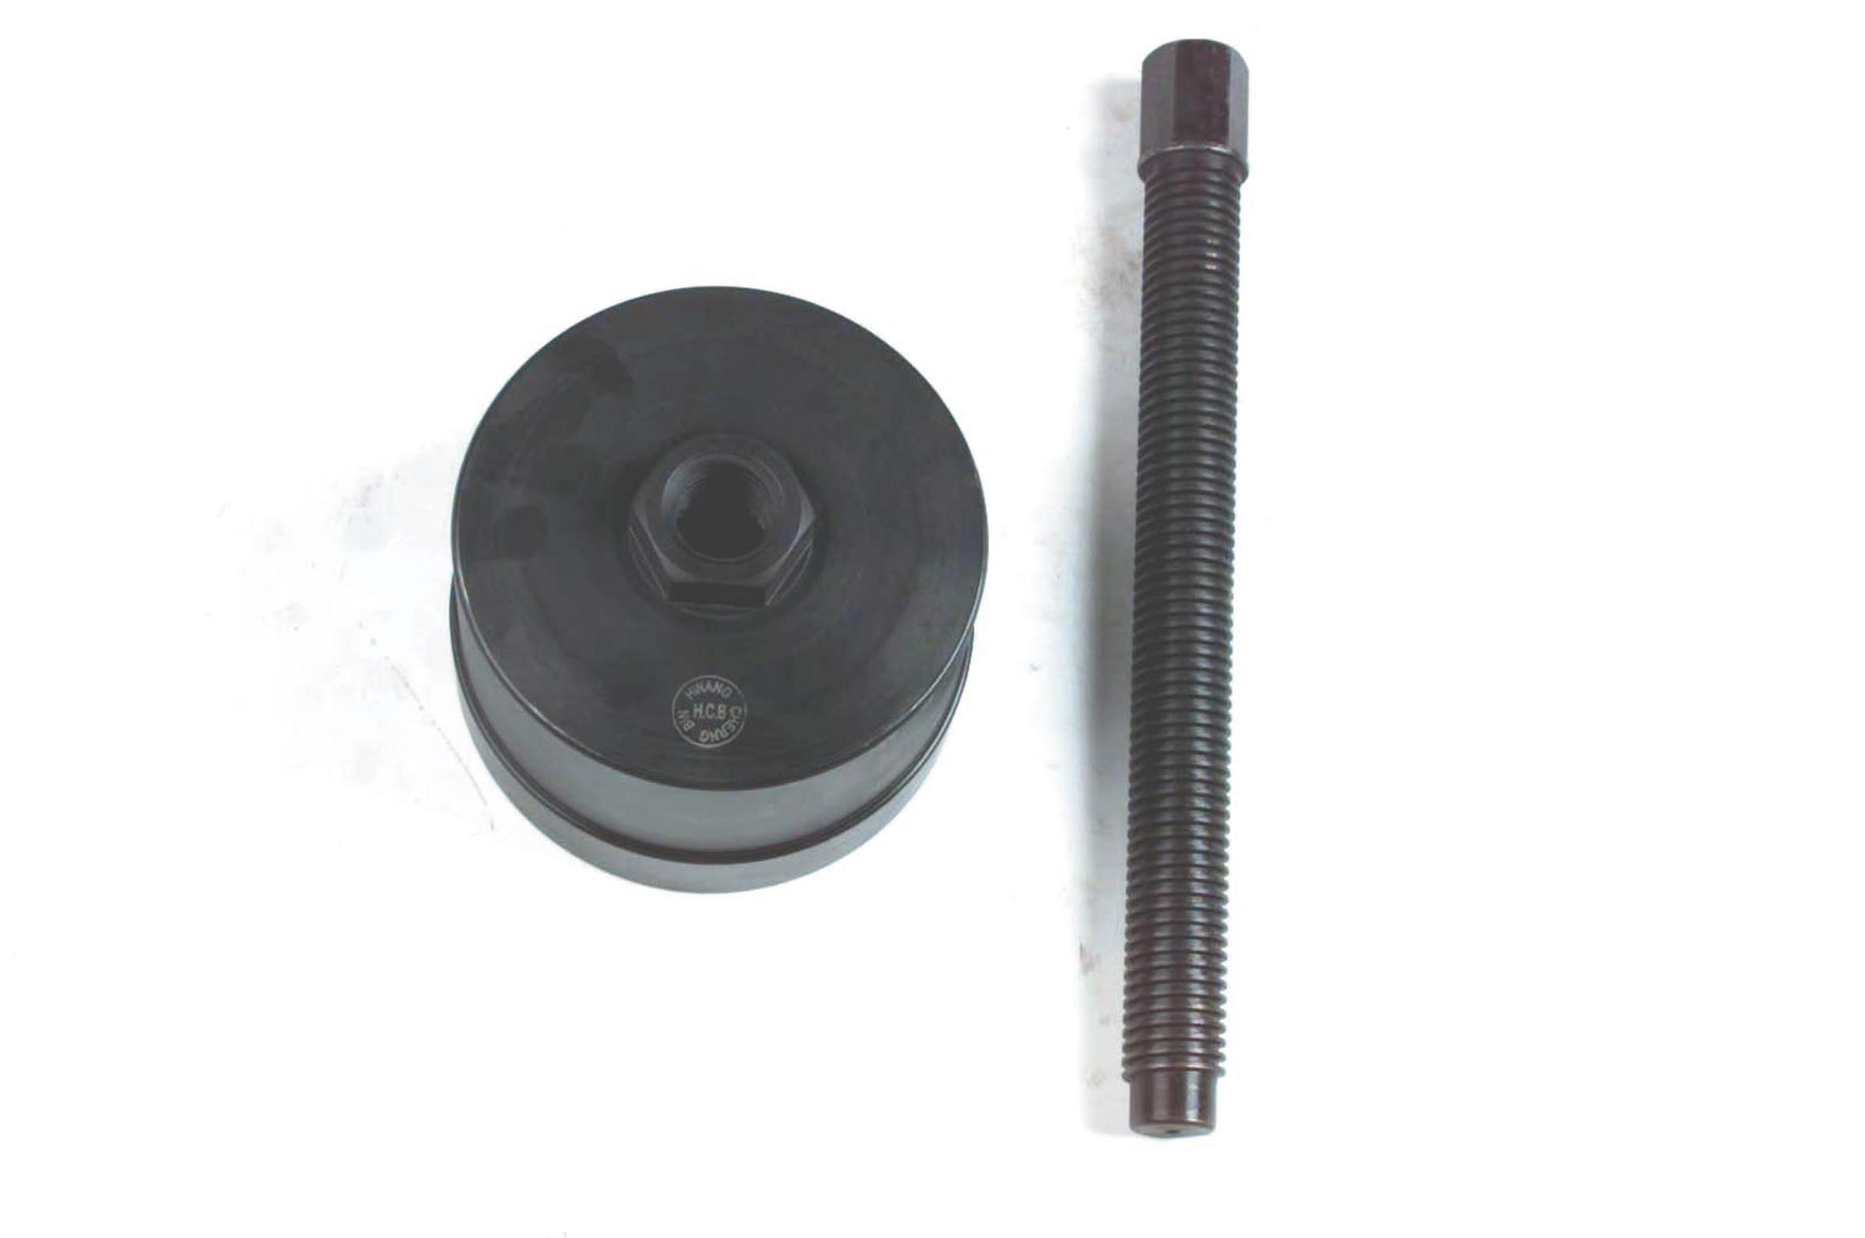

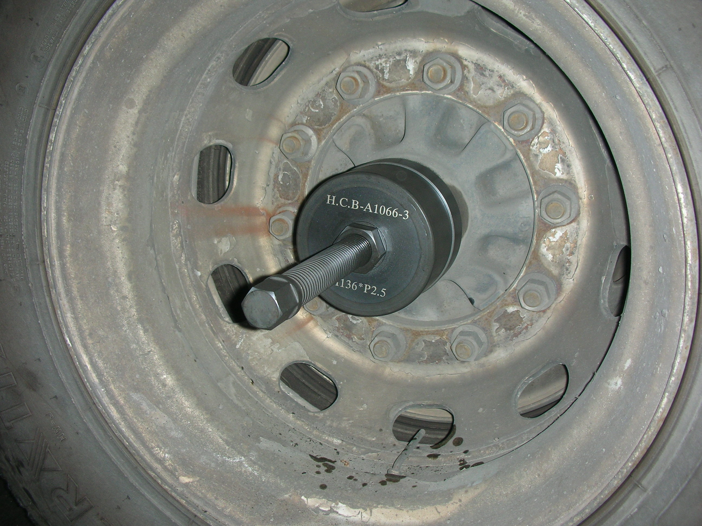
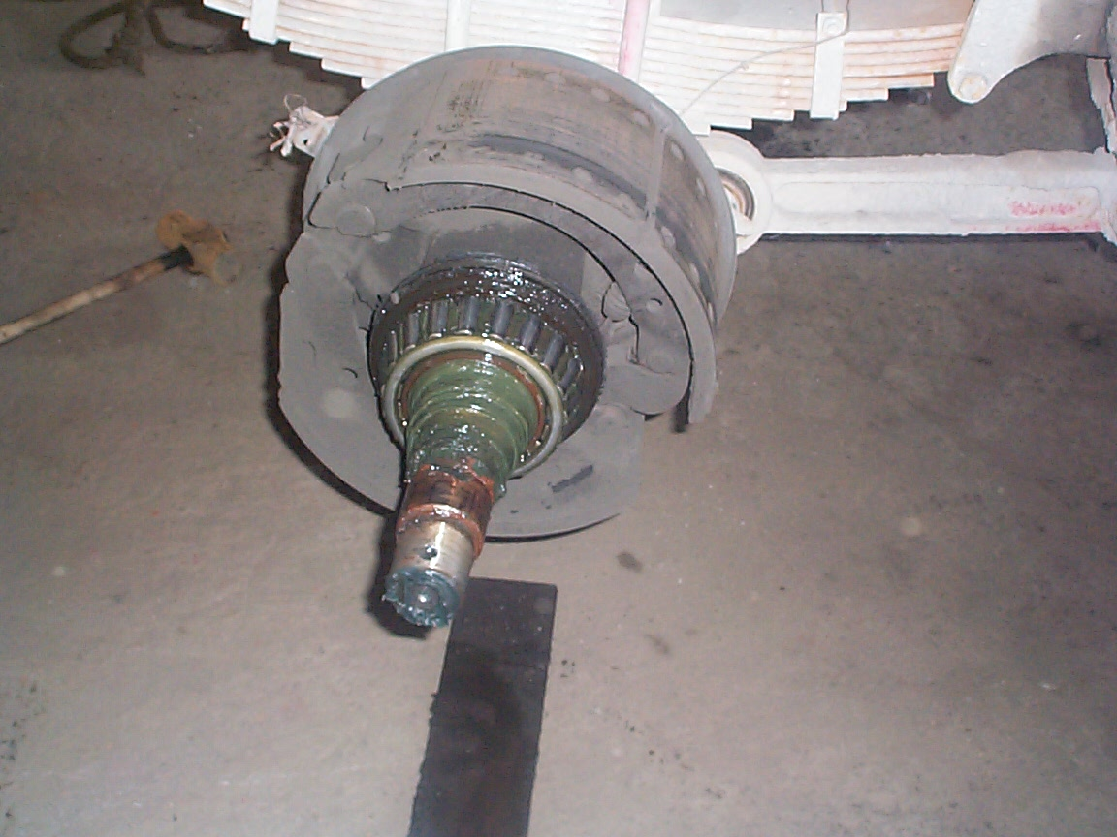
- Screw specification: ø 30 x 6W
- Applicable: BPW ECO Plus 8~12 tons, BPW ECO 10 tons new model
- N.W.:3.6KGS

H.C.B-A1066-3-2
BPW 12 TONS AXLE EXTRACTOR
(M136 x P2.5)

- Screw specification: ø 30 x 6W
- Applicable: BPW ECO Plus 8~12 tons, BPW ECO 10 tons new model
- N.W.:3.6KGS

