
H.C.B-A1066-3-1
BPW 12 TONS AXLE EXTRACTOR (M135 x P2.0)
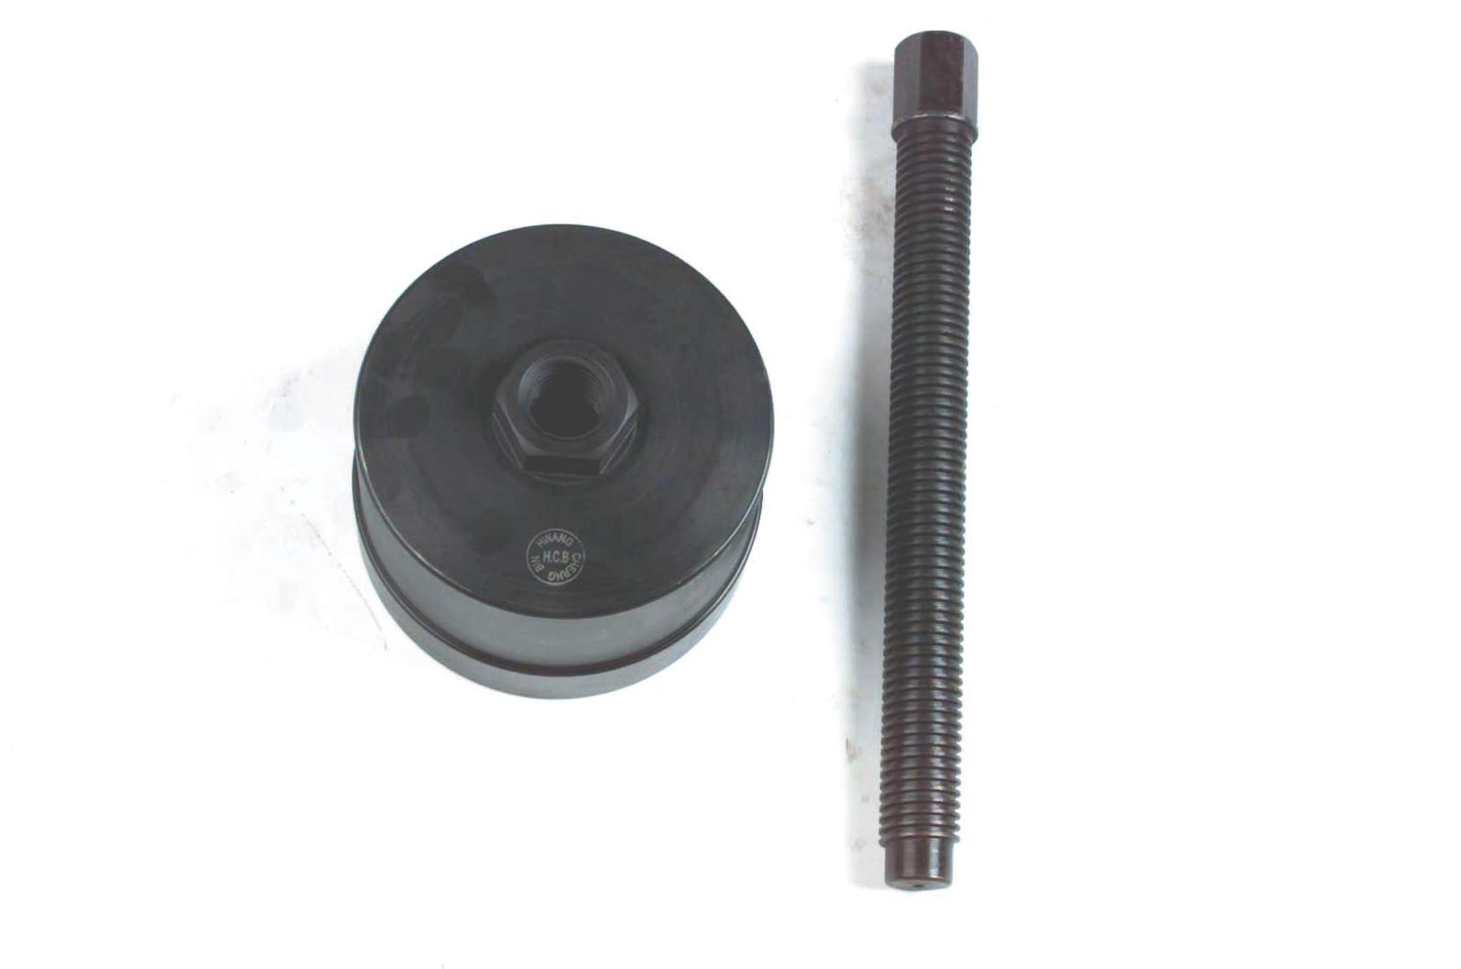
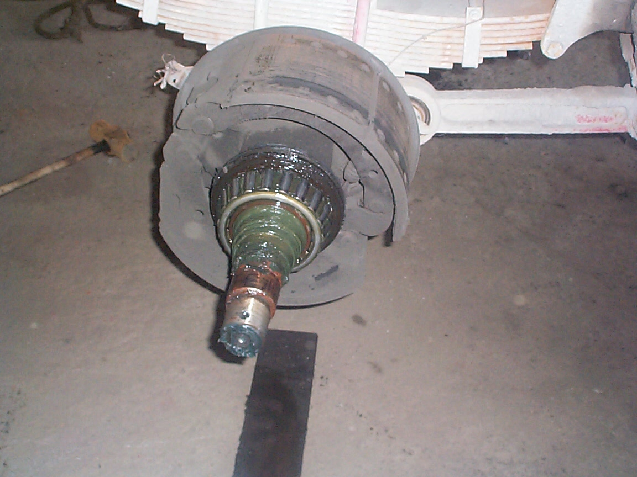
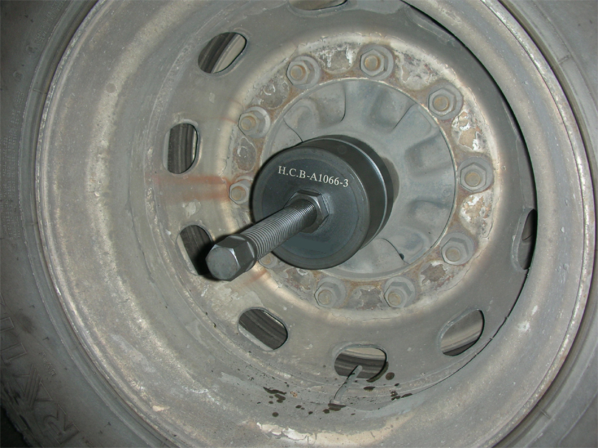
- Screw specification: ø 30 x 6W
- Applicable: BPW ECO 10~12 tons old model.
- N.W.:3.6KGS

H.C.B-A1066-3-1
BPW 12 TONS AXLE EXTRACTOR (M135 x P2.0)
- Screw specification: ø 30 x 6W
- Applicable: BPW ECO 10~12 tons old model.
- N.W.:3.6KGS

