
H.C.B-A1066-2
BPW 16 TONS AXLE EXTRACTOR
(M155 x P3.0)

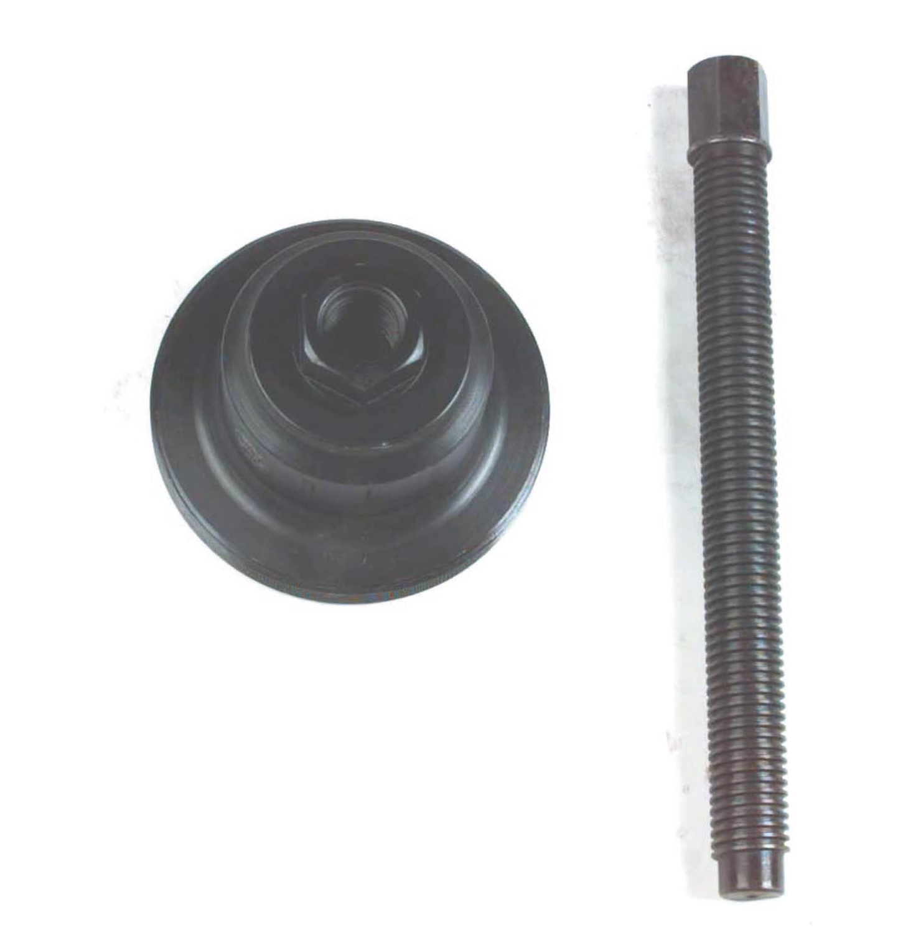
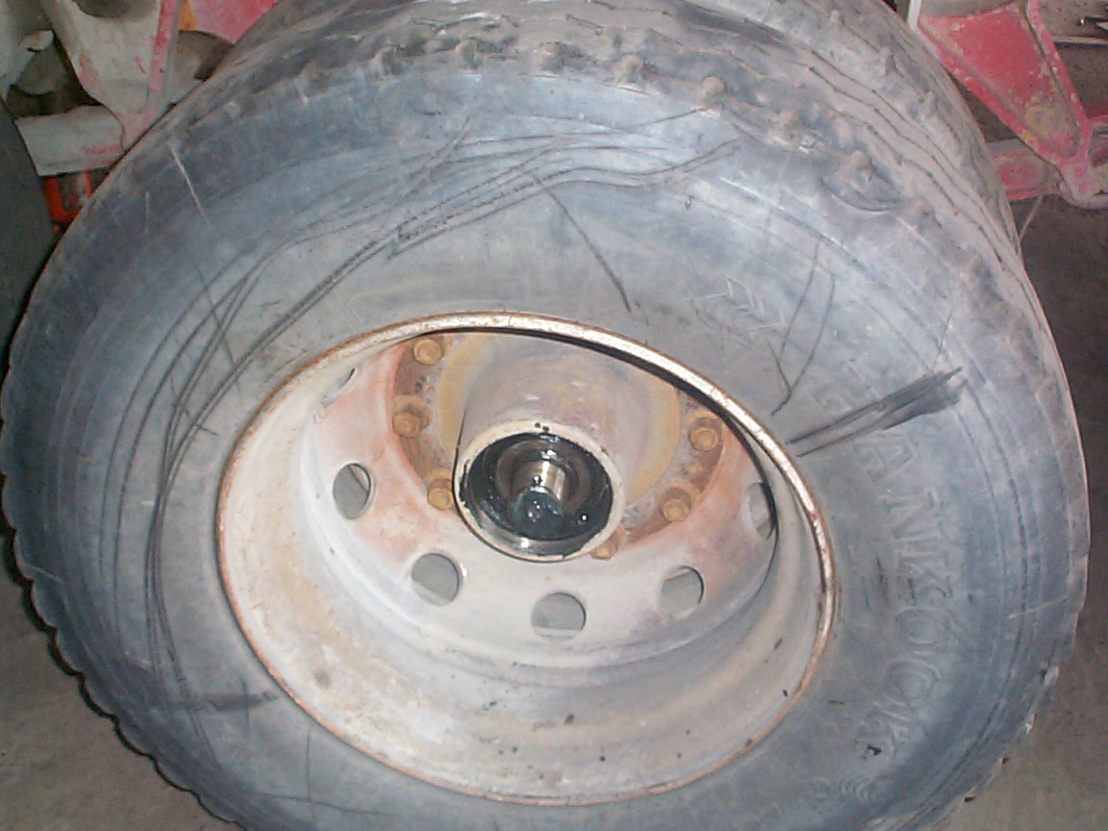
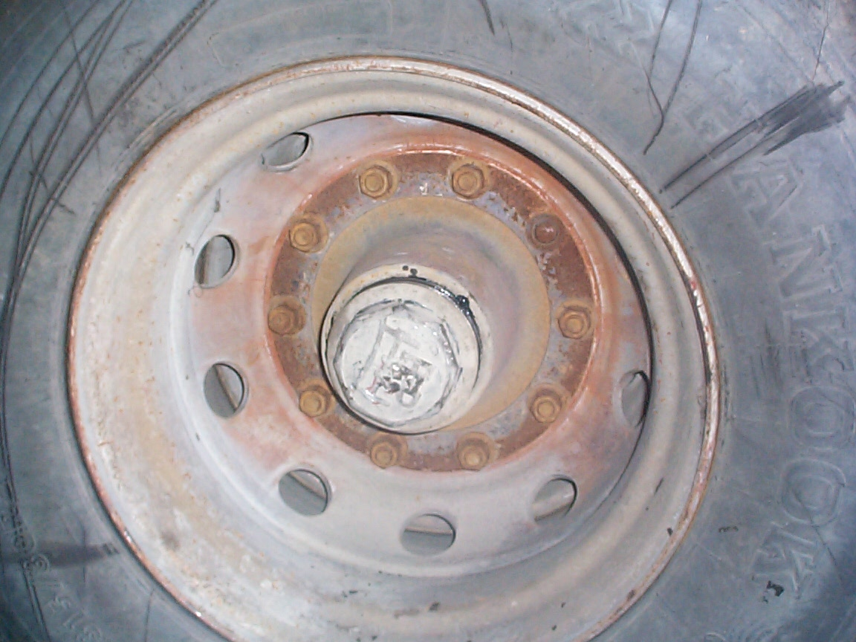

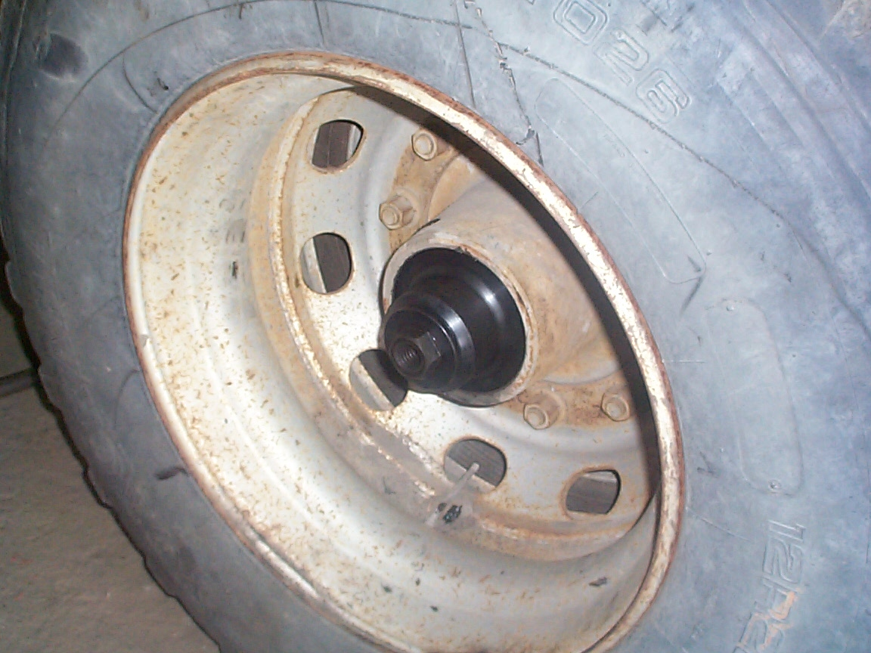
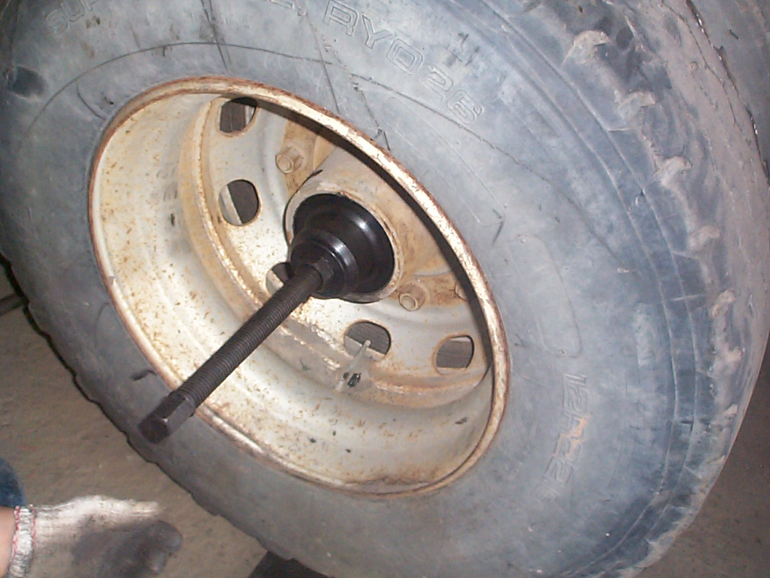

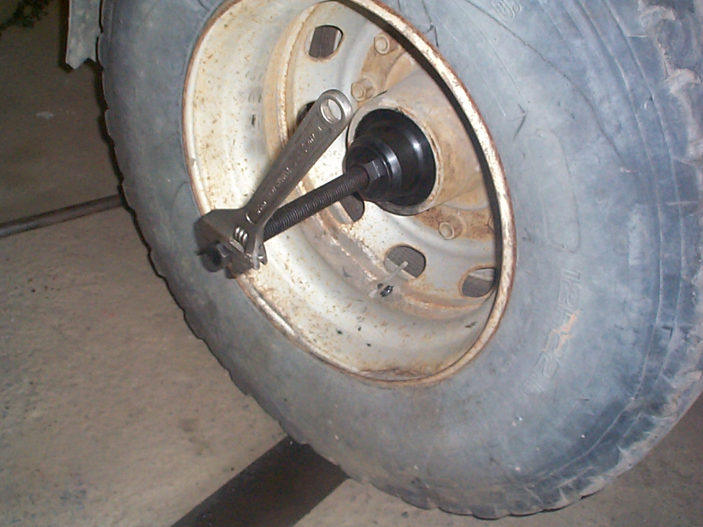

- Specification: M155 X P3.0
- Screw specification: ∮30 X 6W

H.C.B-A1066-2
BPW 16 TONS AXLE EXTRACTOR
(M155 x P3.0)

- Specification: M155 X P3.0
- Screw specification: ∮30 X 6W

