
H.C.B - A1066-1
BPW 12 TONS AXLE EXTRACTOR
(M125 x P2.0)

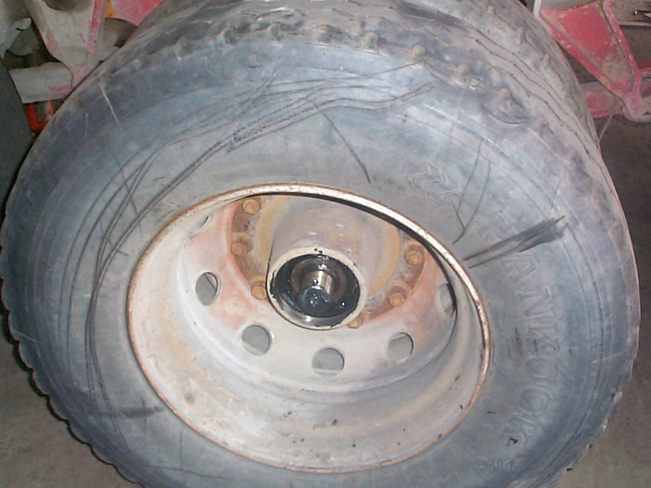
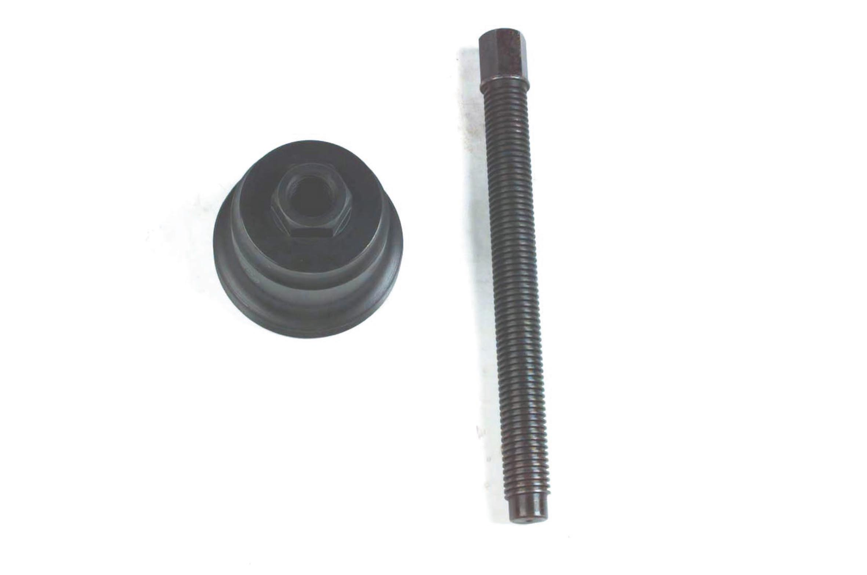
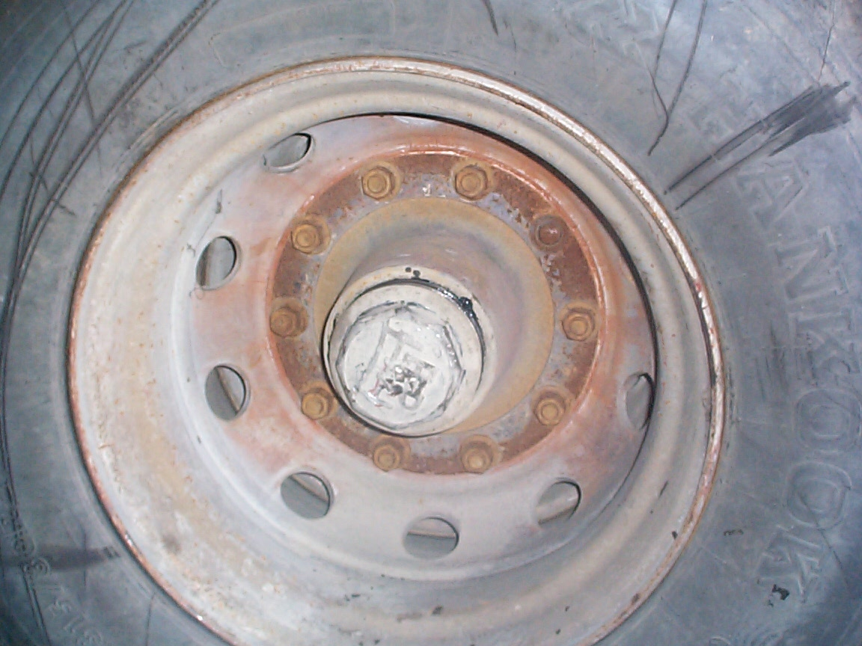

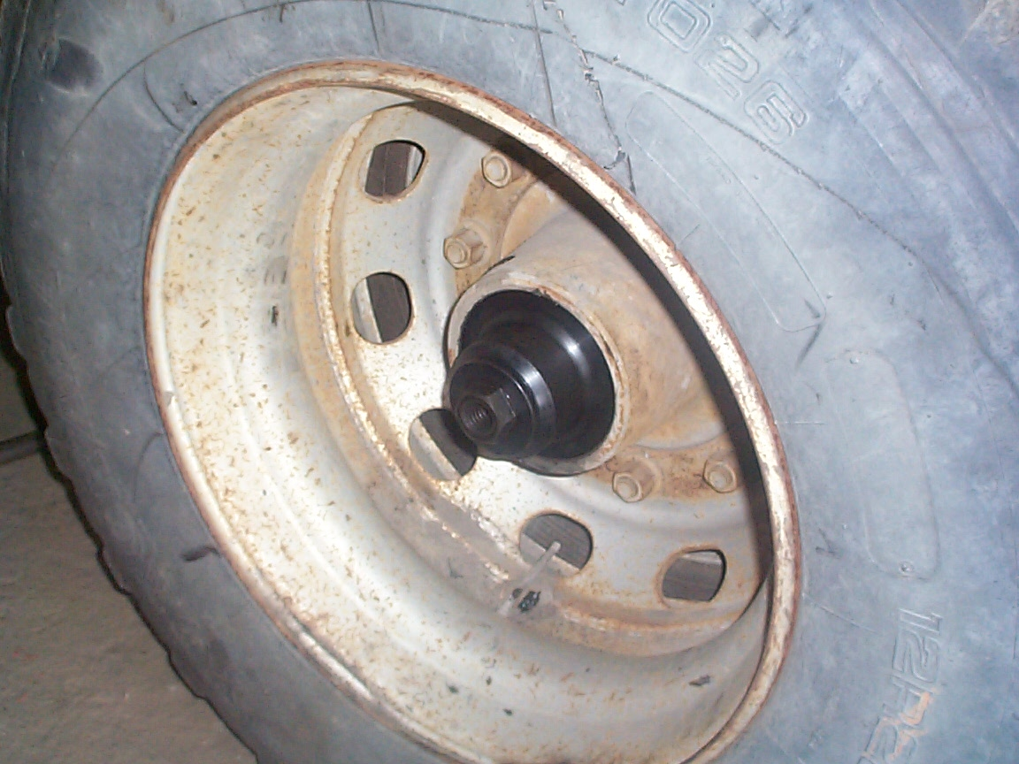
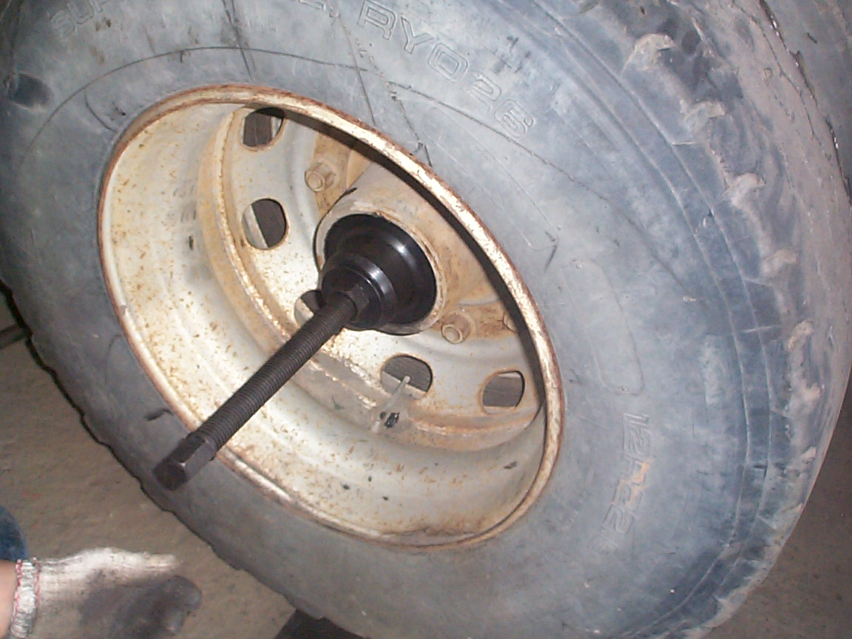

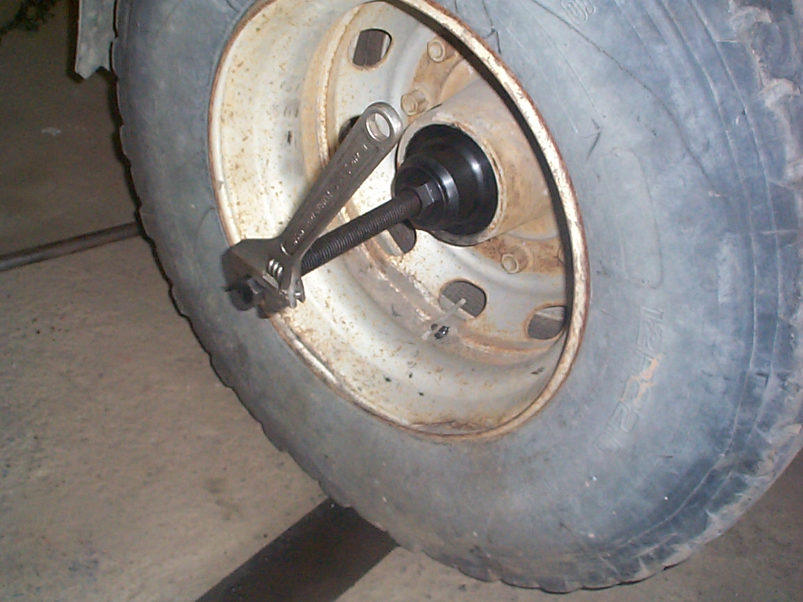

- Specification: M125 X P2.0

- Screw specification: Φ30 X 6W

- N.W.:2.8KGS

- For former model of 12 tons truck

H.C.B - A1066-1
BPW 12 TONS AXLE EXTRACTOR
(M125 x P2.0)

- Specification: M125 X P2.0

- Screw specification: Φ30 X 6W

- N.W.:2.8KGS

- For former model of 12 tons truck

