
H.C.B-A1027
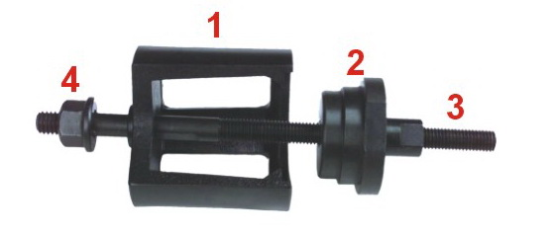 | 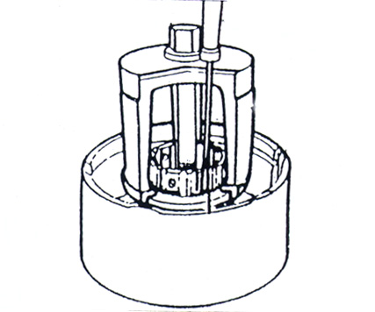
H.C.B-A1027-1  BENZ ASSEMBLY FIXTURE | H.C.B-A1027-1  DIAGRAM
BENZ SLEEVE, ASSEMBLY DEVICE &
ASSEMBLY FIXTURE
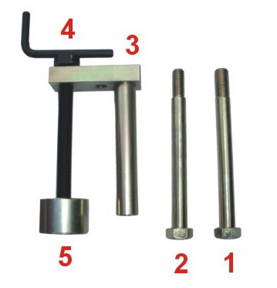 | 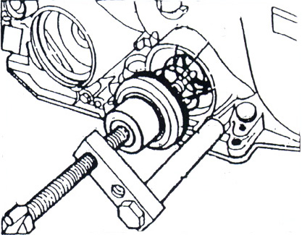
H.C.B-A1027-2  BENZ ASSEMBLY DEVICE | H.C.B-A1027-2  DIAGRAM
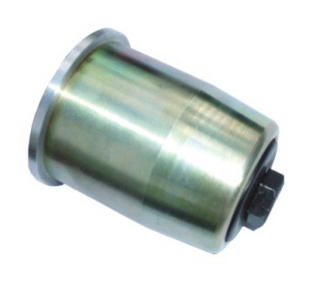 | 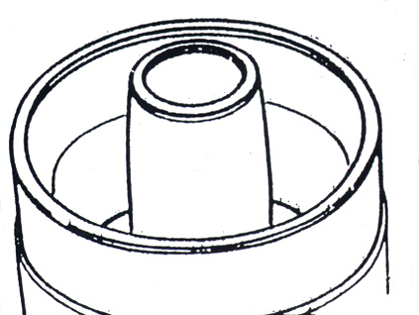
H.C.B-A1027-3  BENZ SLEEVE | H.C.B-A1027-3  DIAGRAM
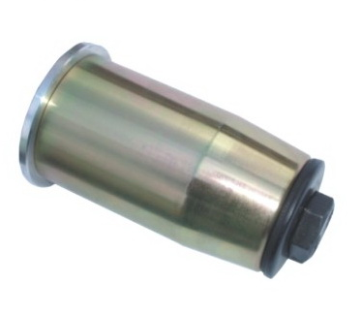 | 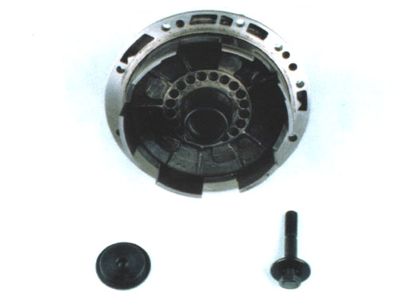
H.C.B-A1027-4  BENZ SLEEVE | H.C.B-A1027-4  DIAGRAM
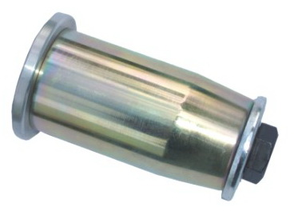 | 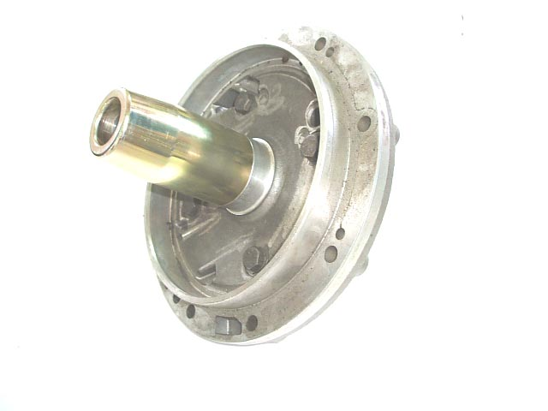
H.C.B-A1027-5  BENZ SLEEVE | H.C.B-A1027-5  DIAGRAM

