
H.C.B-A1015

BLIND HOLE BEARING PULLER

CAPACITY： 3/8” to 1-1/4” SAE

TOTAL LENGTH： 20-1/2”
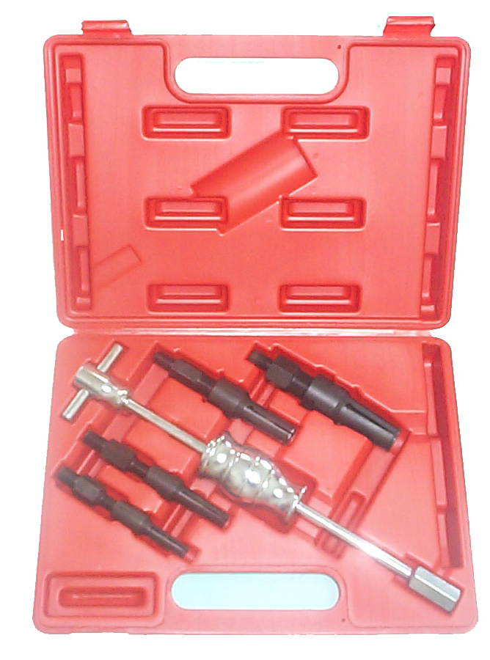

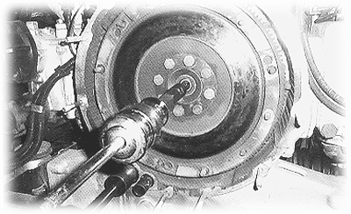

H.C.B-A1015

WARNING

When using electric tools, machines or equipment, basic safely precautions should always be followed to reduce the risk of fire, electric shock, and personal injury.

8
H.C.B-A1015

- ONE SLIDE HAMMER ASSEMBLE & 4 CLAMP.
- ATTACHMENTS:
➀3/8” to 1/2” (10~14mm)
➁9/16” to 11/16” (15~19mm)
➂5/8” to 1” (18~25mm)
➃1” to 1-1/4” (25~32mm) ID bearings’ pulling.

- OPEN CLAMPS BY TURNING HANDLE CLOCKWISE TO SNUG AGAINST THE BEARING FOR PULLING OUT EVENLY WITHOUT DAMAGE THE PARTS.

GENERAL

Your Blind Bearing Puller has four different attachments (H.C.B-A1015-1 to 4). Each attachment has a specific range of use. Use the attachment specific to your needs. The range of use for each attachment is as follows:

1
H.C.B-A1015

H.C.B-A1015-1 | 3/8” to 1/2” SAE (10-14mm) | For sedan
H.C.B-A1015-2 | 9/16” to 11/16” SAE (15-19mm) | For sedan
H.C.B-A1015-3 | 5/8” to 1” SAE (18-25mm) | For sedan
H.C.B-A1015-4 | 1” to 1-1/4” SAE (25-32mm) | For truck
Prior to use, disassemble each attachment as shown below and grease where indicate as shown in Figure 1.

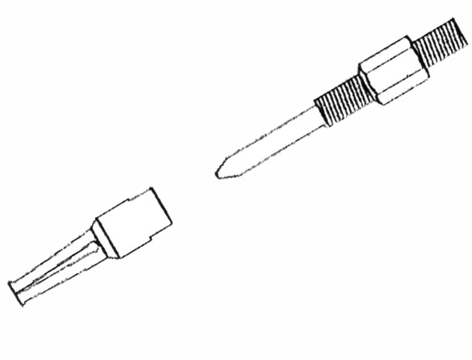
Grease

Loosen

Attachment Head

Figure 1 –Greasing Attachments Reassemble each attachment.

2
H.C.B-A1015

Please pull out evenly. If bearing pulls out unevenly during operation, stop to remove Blind Bearing Puller. Gently tap bearing with rubber mallet until bearing is even.

Step 7: Repeat Steps 4-6 until bearing has successfully pulled.

Step 8: Close clamps by turning handle counterclockwise. Remove bearing.

PARTS LIST

Ref. | Item Description | Quantity
H.C.B-A1015-1 | Attachment 3/8” to 1/2” SAE (10-14mm) | 1
H.C.B-A1015-2 | Attachment 9/16” to 11/16” SAE (15-19mm) | 1
H.C.B-A1015-3 | Attachment 5/8” to 1” SAE (18-25mm) | 1
H.C.B-A1015-4 | Attachment 1” to 1-1/4” SAE (25-32mm) | 1
H.C.B-A1015-5 | Handle | 1
H.C.B-A1015-6 | Hammer | 1
H.C.B-A1015-7 | Shaft | 1

7
H.C.B-A1015

Figure 4 – Insert Attachment into bearing

Step 3: Grasp the attachment head while turning the handle (H.C.B-A1015-5) clockwise until clamps are snug against the bearing as shown in Figure 5.This will open the attachment head clamps.

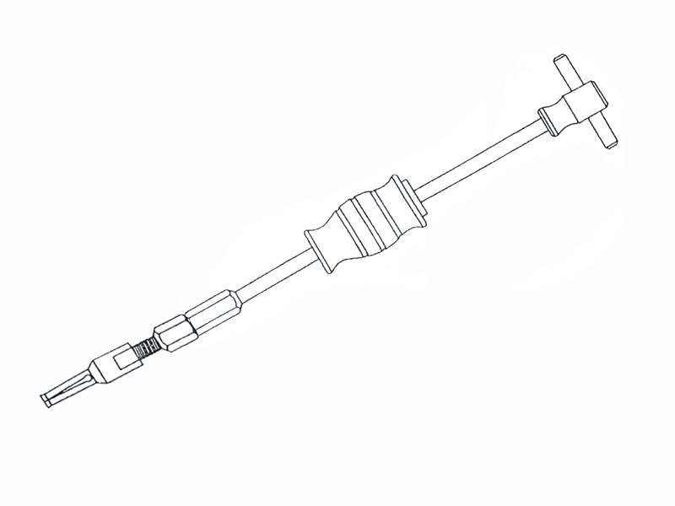
Handle (H.C.B-A1015-5)

Hammer (H.C.B-A1015-6)

Hold Here

Figure 5 – Open/Close the attachment Head
Step 4: Firmly grasp HAMMER (H.C.B-A1015-6) and handle with hands. Spread feet shoulder width apart.

Step 5: Gently push hammer forward.

6
H.C.B-A1015

ASSEMBLY

Step 1: Your Blind Bearing Puller comes partly assembled.

Step 2: Select the Attachment with the appropriate range of use for your application.

Loosen

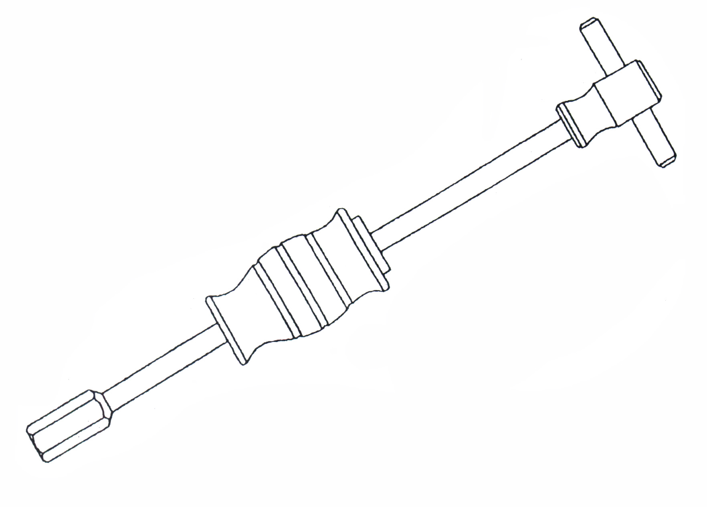

H.C.B-A1015-5 Handle

Tighten

H.C.B-A1015-6 Hammer

Figure 2 – Hammer Replacement

3
H.C.B-A1015

Step 3: Thread attachment into the shaft as shown in Figure 3. Do not cross-thread attachment.

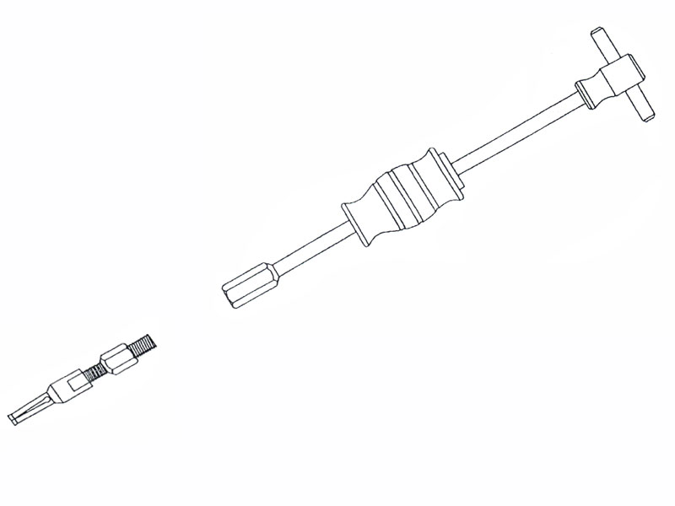
Tighten
Figure 3 – Connect Attachment to shaft

Step 4: Tighten attachment using a wrench. Do not over tighten.

4
H.C.B-A1015

OPERATION

Step 1: Select proper attachment (H.C.B-A1015-1 to 4) for job. Assemble Blind Bearing Puller with selected attachment. Make sure clamps are completely closed.

Step 2: Insert attachment head into inner diameter of bearing as shown in Figure 4.

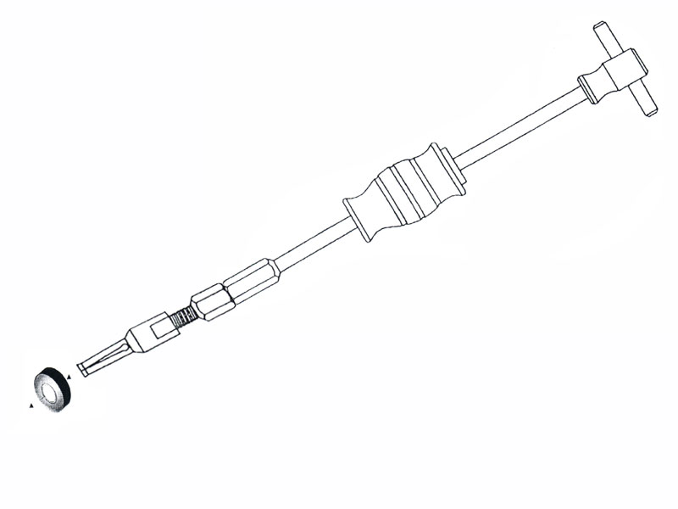

Attachment Head

Bearing

5

